Table of Contents

Module 2 Objectives 1

Objective: 1

Windows Server 1

1. Verify your hostname and FQDN 1

2. Statically configure the TCP/IP settings 3

3. Create a virtual machine checkpoint 5

Windows Active Directory 2019 5

Install and configure Active Directory to promote your server to a domain controller 5

In Active Directory, create an Organizational Unit named ‘WinUsers’ 14

In the ‘WinUsers’ OU create user accounts for ‘WinUser1’ and ‘WinUser2’ and set their passwords to ‘Password2’ 16

In the ‘WinUsers’ OU, create a global security group named ‘SharePoint-G’ 18

Managed Service Account 20

SQL Server 2019 24

SharePoint 2019 36

Install SharePoint 2019 Enterprise on the Windows 2019 server. 40

Configure web-based file collaboration 49

Share your SharePoint site with your WinUsers * / ** 53

Create, upload and share at least 1 test document between ‘WinUser1’ and ‘WinUser2’using SharePoint. 54

Log on to the server as WinUser1 and verify you have access to the document 58

Log on to the server as WinUser2 and verify you have access to the document 59

Linux 59

Verify your hostname and FQDN is correct 60

Statically configure the TCP/IP settings as identified in the document titled 60

Create a virtual machine checkpoint 61

Create users and set their passwords to ‘Password2’ 61

Install all prerequisite software for OpenDocMan document sharing solution 62

OpenDocMan Summary 80

SharePoint Summary 80

**Scenario data is highlighted in Yellow**

**Scripts and CLs are highlighted in Green**

**Errors highlighted in Red**

# Module 2 Objectives

Objective: Many companies use document sharing software so their employees can collaborate on projects. Not all companies rely on Google Docs for this. For this Module, you will install Active Directory Domain Services, SQL Server 2019, and SharePoint Server 2019 on the Windows Server virtual machine and configure web-based document sharing. You will also install a chosen document sharing web-based solution on your Linux server.

## Windows Server

### 1. Verify your hostname and FQDN

* Open “Server Manager” if not already open, and select local server from the left navigation pane.
* Host and domain names can be verified in the properties of the local server. Select the Computer name to update the hostname and domain name as needed.

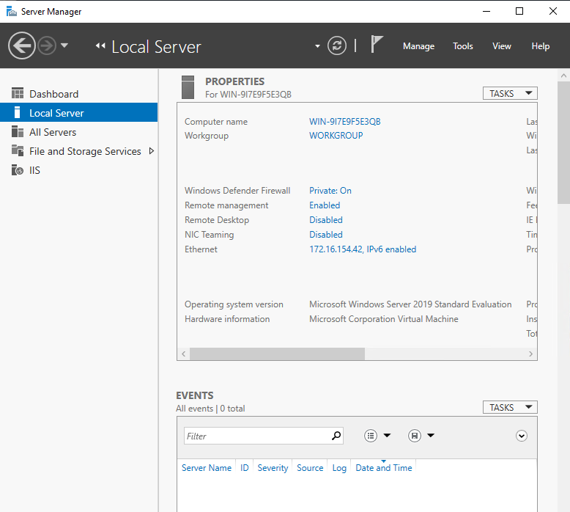

Select change to rename the computer or domain.

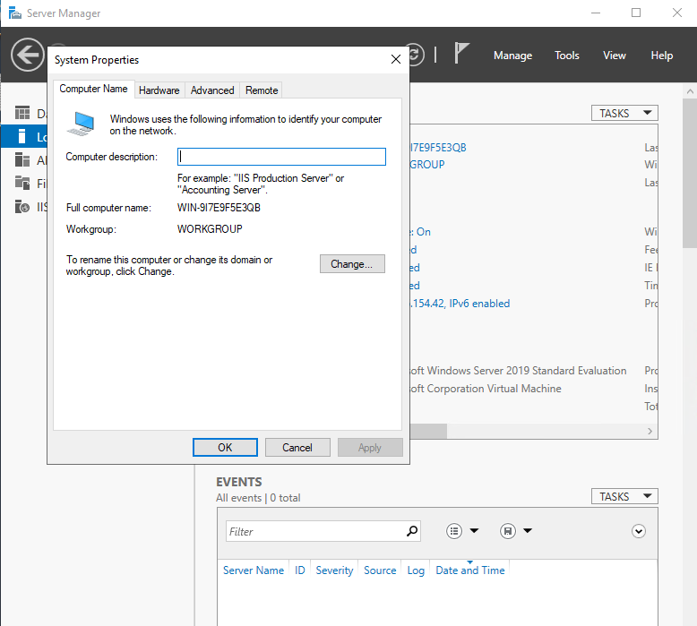

**Hostname: WinServer142 \***

**Domain: domain142.lab \***

**FQDN: WinServer142.domain142.lab \***

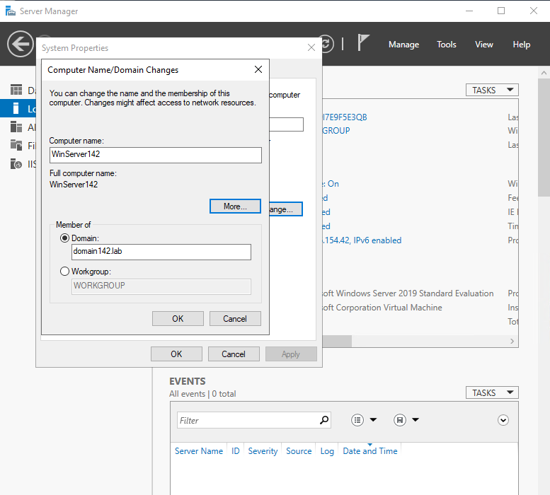

I received this error when trying to change the domain name likely because the domain has not been established.

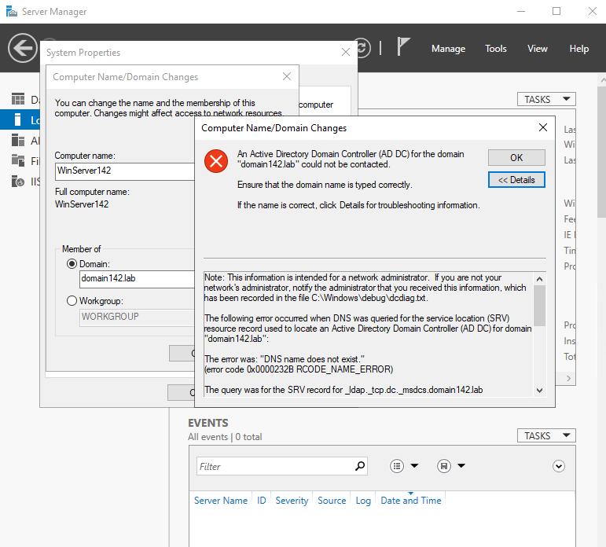

Selected workgroup for now to apply the name change update. I will restart after verifying TCP/IP Settings.

### 2. Statically configure the TCP/IP settings

**The TCP/IP settings are assigned as :**

**IP: 172.16.154.42 \***

**SM: 255.255.0.0**

**GW: 172.16.0.1**

**DNS: 172.16.0.1**

Verify Static Network Settings

Click the network icon in the task bar to select Network & Internet settings

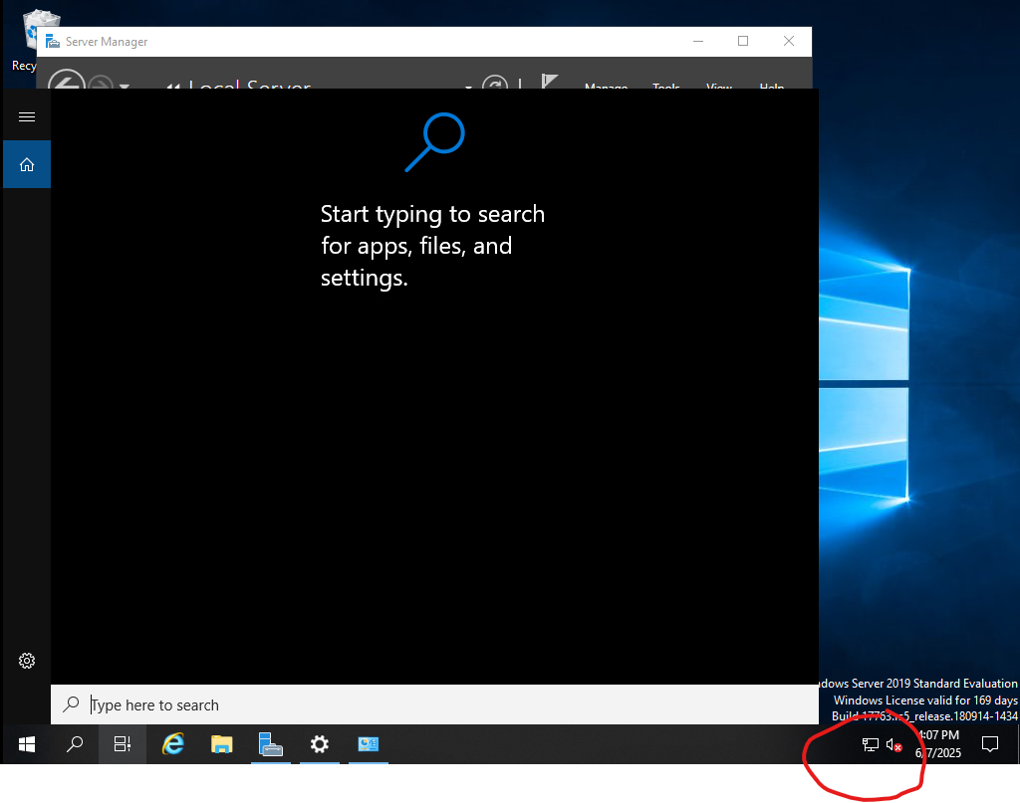

Select Ethernet, properties, and IPV4

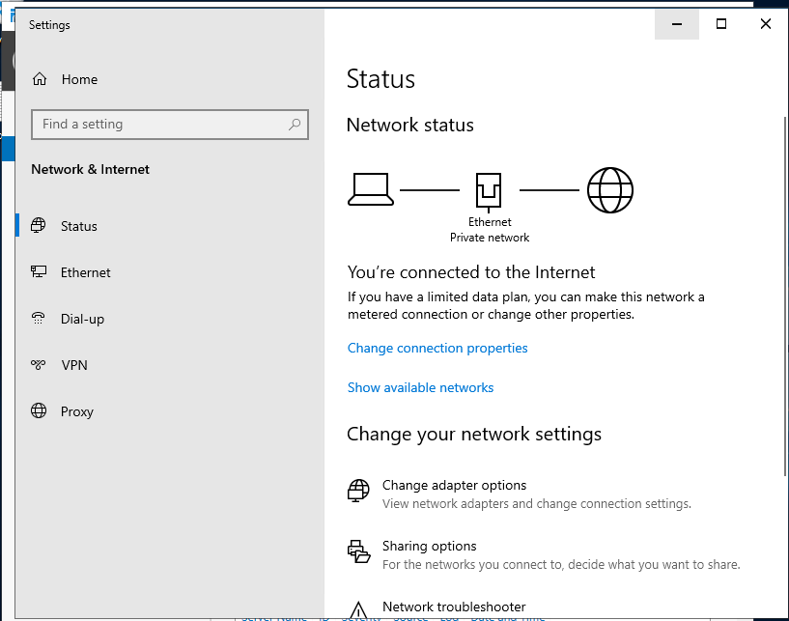

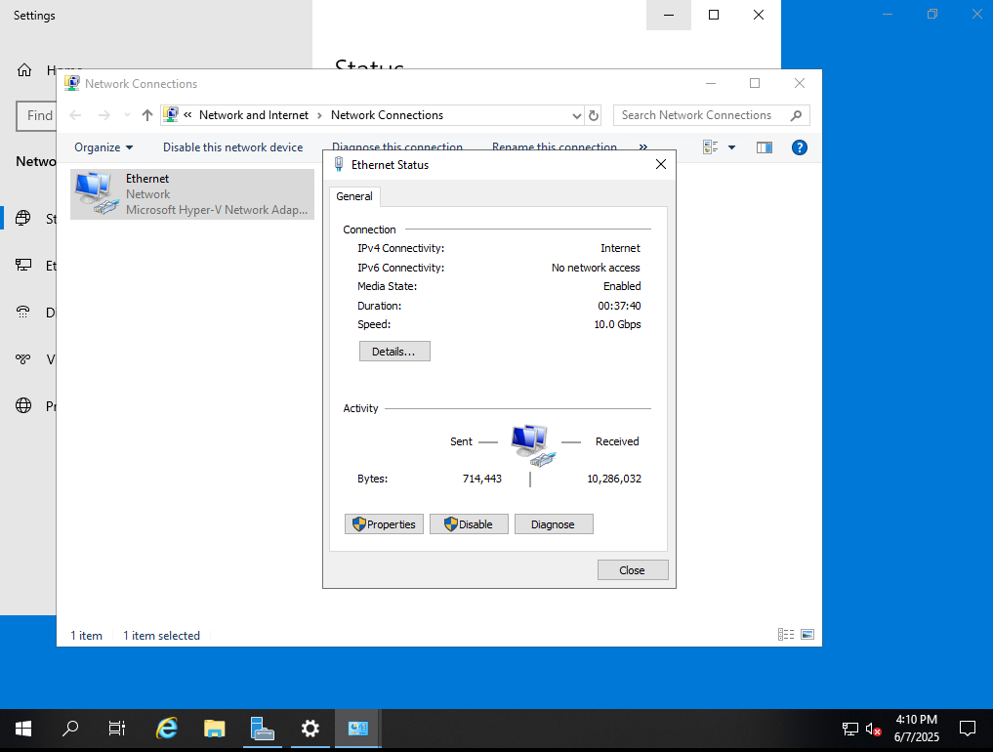

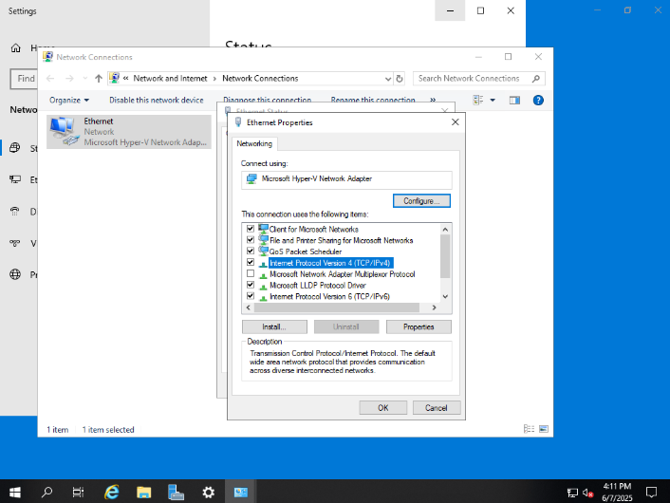

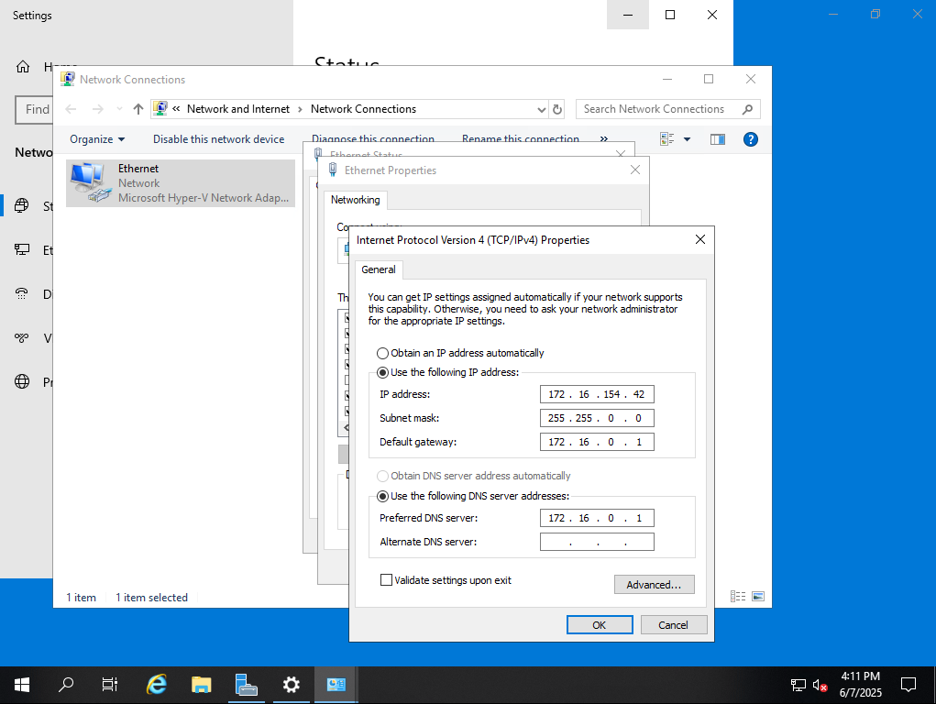

Once verified I will restart my VM to apply the computer name change.

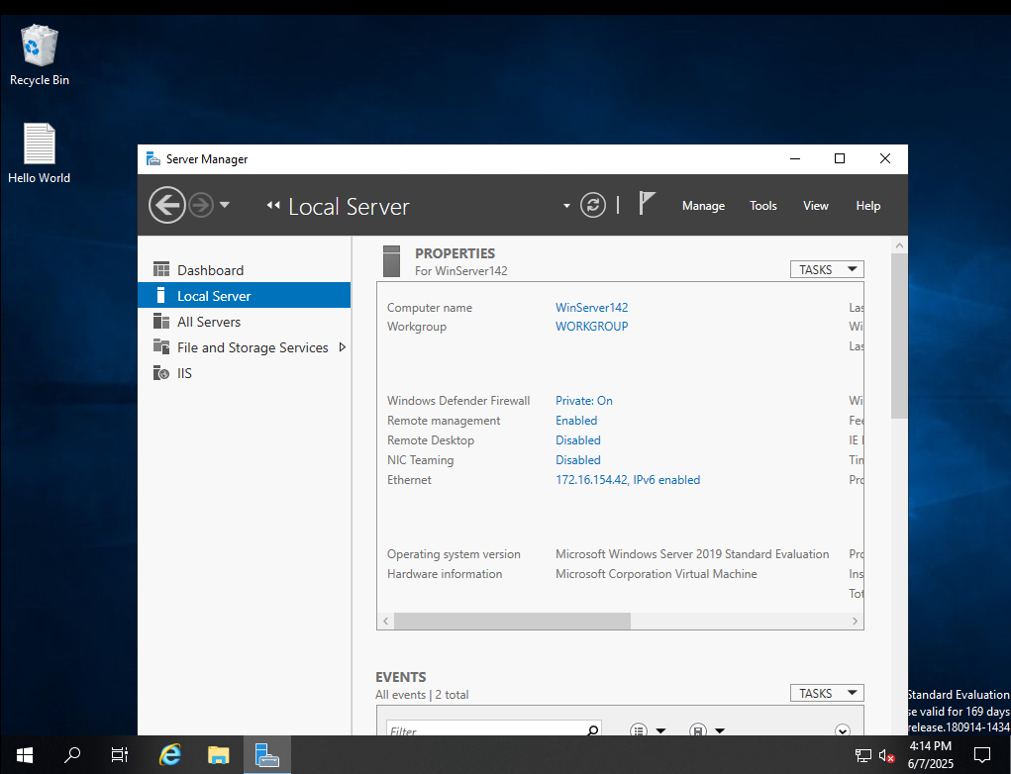

### 3. Create a virtual machine checkpoint

## Windows Active Directory 2019

Install and configure Active Directory to promote your server to a domain controller using the specifications identified in the document titled “Specifications for ITNW-2354 Labs.pdf”

Select Manage > Add Roles and Featrues from the Top Menu Bar in Server Manager

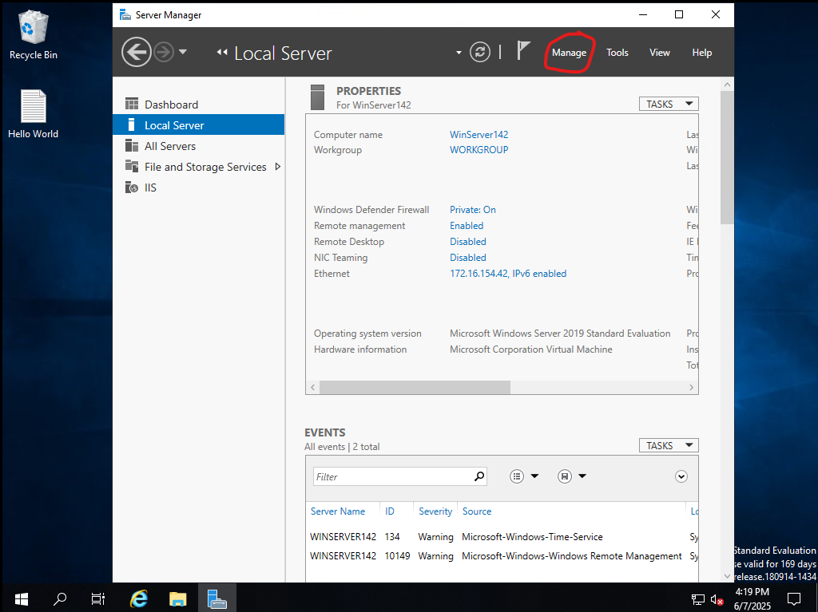

Select Role-Based or Feature-Based installation type

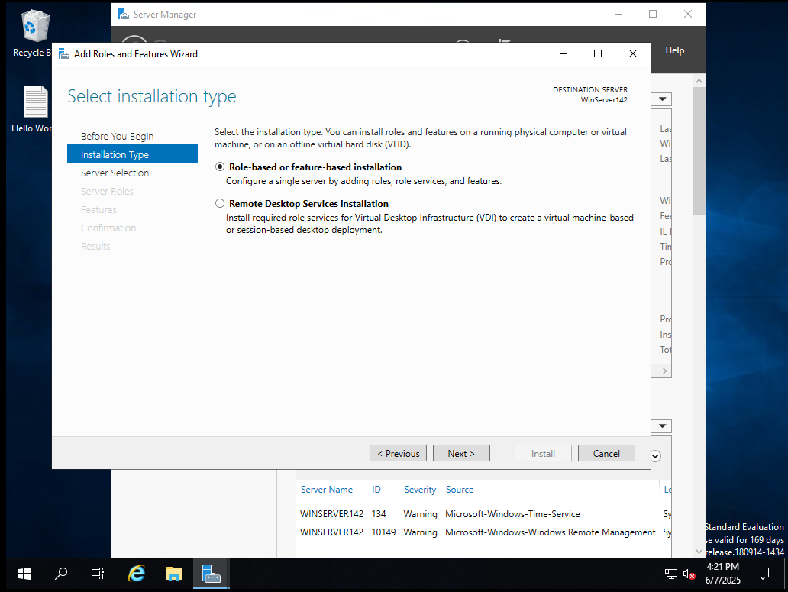

Select the appropriate server from the sever pool.

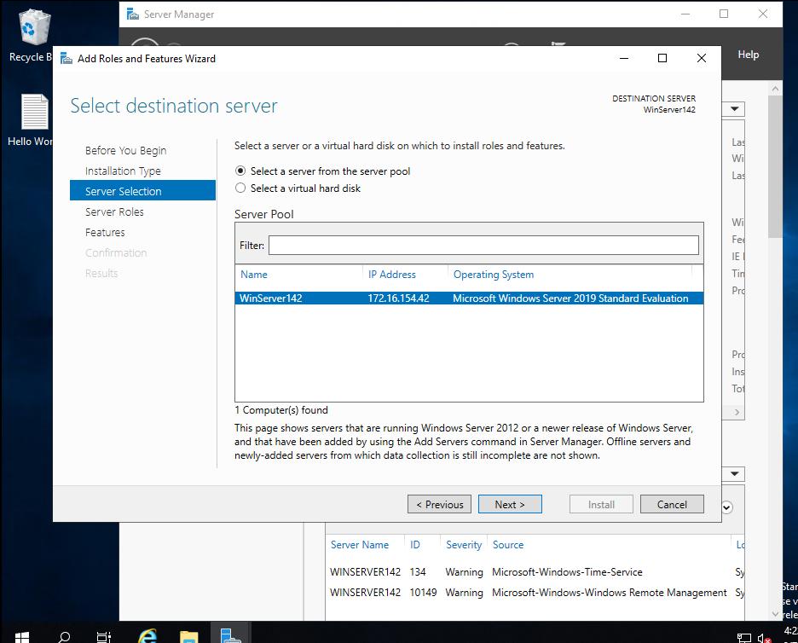

Select Active Directory Domain Services Role and add features

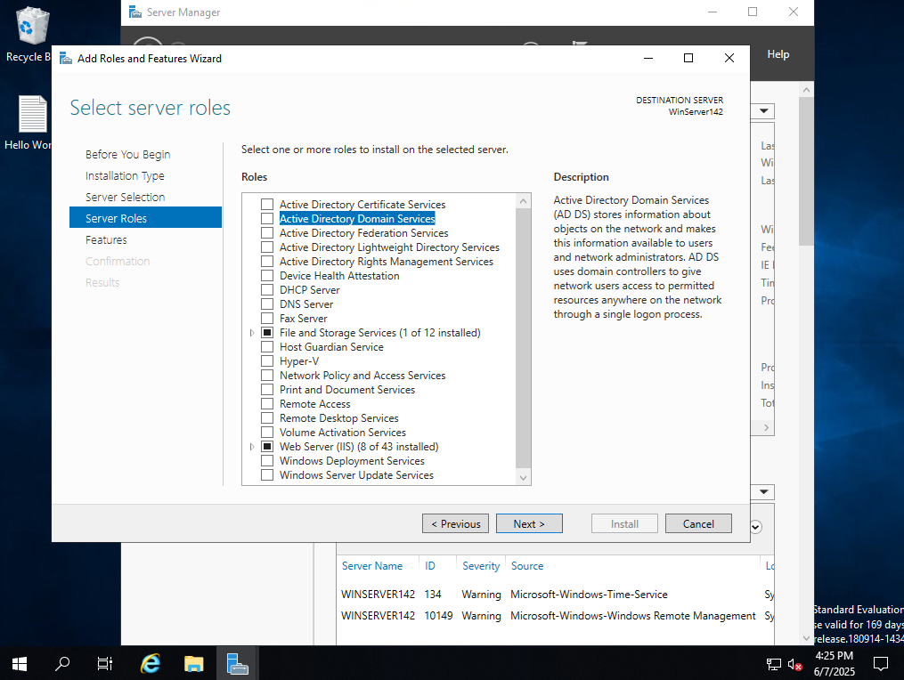

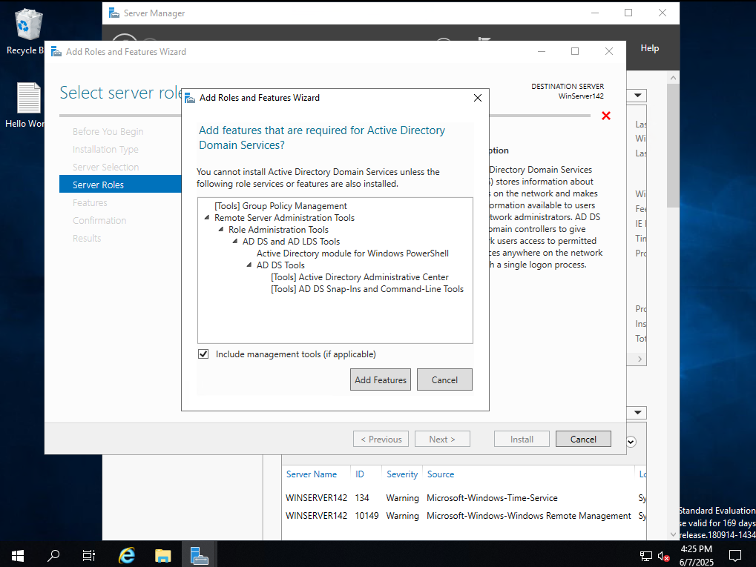

Click next through the next few screens to install. Make note of the DNS requirement for AD to work.

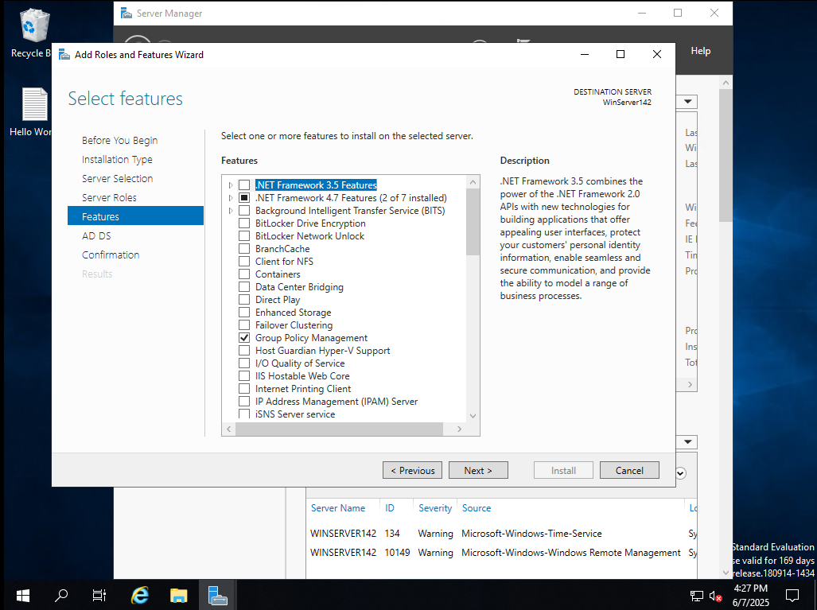

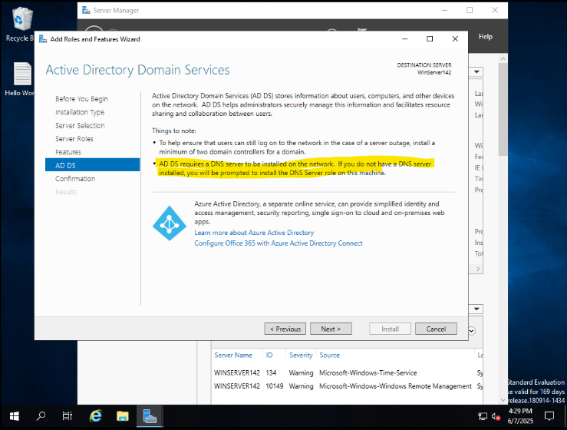

Restart to apply the changes.

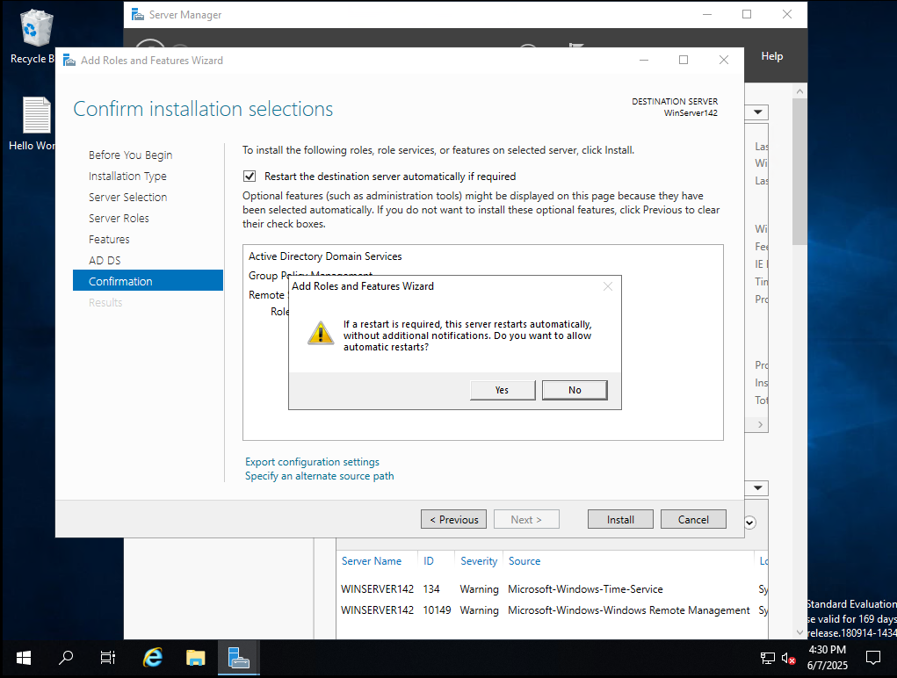

Click Install and close

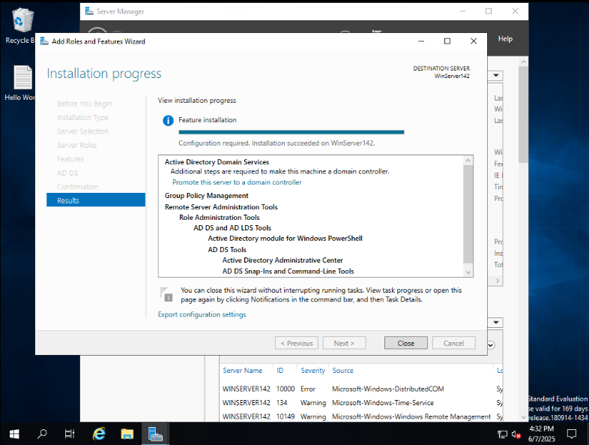

Click the notification under flag in the menu bar.

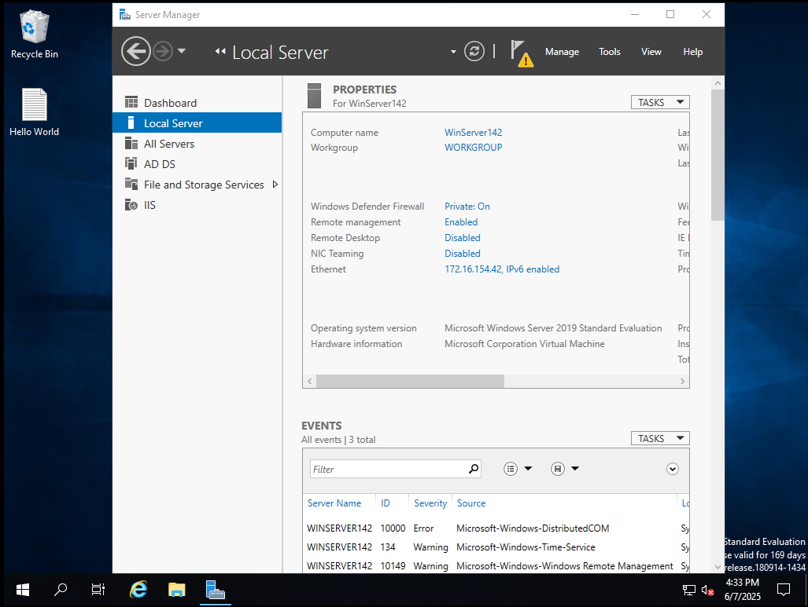

Select promote this server to a domain controller.

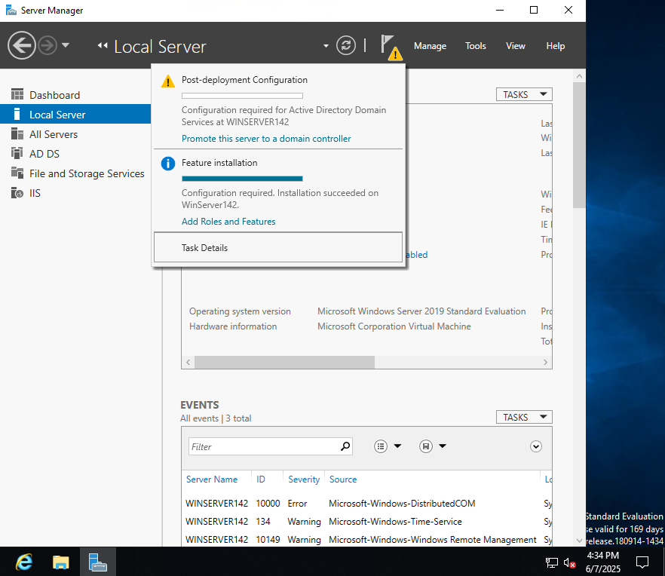

Add a new forest and input the specified **domain name: domain142.lab** and select next.

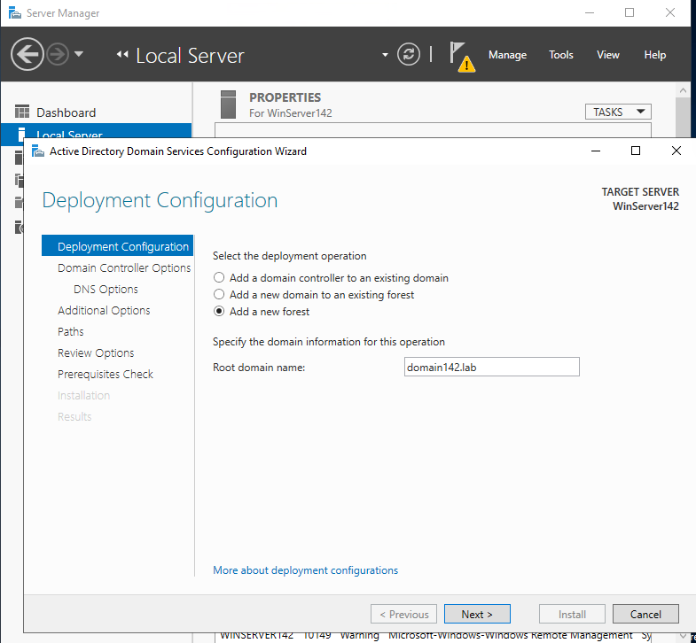

Keep DNS server selected as well as global catalog. Add the specified DSRM password **DSRM PW: P@ssword6**

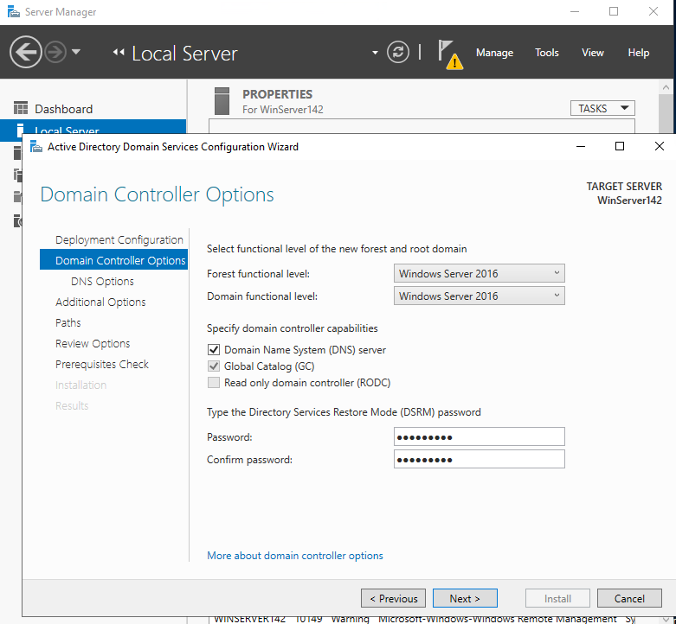

#### **Alert:**

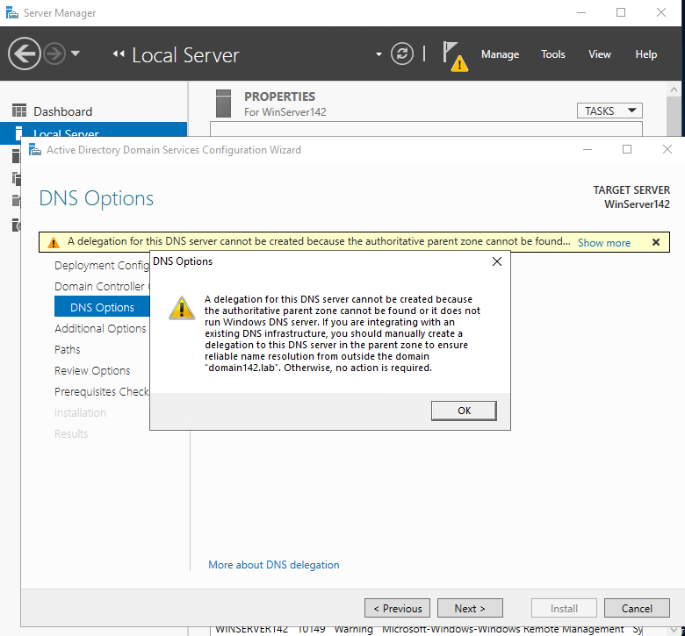

This happens because your root domain domain142.lab is private and internal, and there's no external parent zone (like lab) that can delegate DNS to it.

For now we can ignore it.

Verify domain name

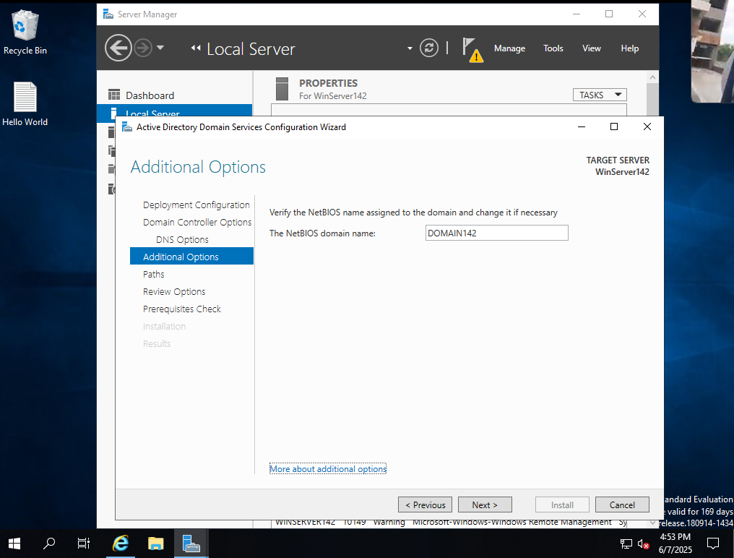

Keep the remaining default settings.

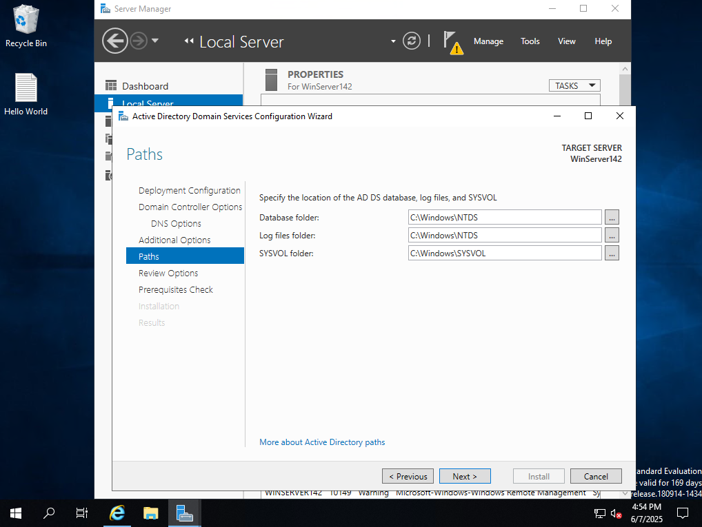

View the results of your prerequisites check and install

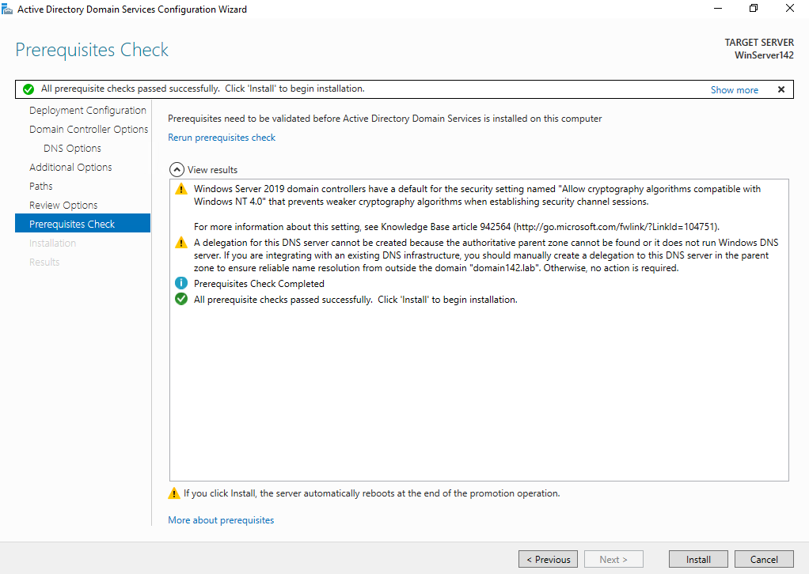

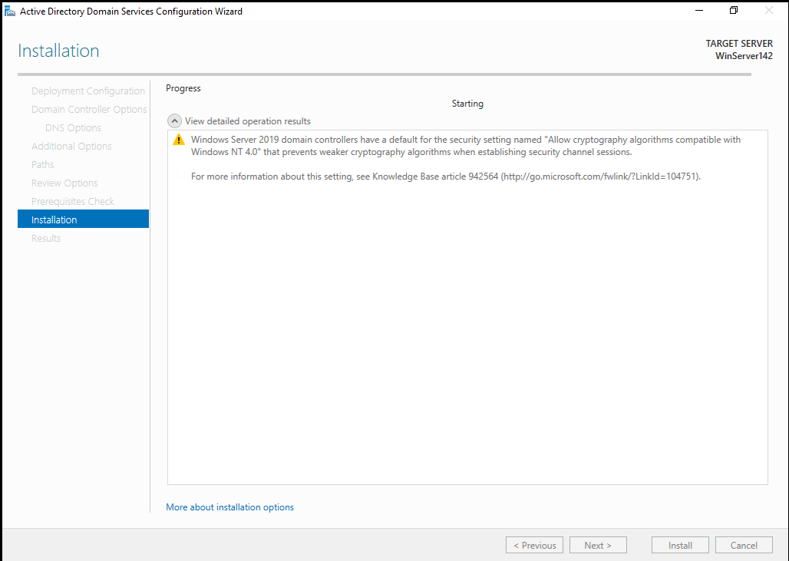

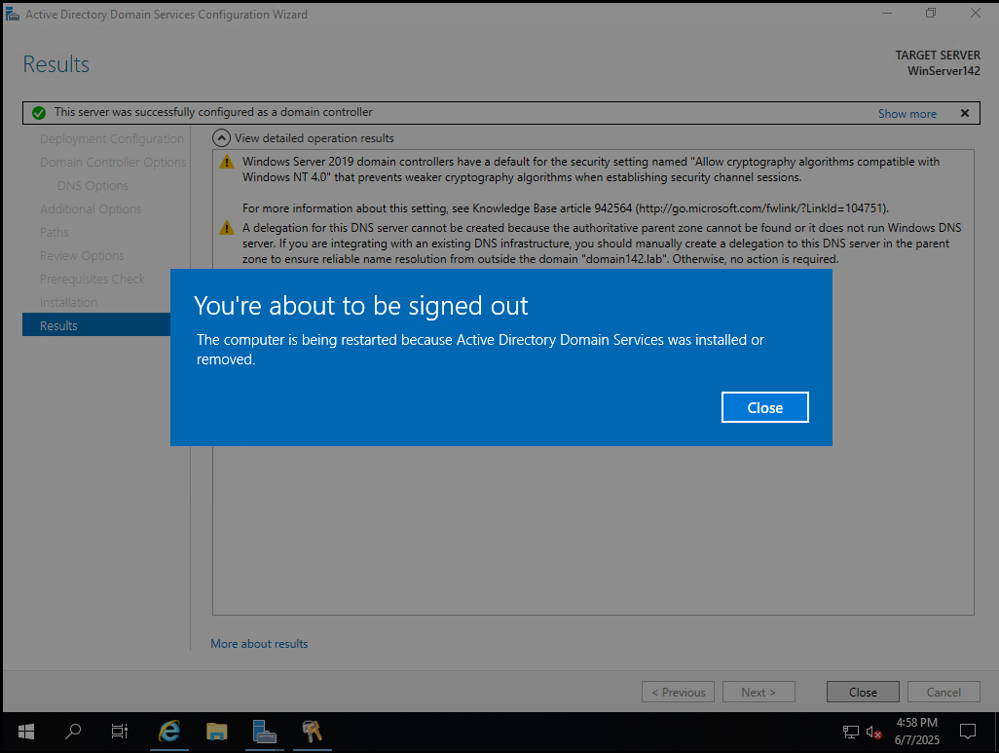

Verify Computer and Domain name in properties

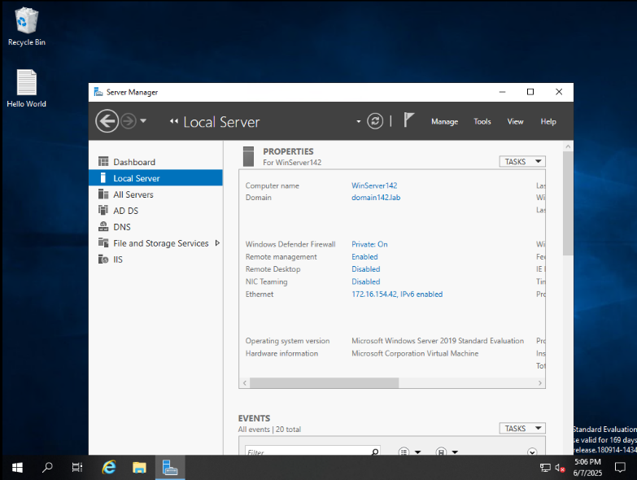

### In Active Directory, create an Organizational Unit named ‘WinUsers’

Select “AD DS” from the navigation pane, right click on the WINSERVER142, and select the Active Directory Users and Computers

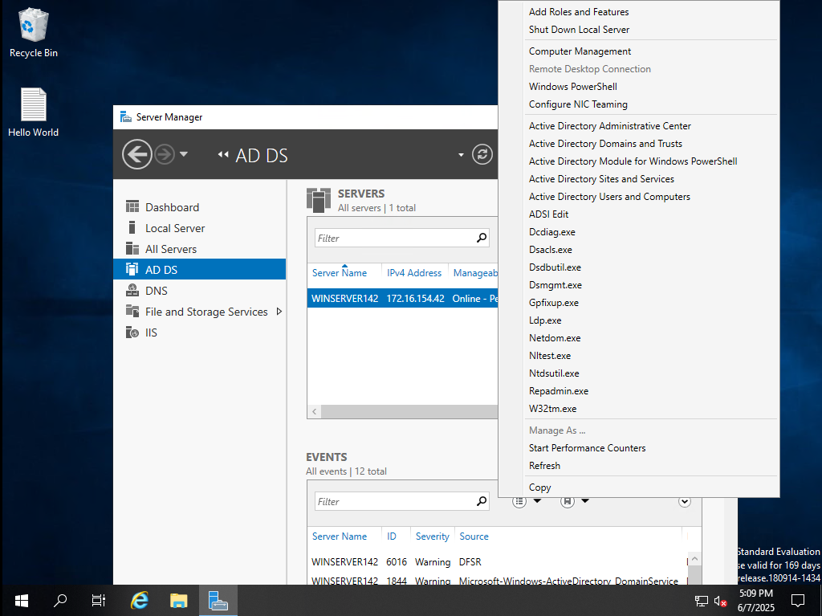

Right click on domain142.lab > New > Organizational Unit

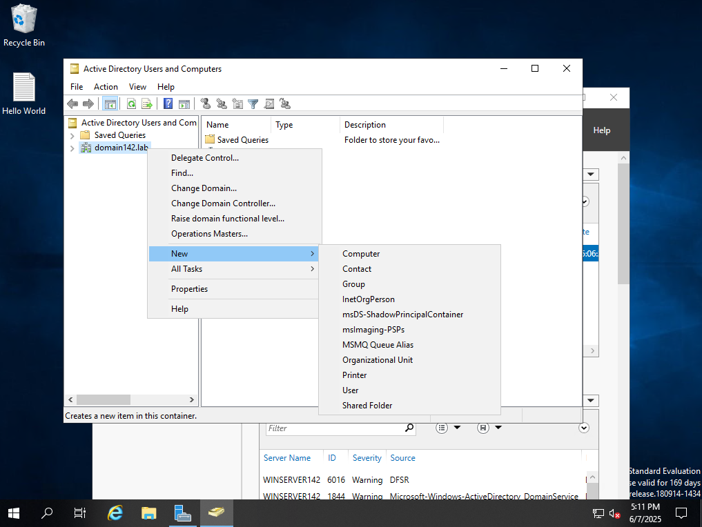

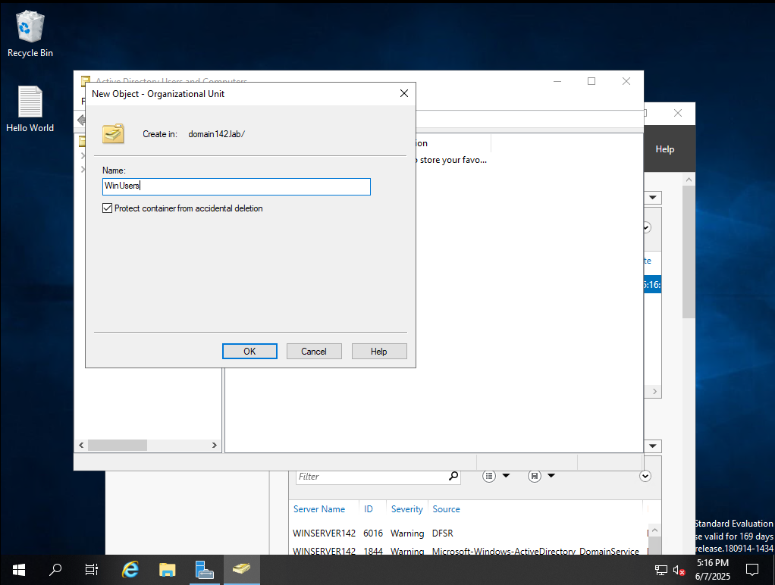

Left click on the domain to identify WinUsers at the bottom of the domain

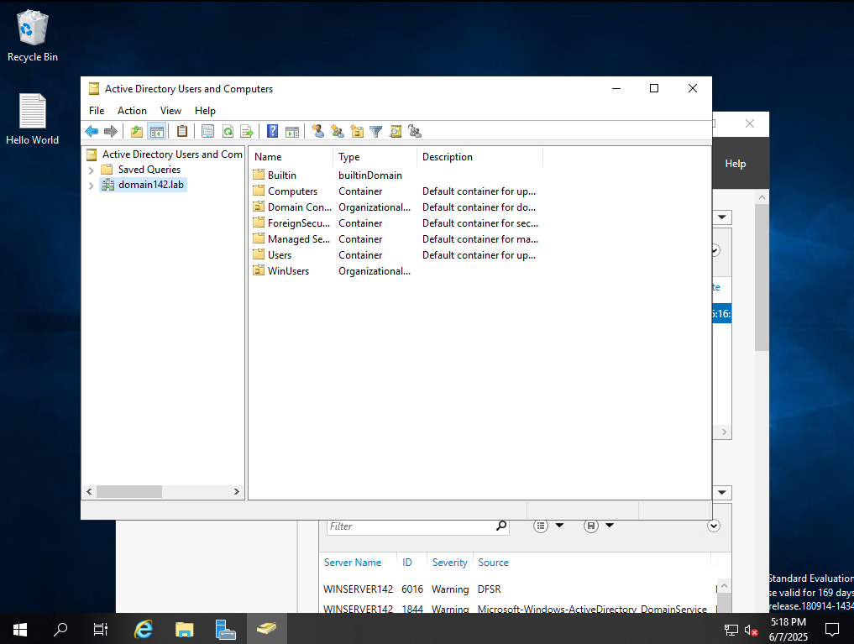

In the ‘WinUsers’ OU create user accounts for ‘WinUser1’ and ‘WinUser2’ and set their passwords to ‘Password2’ (as identified in the document titled “Specifications for ITNW-2354 Labs.pdf”)

Right click OU WinUsers > New > User

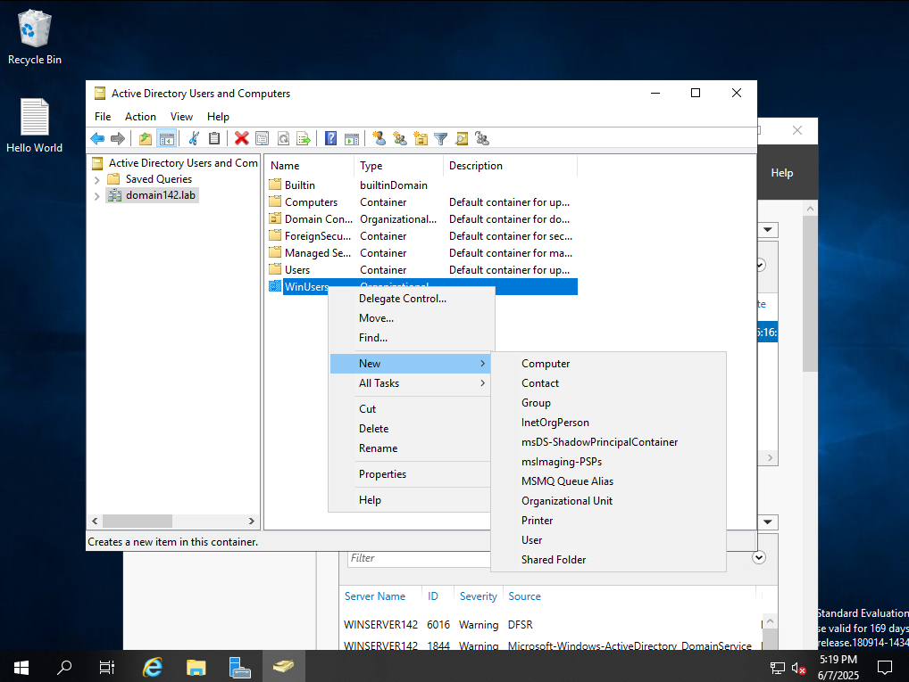

Create both users in accordance with the specifications **WinUsers: Password2**

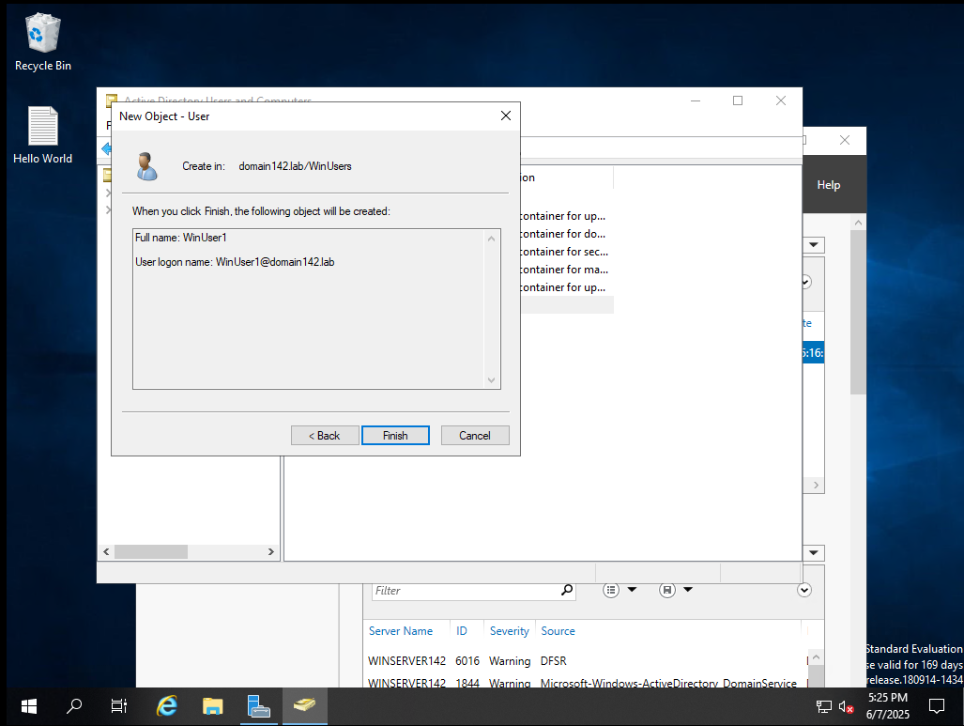

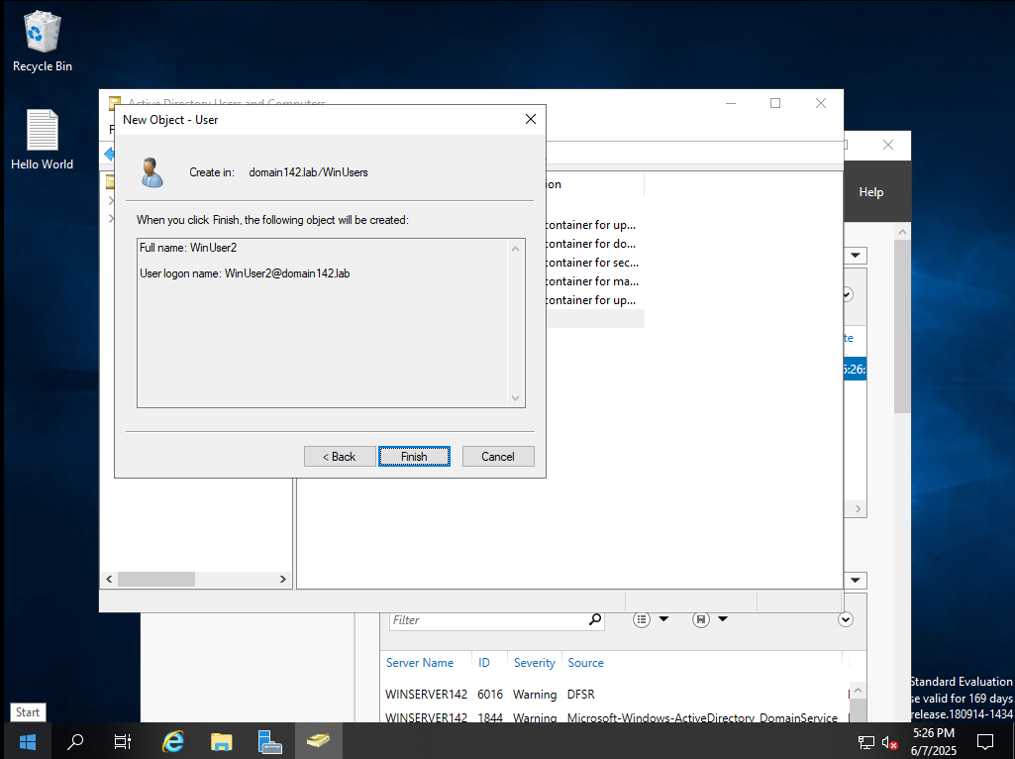

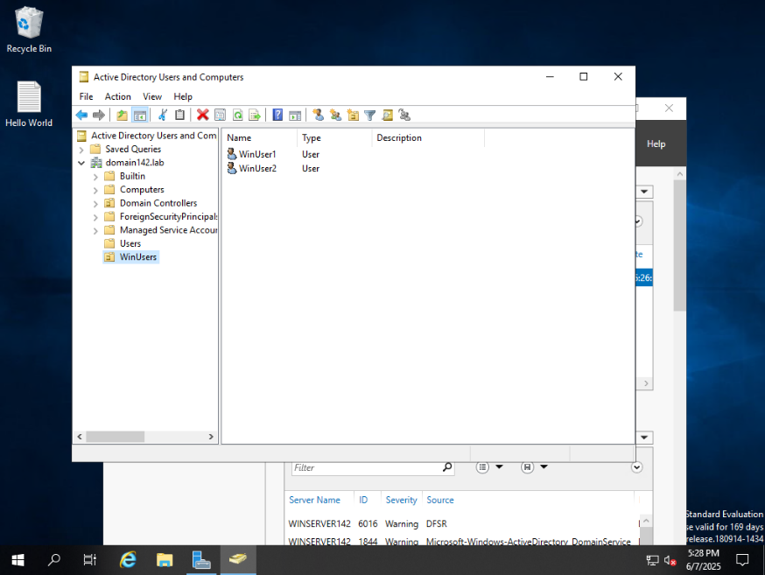

### In the ‘WinUsers’ OU, create a global security group named ‘SharePoint-G’

Right click on WinUsers OU > New > Group

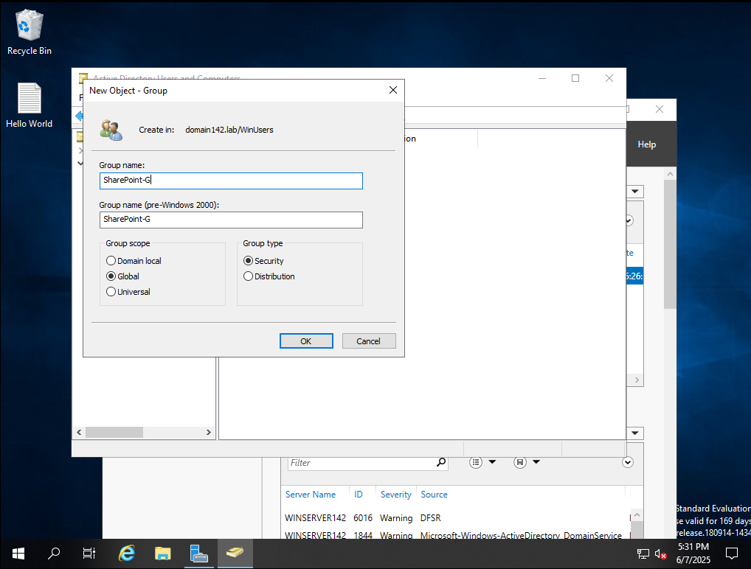

#### Add ‘WinUser1’ and ‘WinUser2’ to ‘SharePoint-G’ group.

Right click users > Add to a group > type share in the “enter the object names box” select check names > select ok

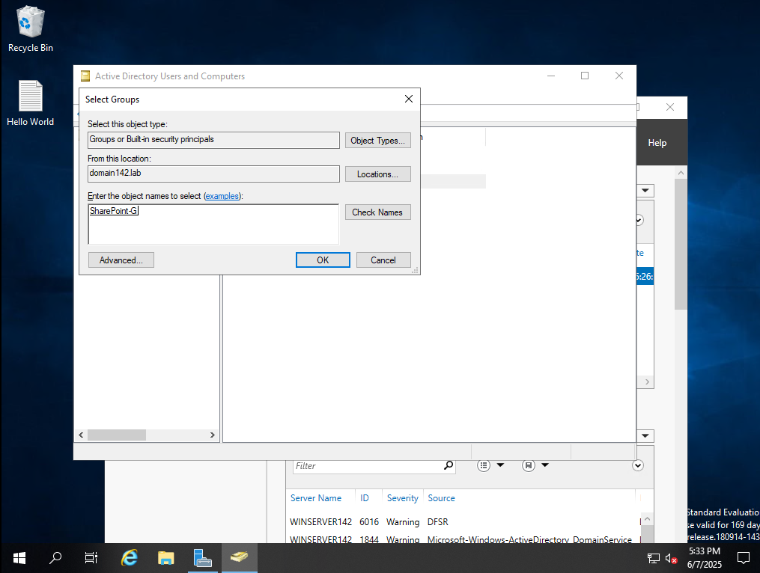

Click the SharePoint-G group and verify both users are Members

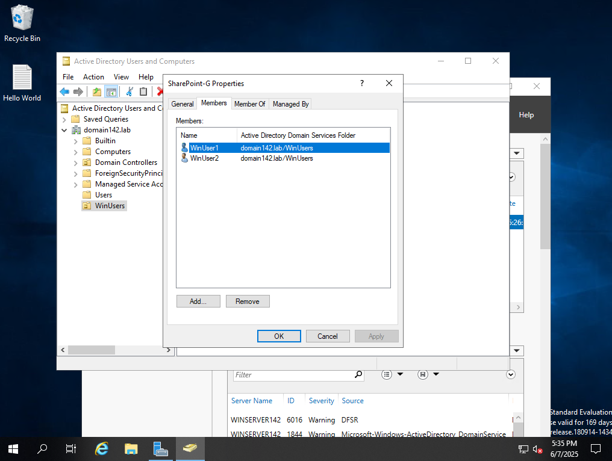

Add ‘WinUser1’ and ‘WinUser2’ to the ‘Print Operators’ group. (this will allow them to log into the server remotely)

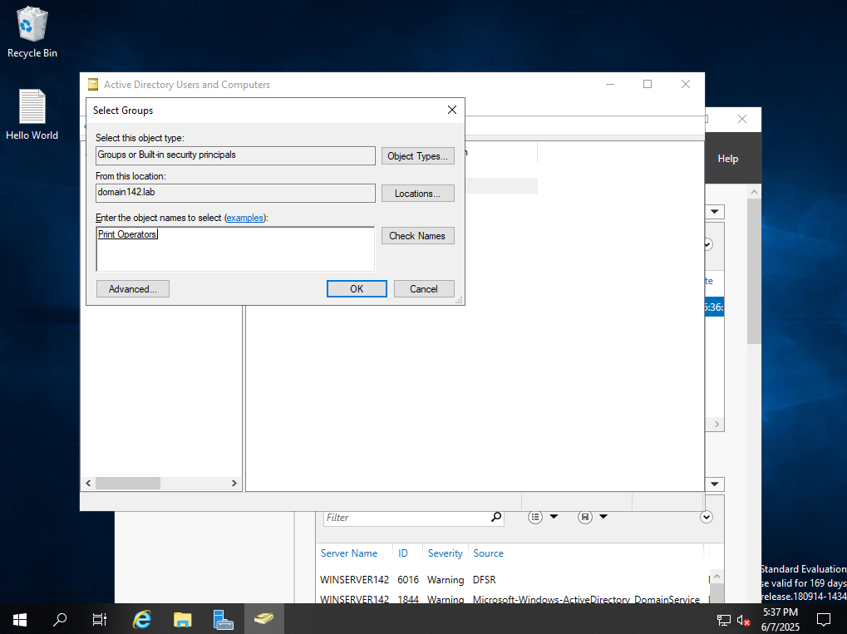

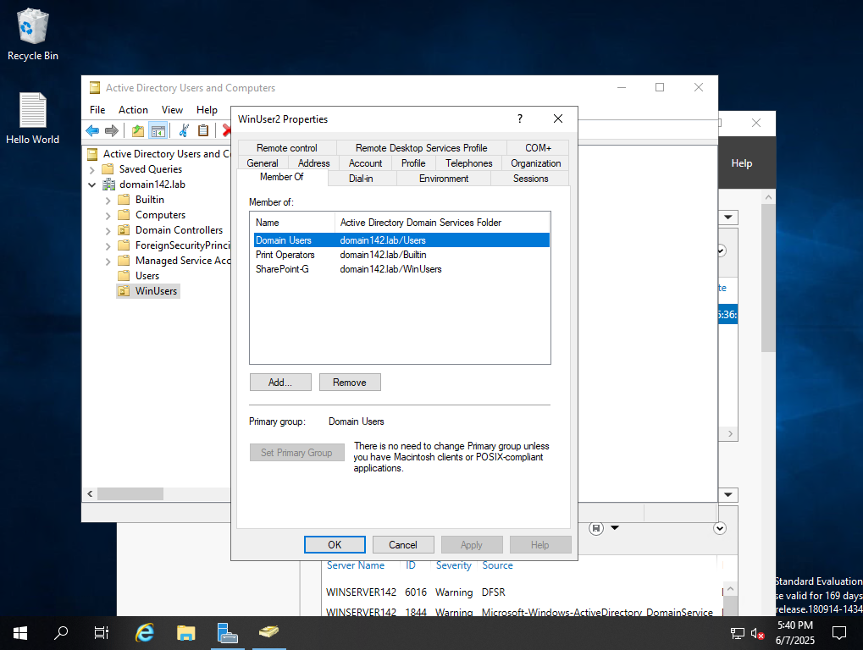

Create checkpoint for Windows AD

## Managed Service Account

Prior to installing SQL Server, I would like to establish a Managed Service Account to manage SQL and SharePoint accounts. <https://www.youtube.com/watch?v=rwPNOxDoqpc>

Open Powershell and run as an administrator. Right click Windows Icon > Right Click Powershell > Select run as administrator.

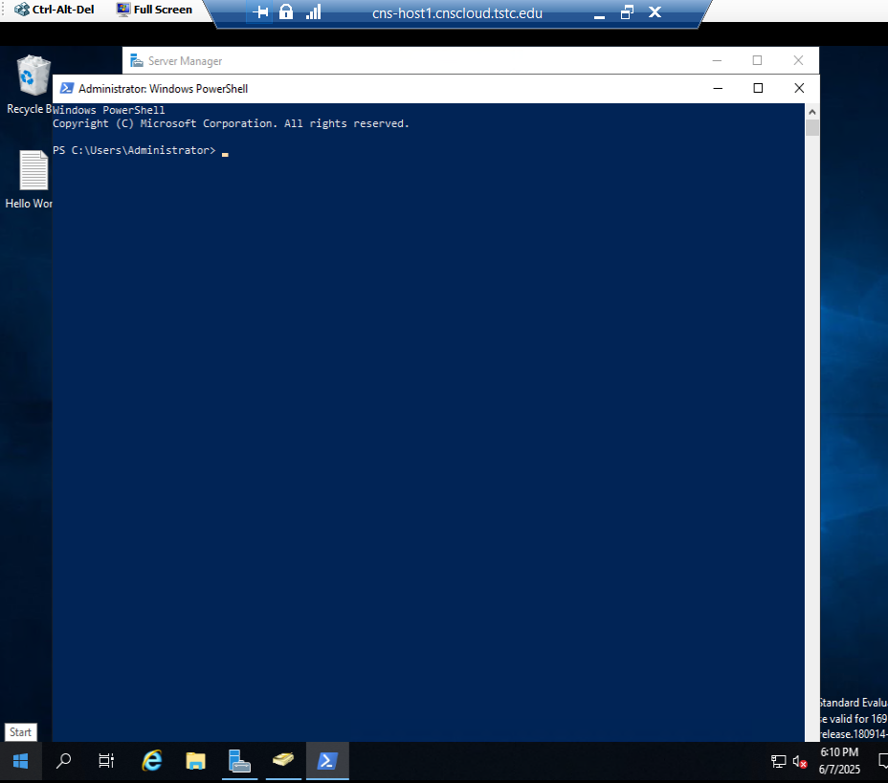

Add Key Distribution Service (KDS) root key and by pass default 10 hour wait for the root key to become effective

**add-kdsrootkey -effectivedate ((get-date).addhours(-10))**

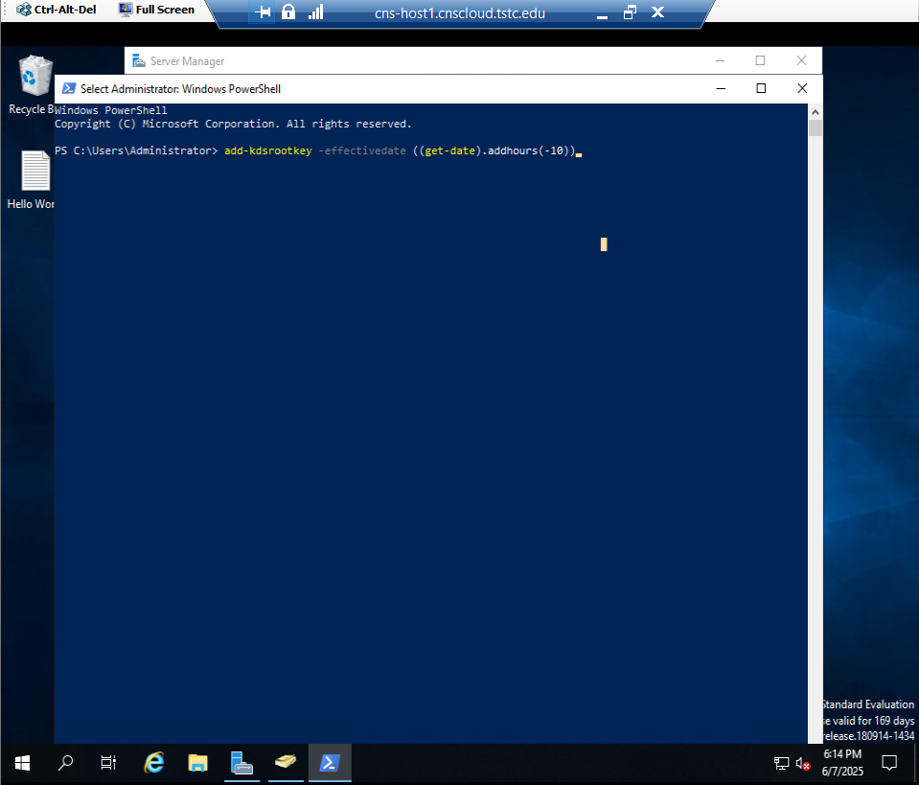

#### **ERROR**

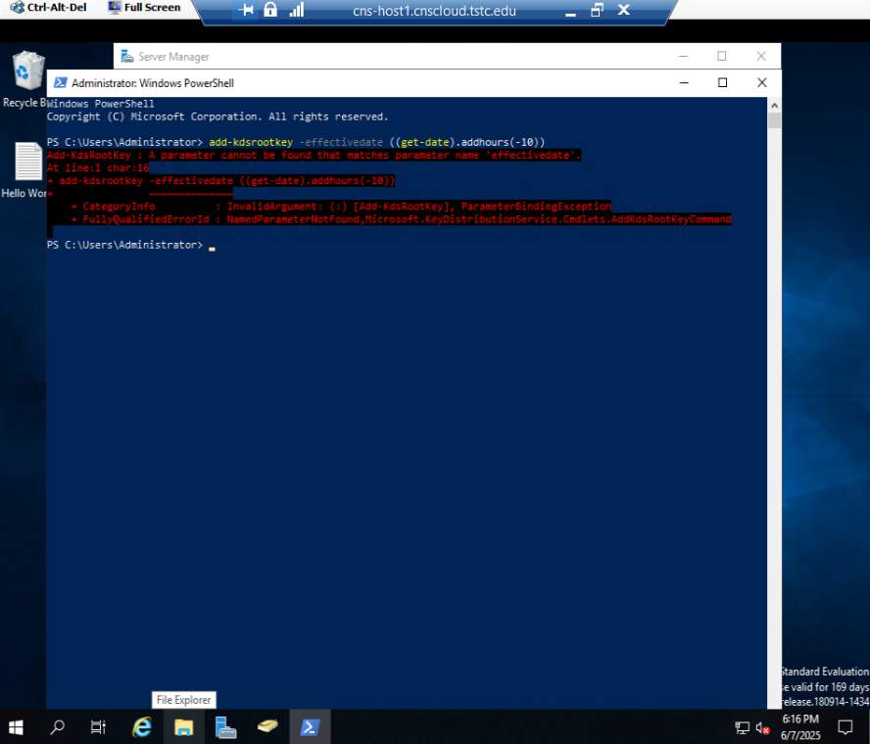

The -effectivedate command may not be recognized. Use effective immediately instead

**Add-KdsRootKey -EffectiveImmediately**

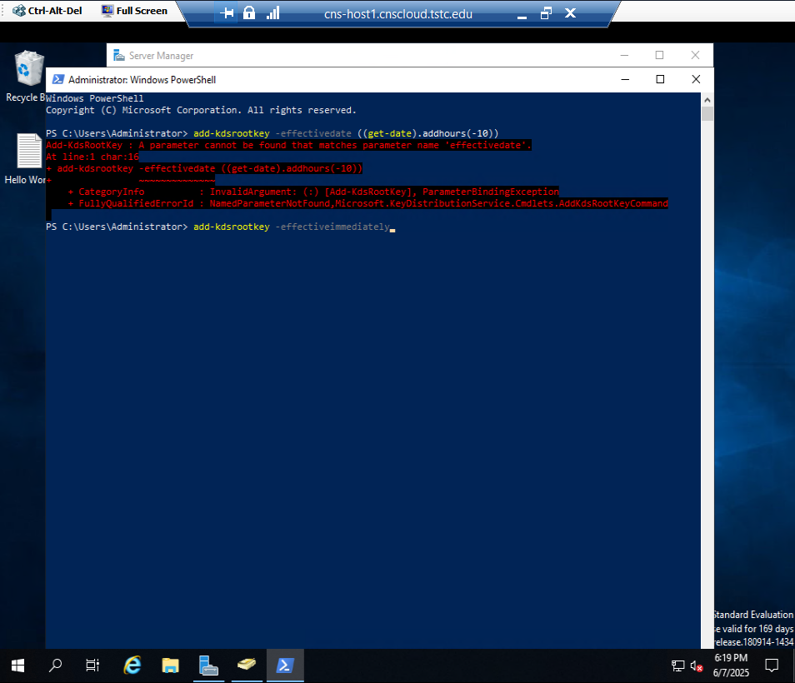

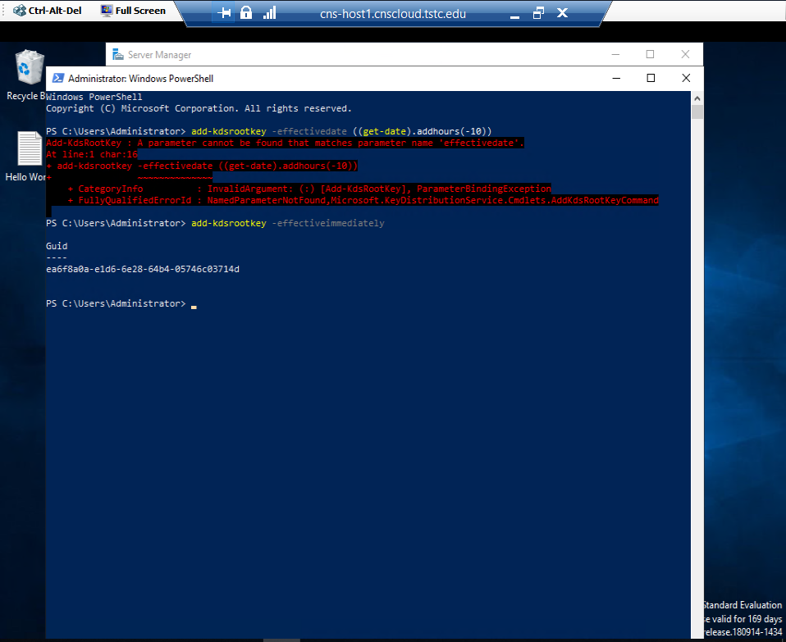

The KDS Root Key was created successfully. Now we can create a new ad service account

New-adserviceaccount -name SQLsvc -dnshostname $env : computername

#### **Error**

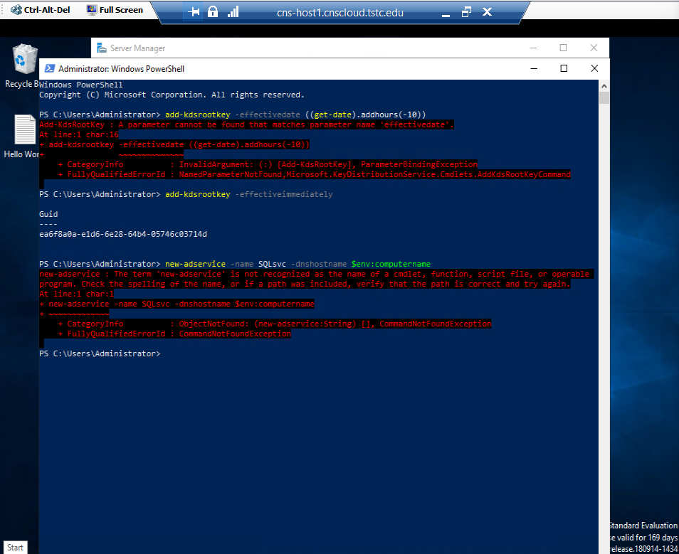

Fix script

New-adserviceaccount -name SQLsvc -dnshostname $env:computername

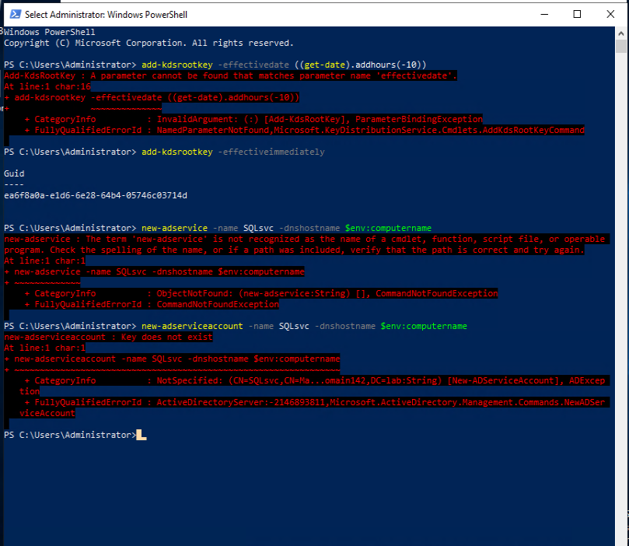

Key has not updated yet. Must give a few minutesimp

**Needed to backdate the root key for it to be effective in a timely manner then create, install, and test the MSA.**

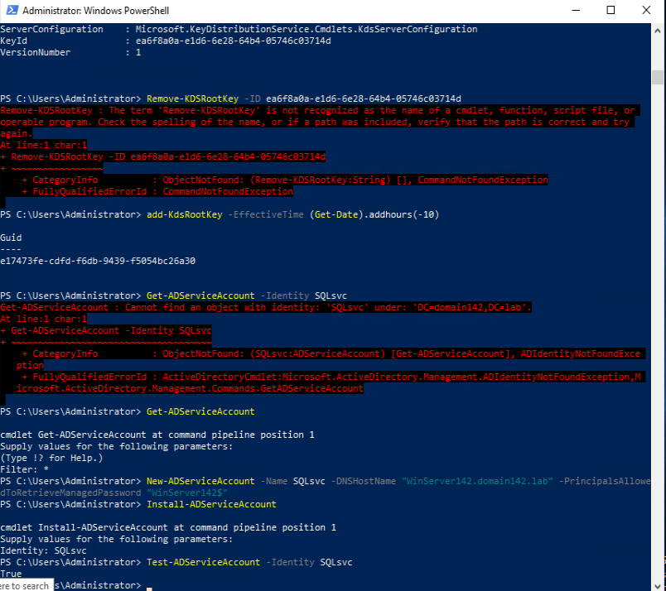

## SQL Server 2019

* Install SQL Server 2019 with ALL features except ‘PolyBase Query’ and anything pertaining to ‘R Server’ or ‘Machine Learning Server/Services’.

The SQL Install files are located on a secondary virtual hard disk attached to your Windows VM. Use Disk Management to enable this secondary virtual hard disk for access to the software installation files.

Right-click Windows > Disk Management

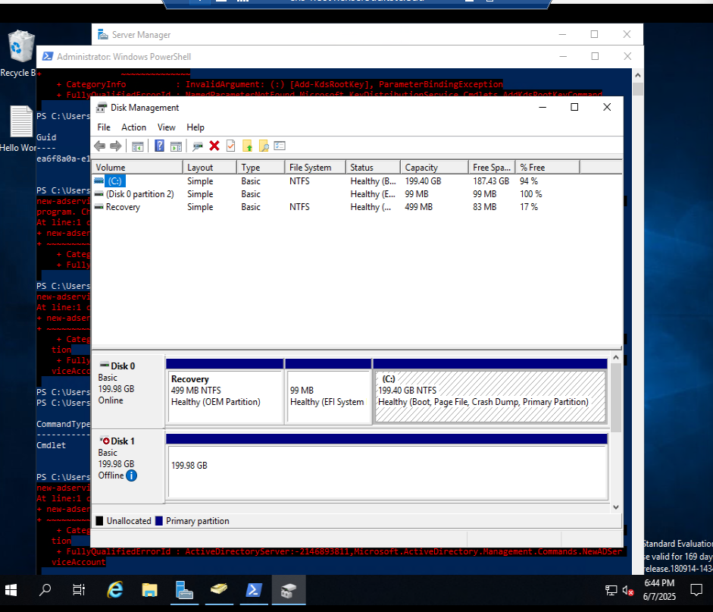

Right-click Disk 1to bring online

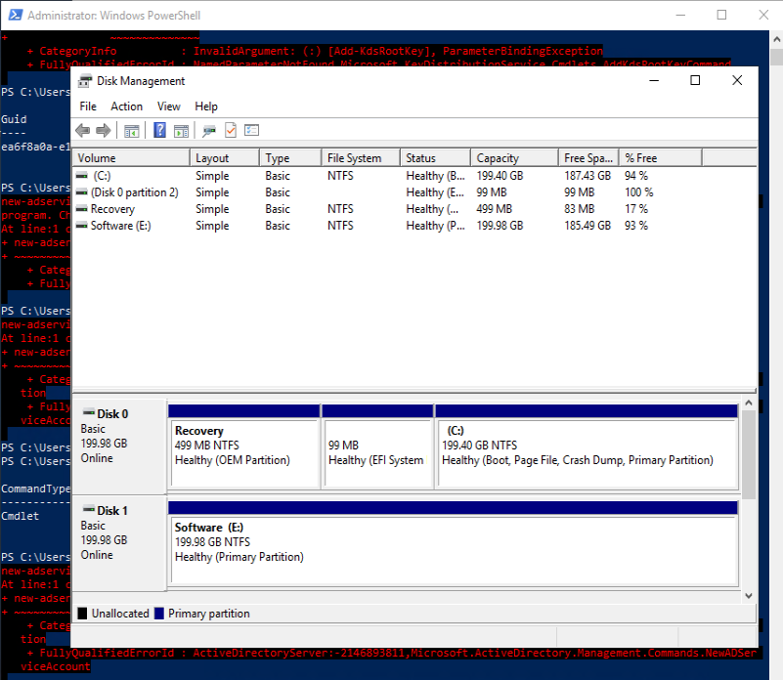

Verify contents in file explorer

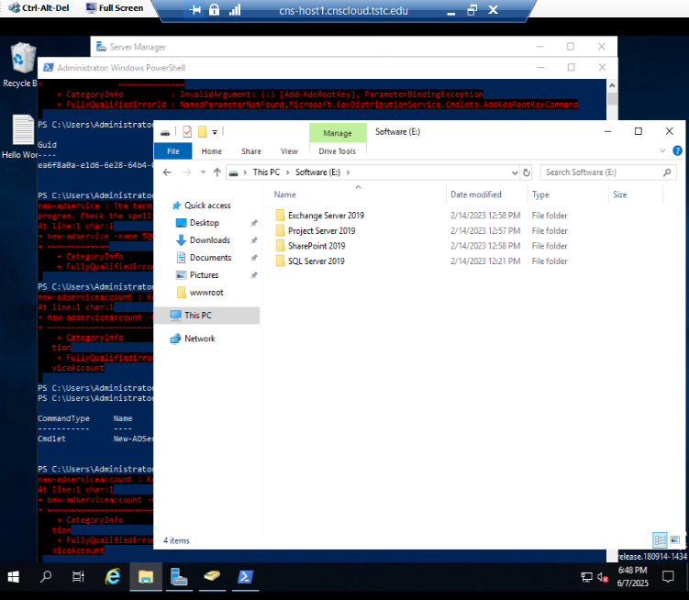

Open the EXE Folder and run the install wizard

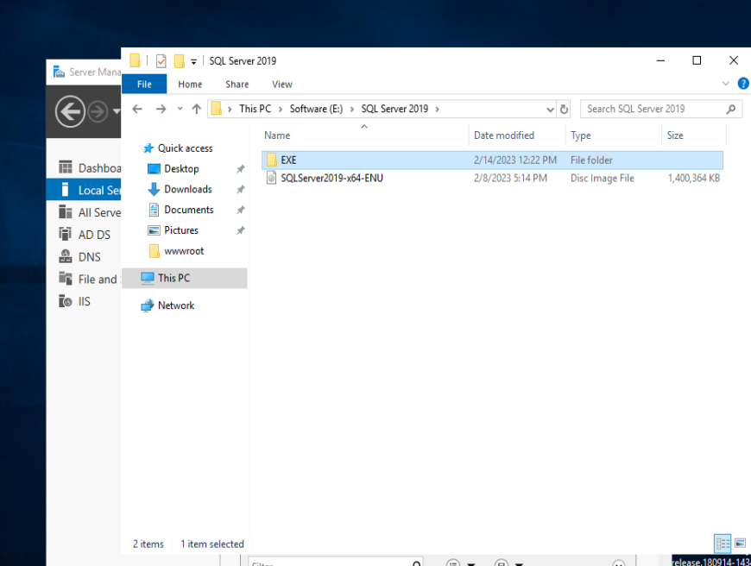

Select Custom Install

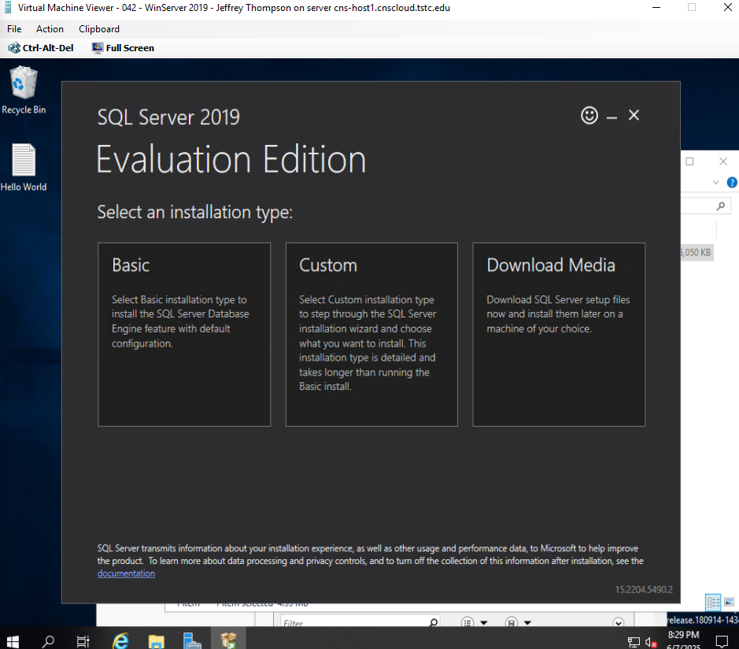

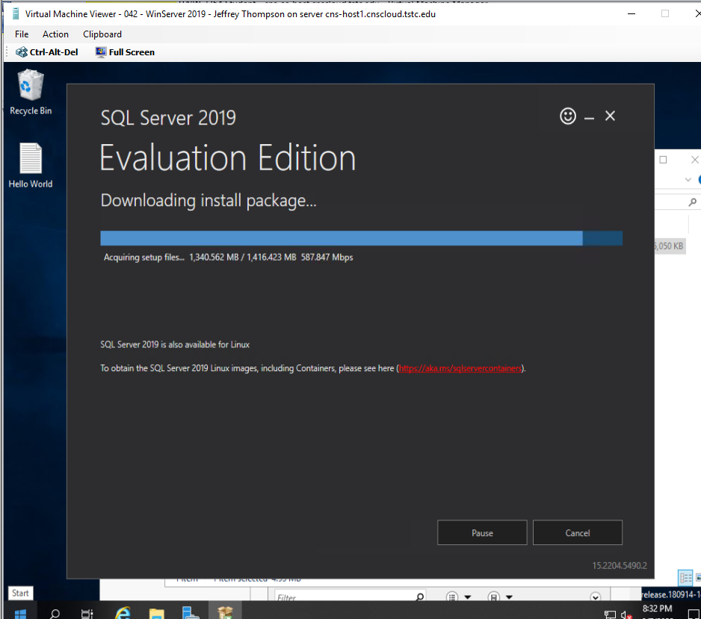

Run system checker

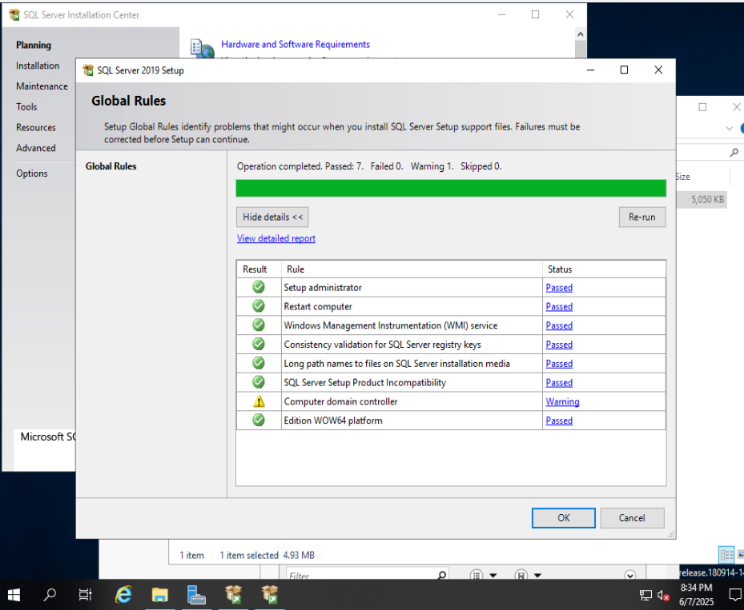

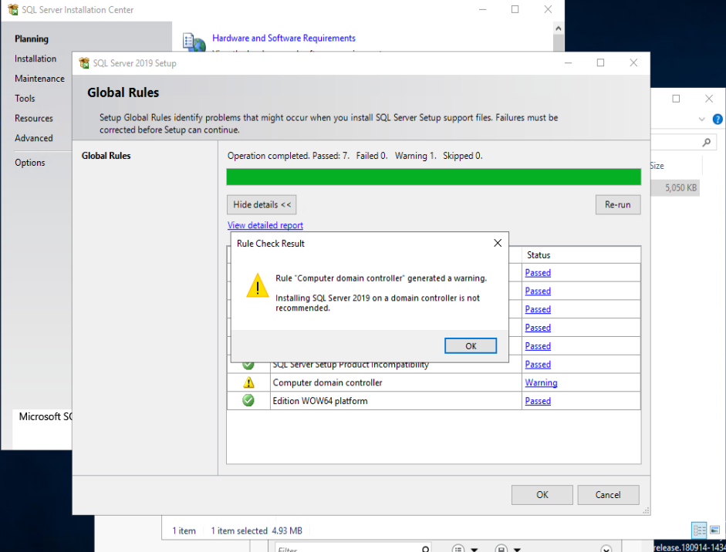

Click Installation > New SQL Server Stand-alone Install

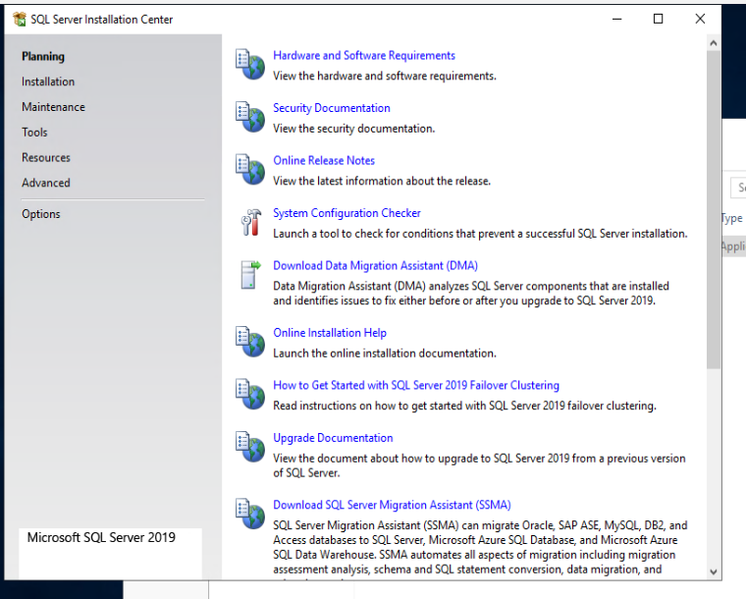

<https://www.youtube.com/watch?v=H1t8dwBFOWQ&t=13s>

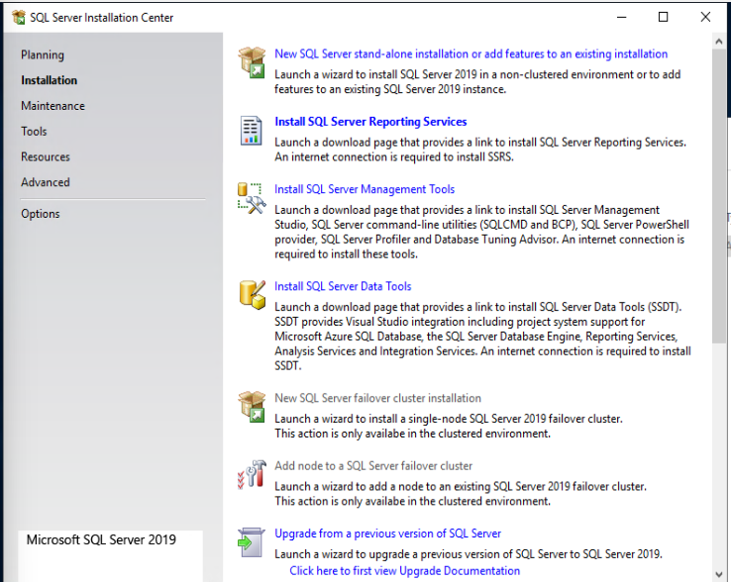

Select Evaluation > click Next

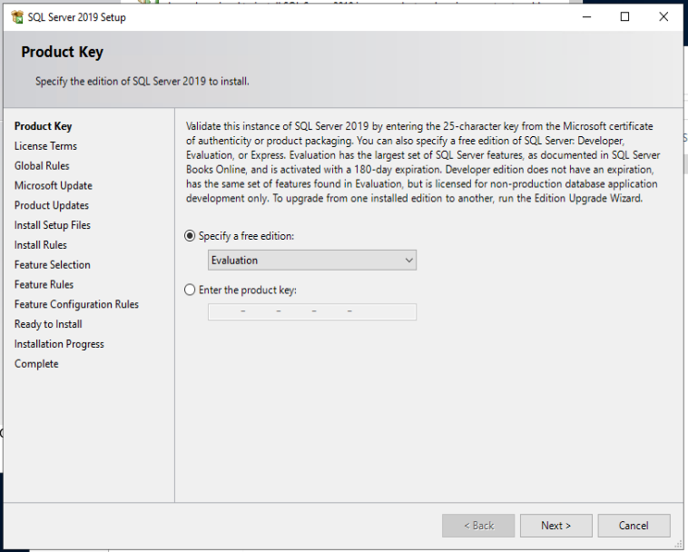

Accept License Terms > click Next

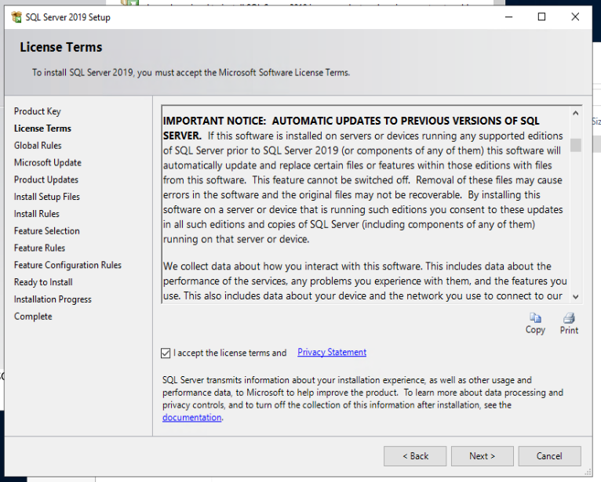

Click next if the global rules all pass

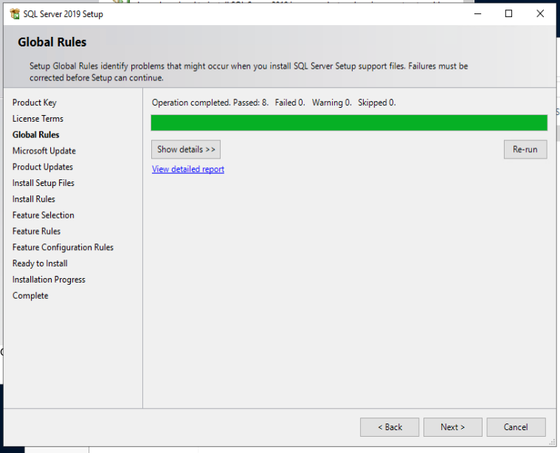

Use Microsoft Update to check for updates

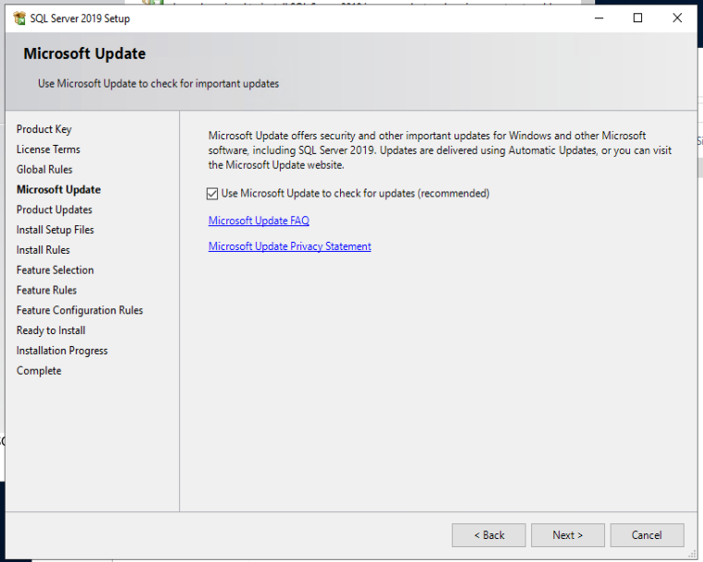

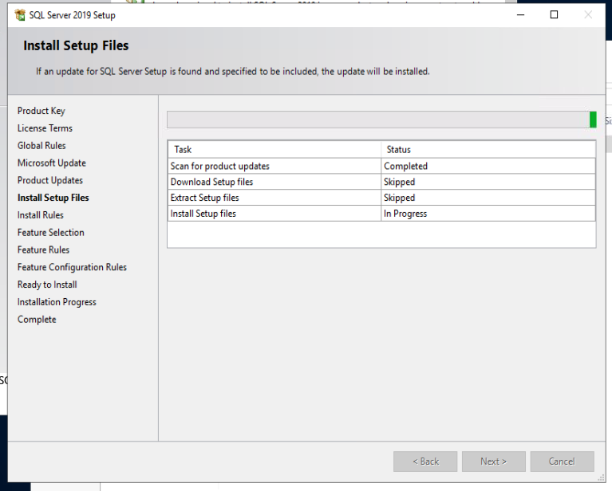

Review Warnings

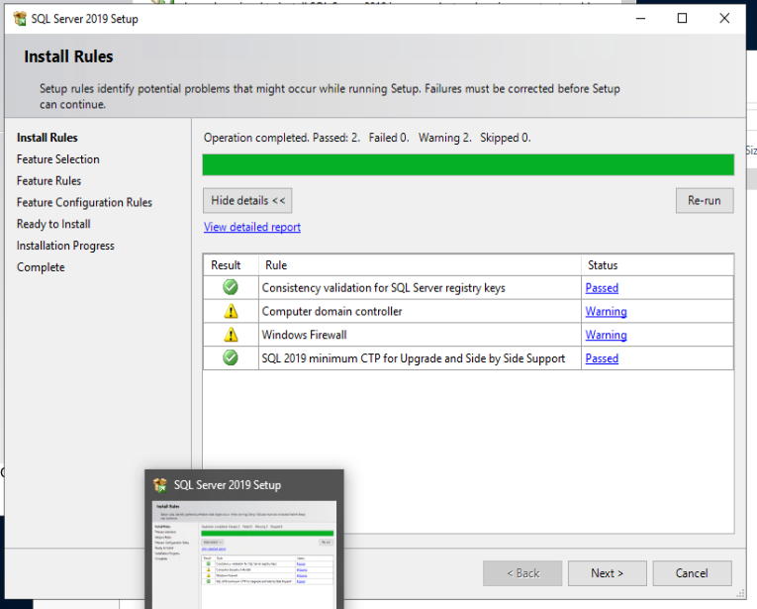

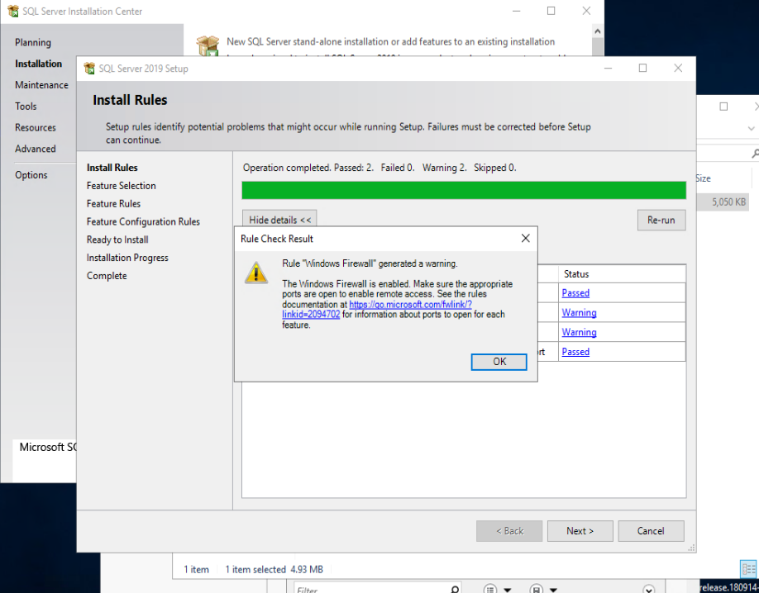

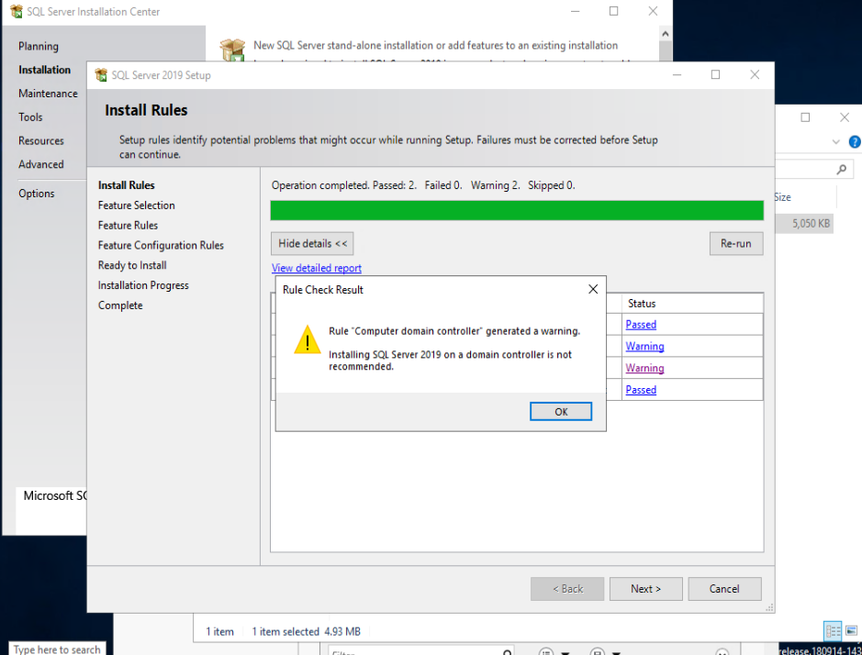

Select the appropriate features except ‘PolyBase Query’ and anything

pertaining to ‘R Server’ or ‘Machine Learning Server/Services’.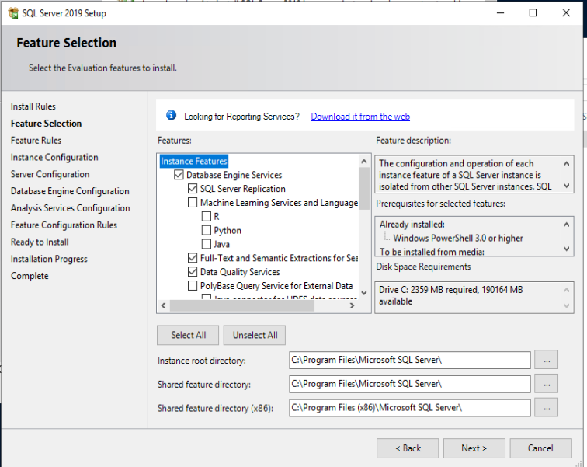

Select Default Instance

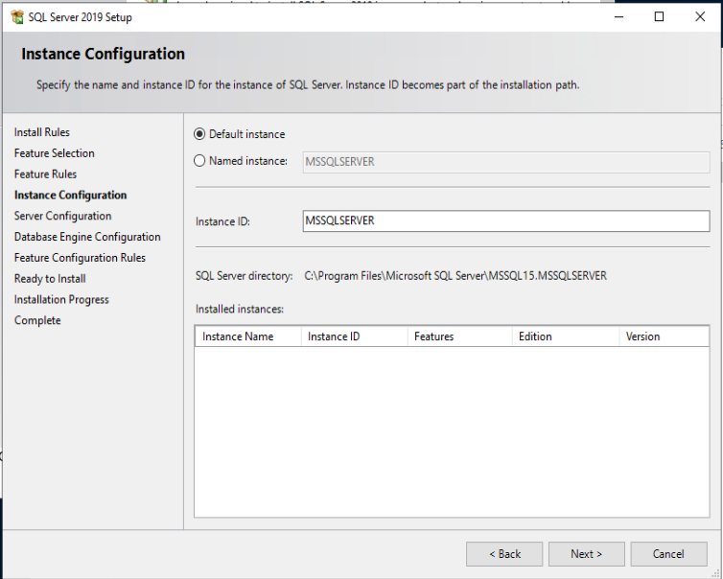

Configure the Server Agent and Database engine for Automatic

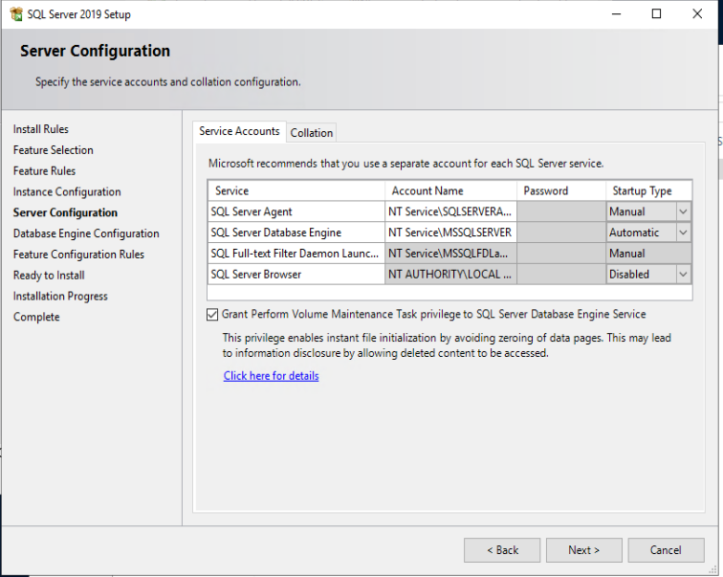

Select Windows Authentication. Add the MSA as an SQL Server Administrator

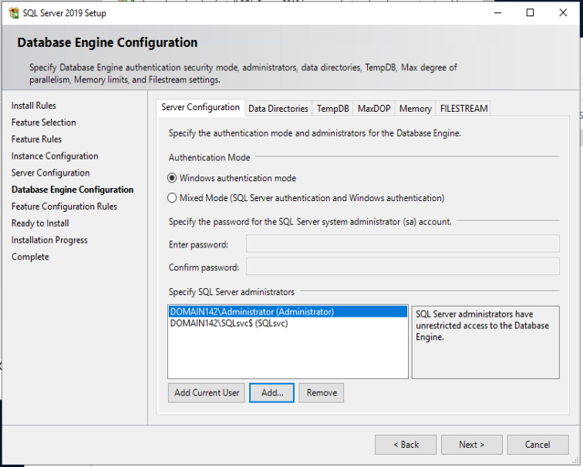

Complete the Install process

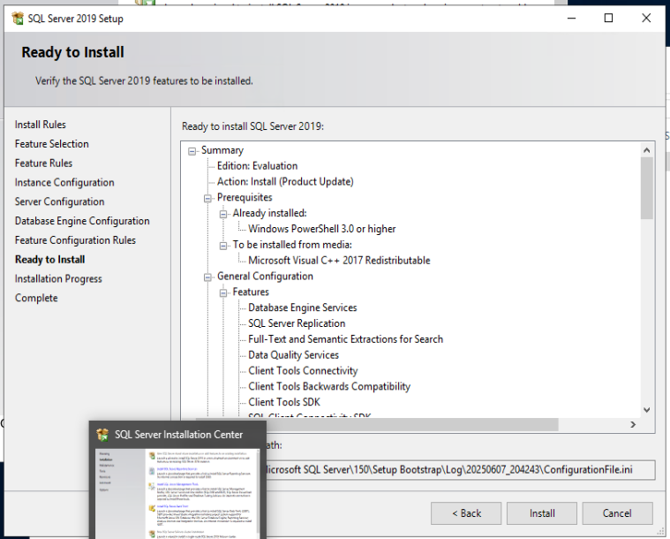

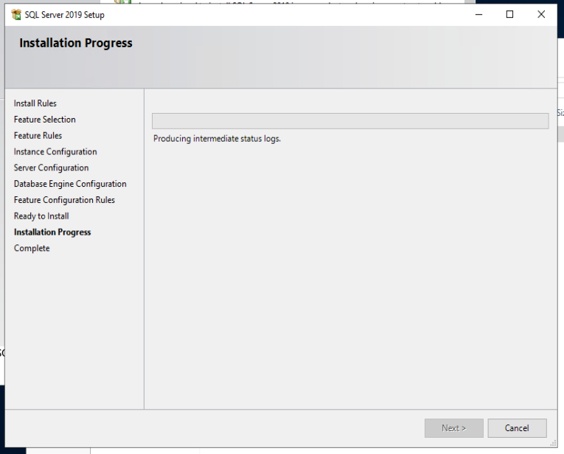

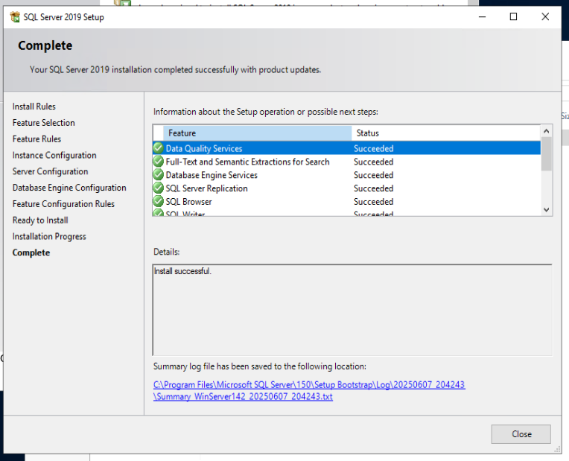

Install SQL Server Manager

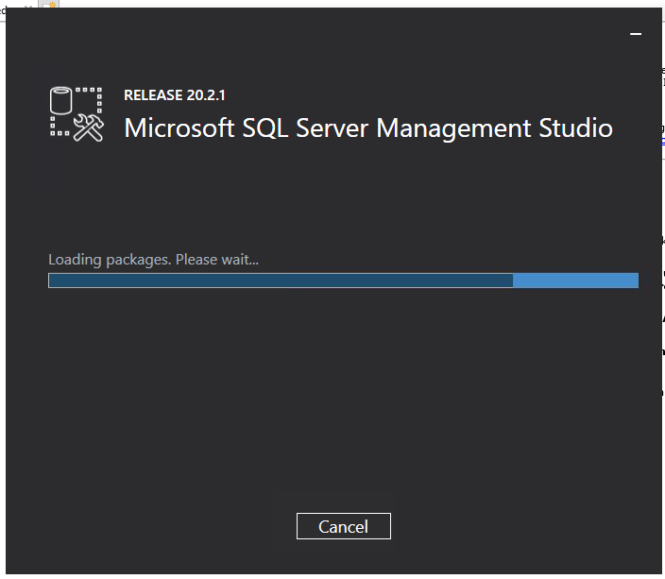

### SharePoint 2019

Preparation

Prior to Installing share point we will create a seperate domain user account and grant SQL permissions to access the database.

In AD DS click Tools > AD Computers and Users >

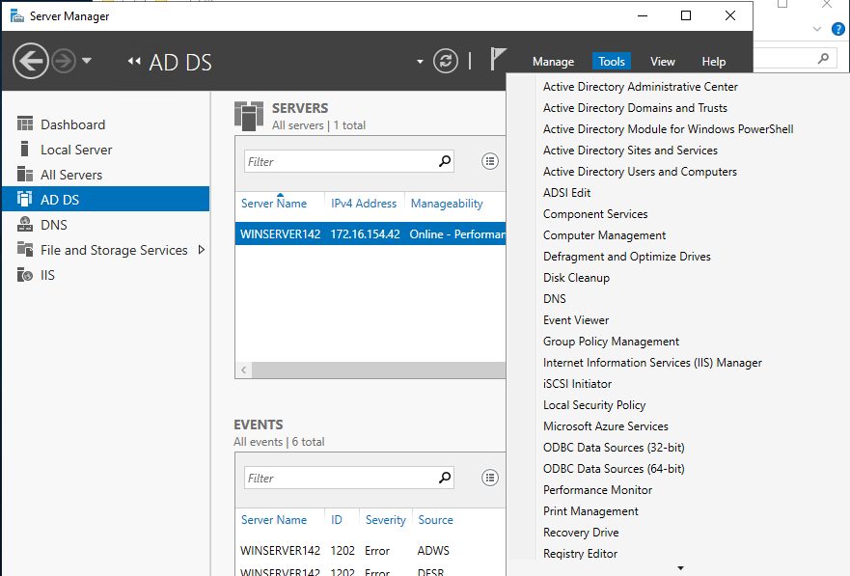

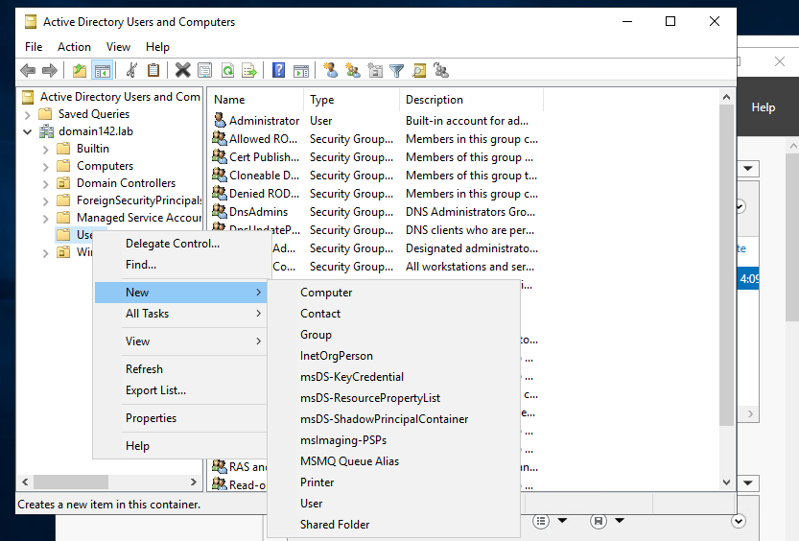

**Username: spfarm**

**Password: Password2**

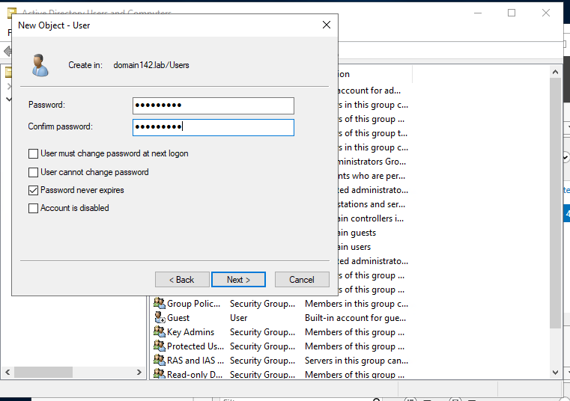

Give the user account permissions in SQL Server

Connect to SQL Server (WinServer142)- You have to start the agent manually. In SQL Config Manager

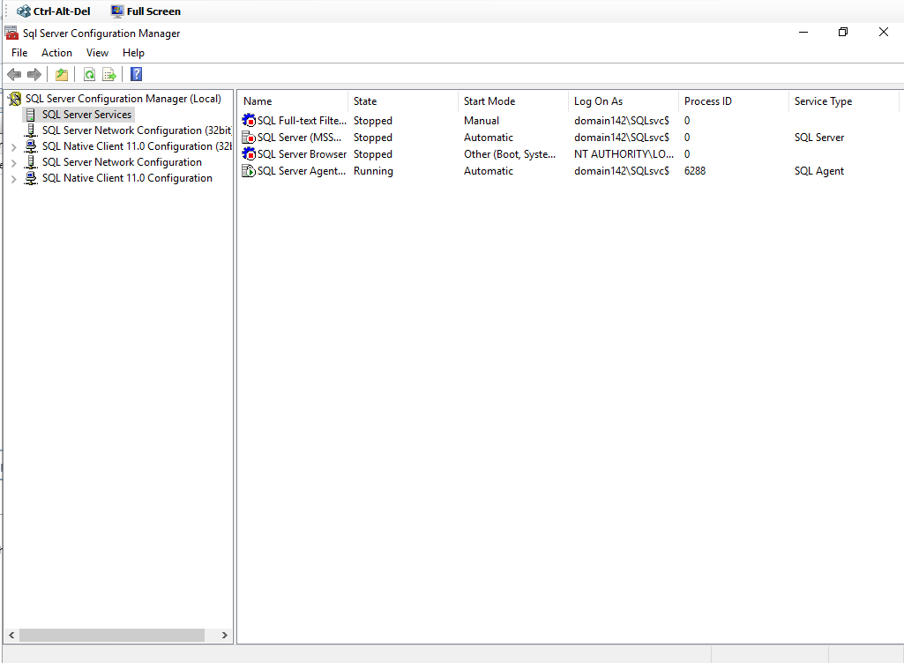

Connect to the server using SSMS

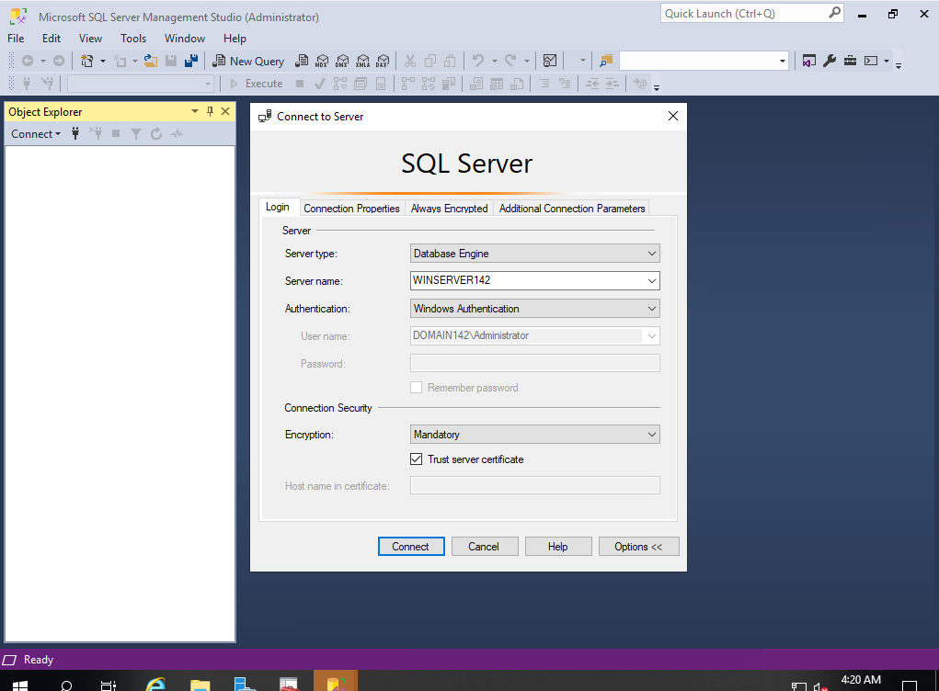

Security > Logins > Right-click > New Login

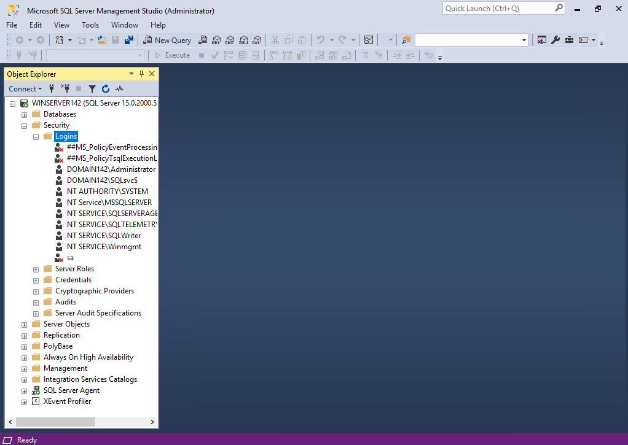

Search for spfarm user

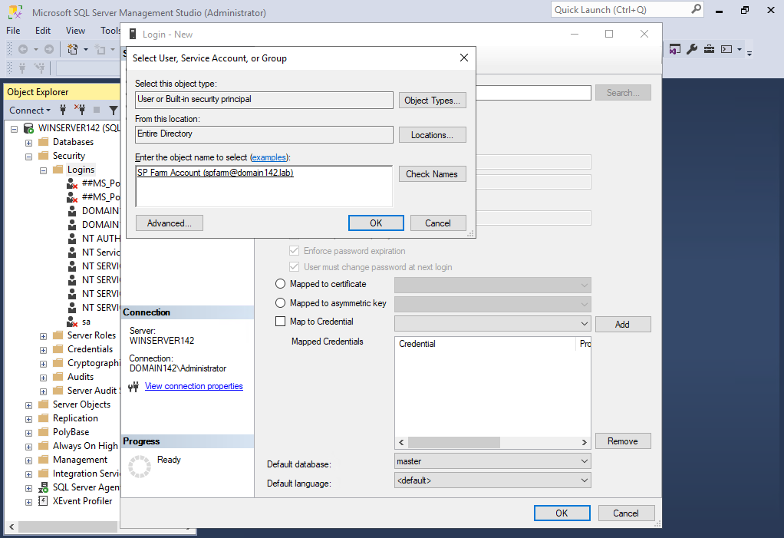

Server roles > dbcreator > securityadmin

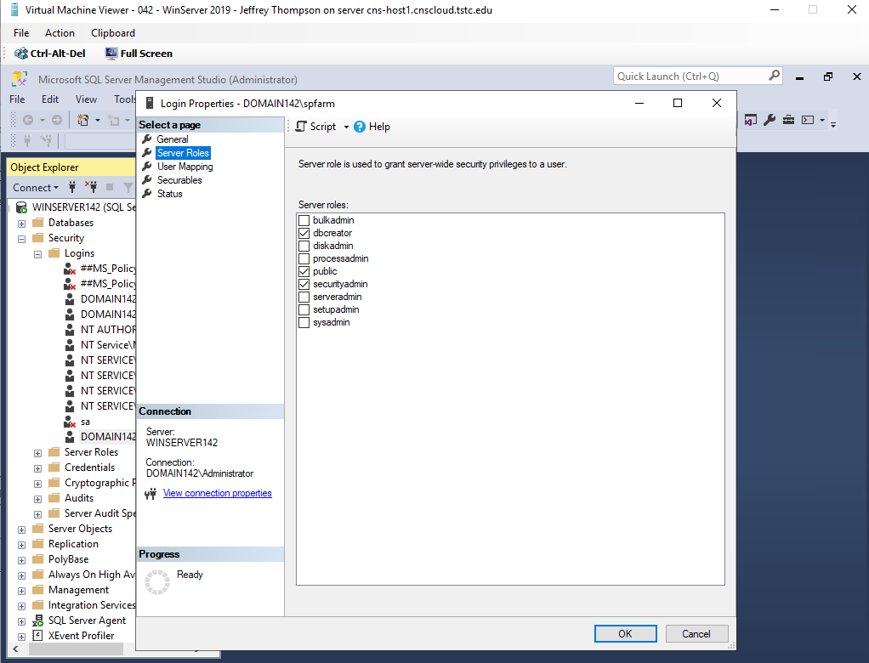

### Install SharePoint 2019 Enterprise on the Windows 2019 server.

Navigate to the installation media in file explorer.

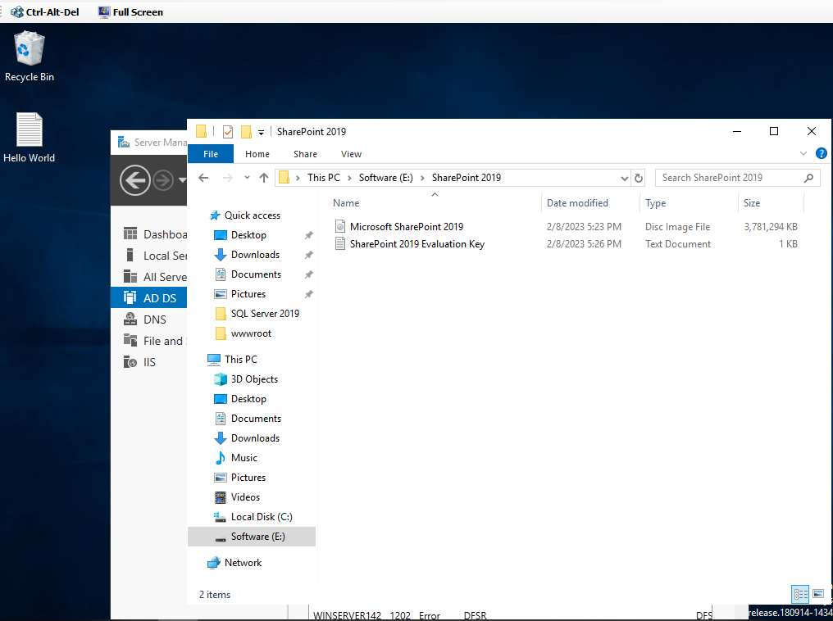

Run the ‘Splash’ utility to make sure the SharePoint prerequisites are installed

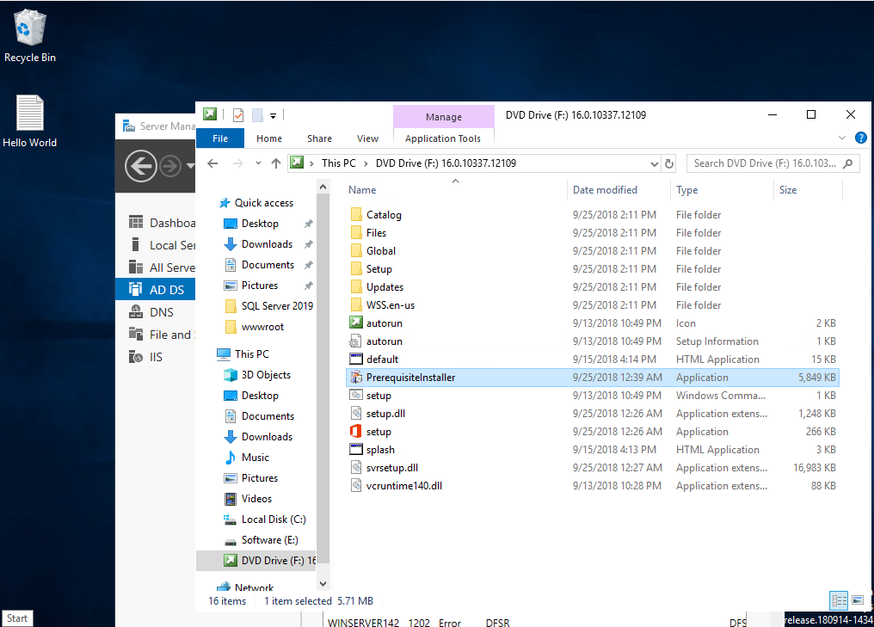

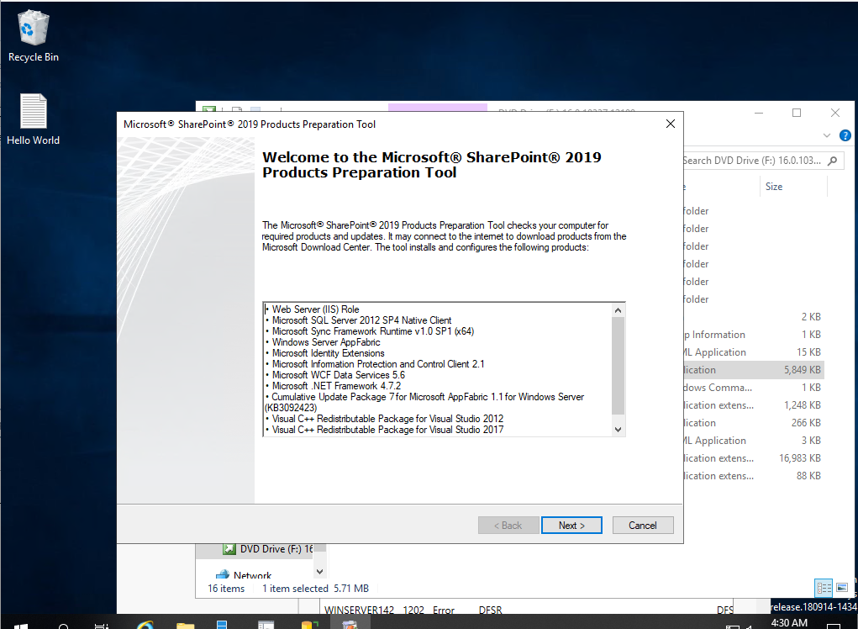

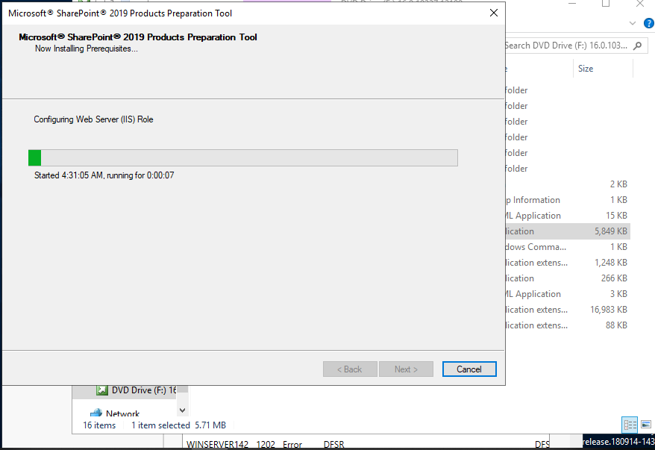

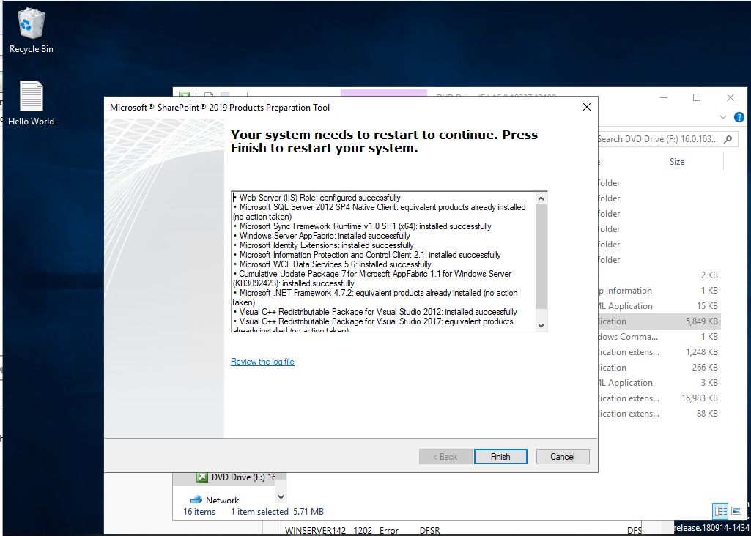

The server will restart. Make sure SQL is turned back on and start the installation of sharepoint.

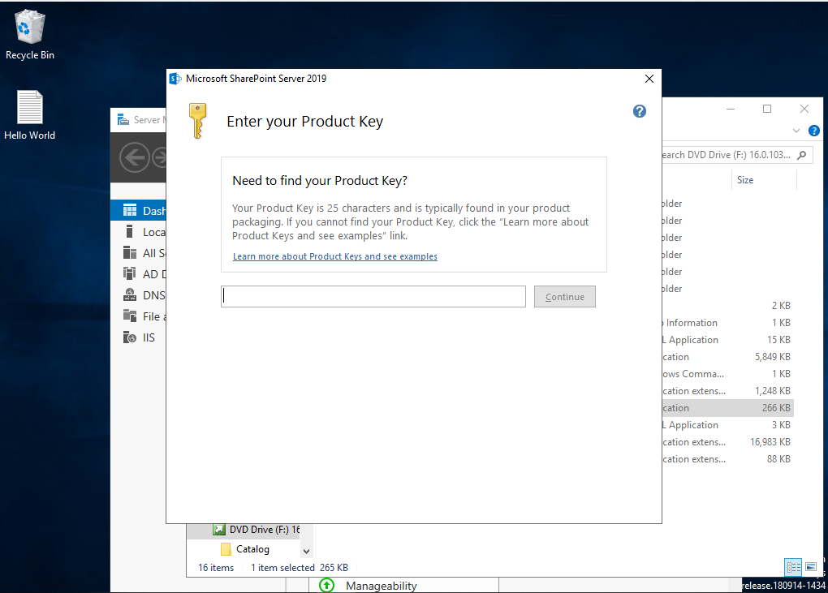

The license key (evaluation) can be found in the ‘SharePoint 2019’ folder on the secondary software drive.

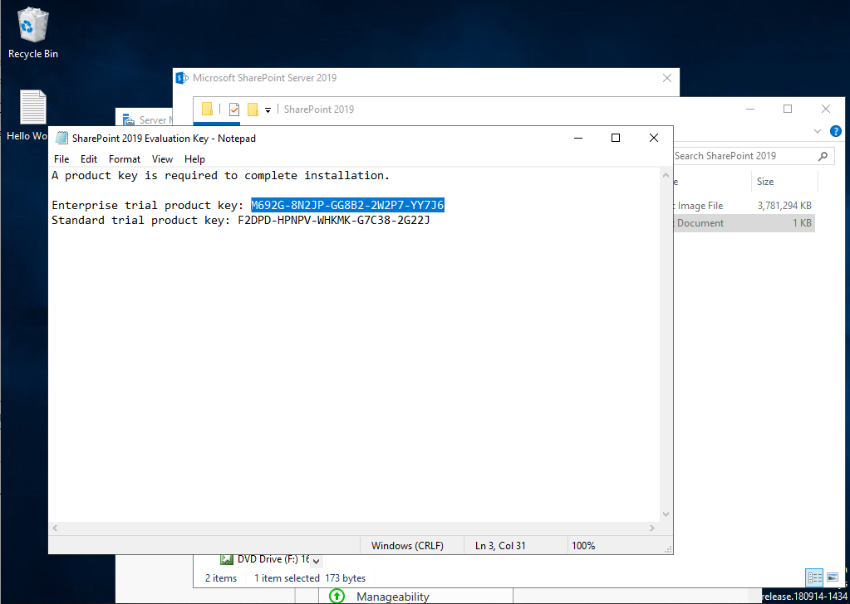

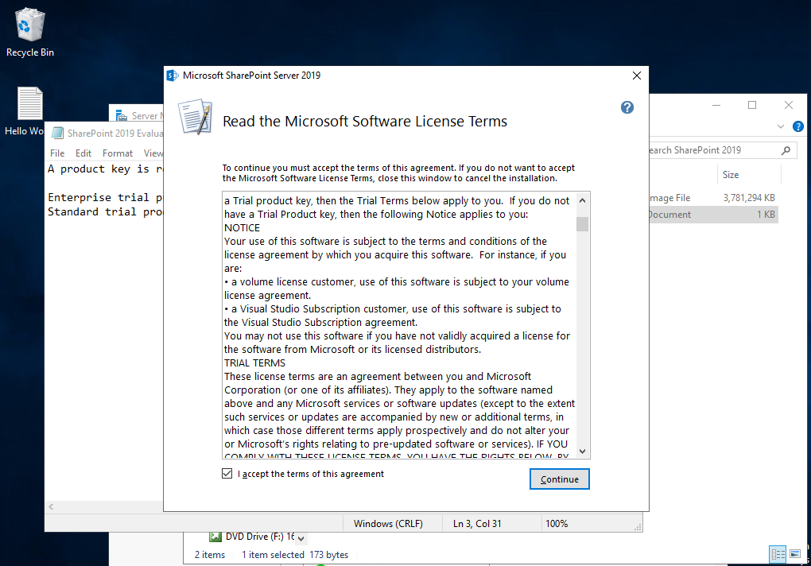

Select the default location and install now

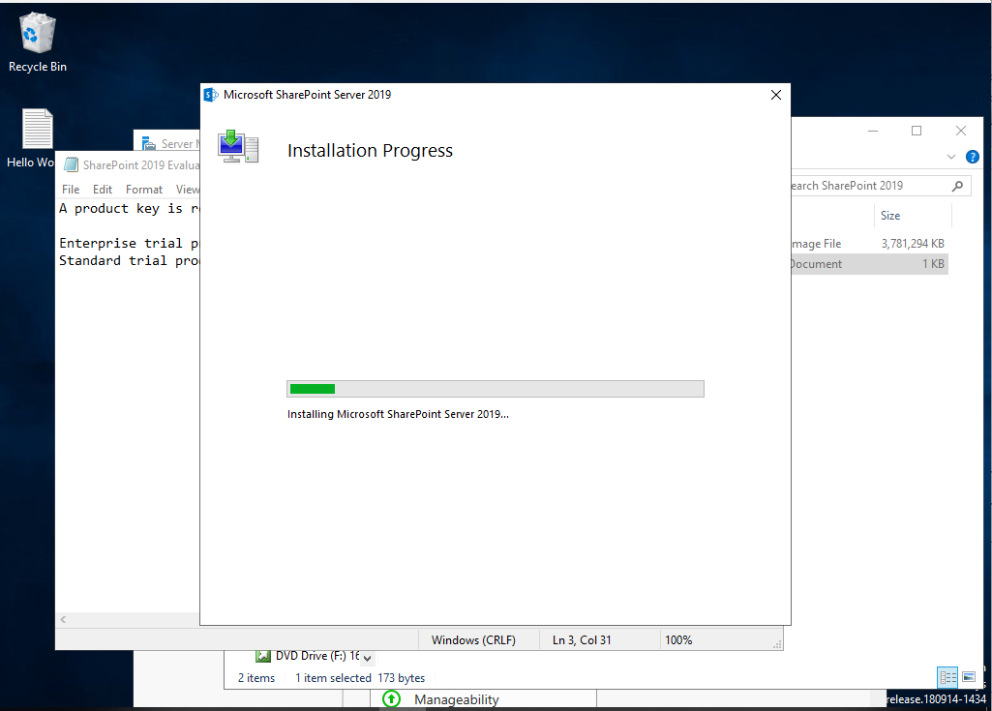

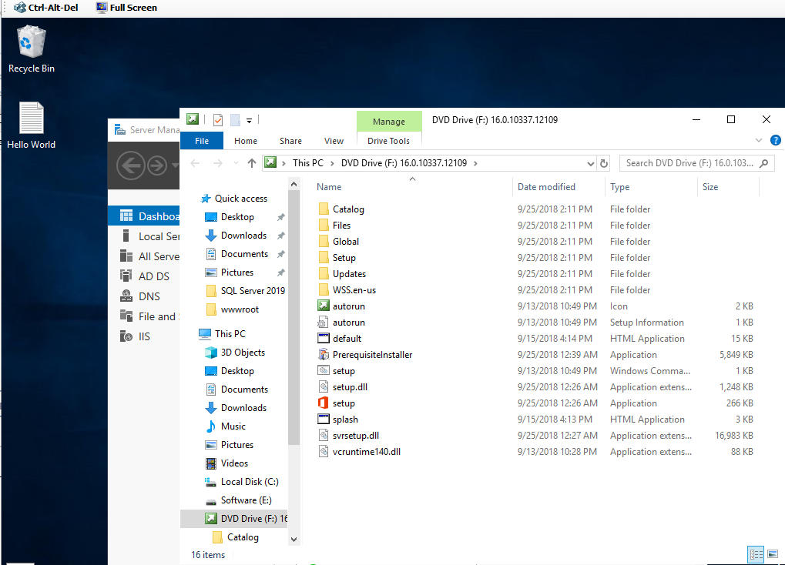

Run configuration Wizard

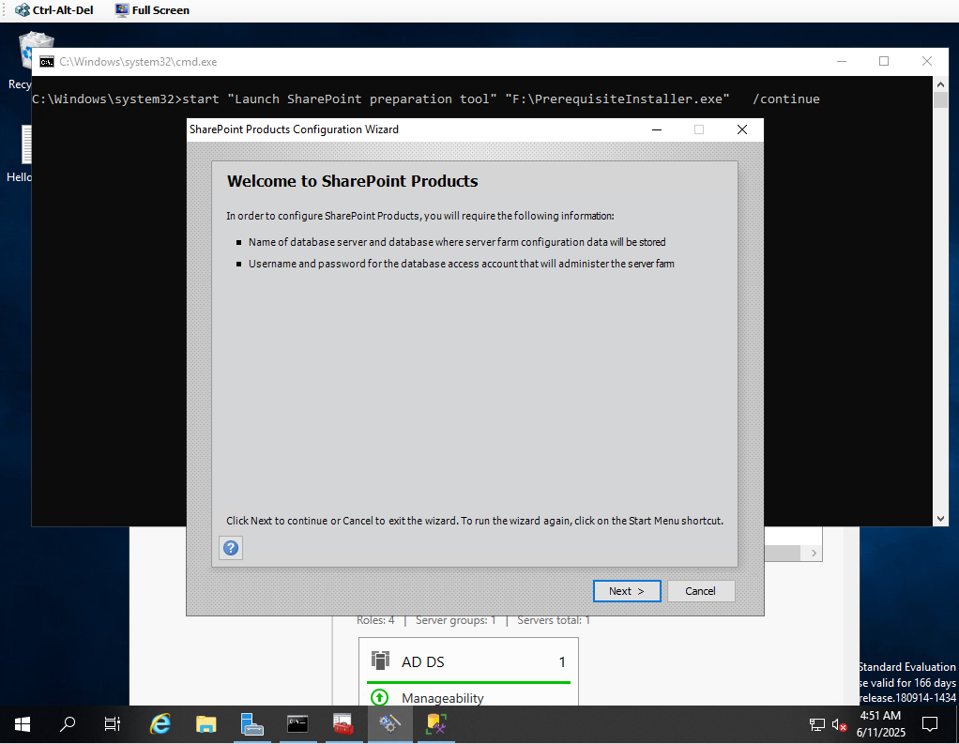

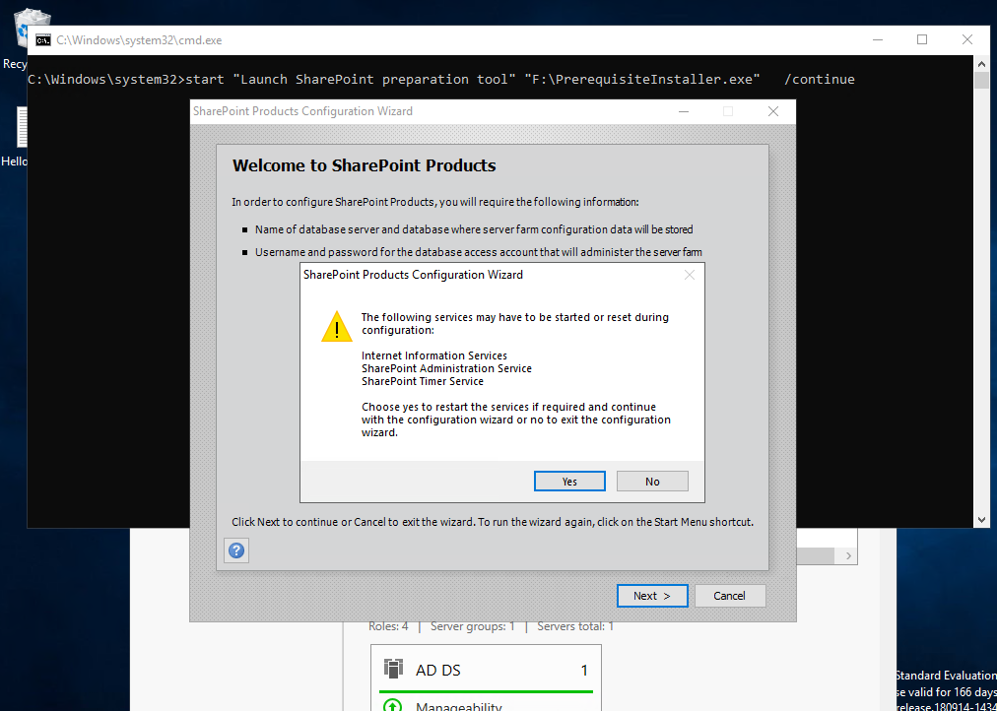

Create a new server farm

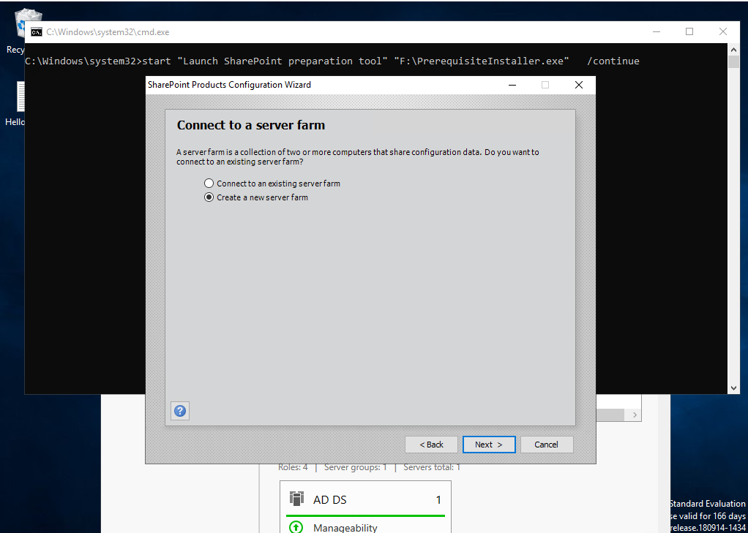

**Database server: WinServer142**

**Database name: SharePoint_Config**

**Username: domain142\spfarm**

**Password: Password2**

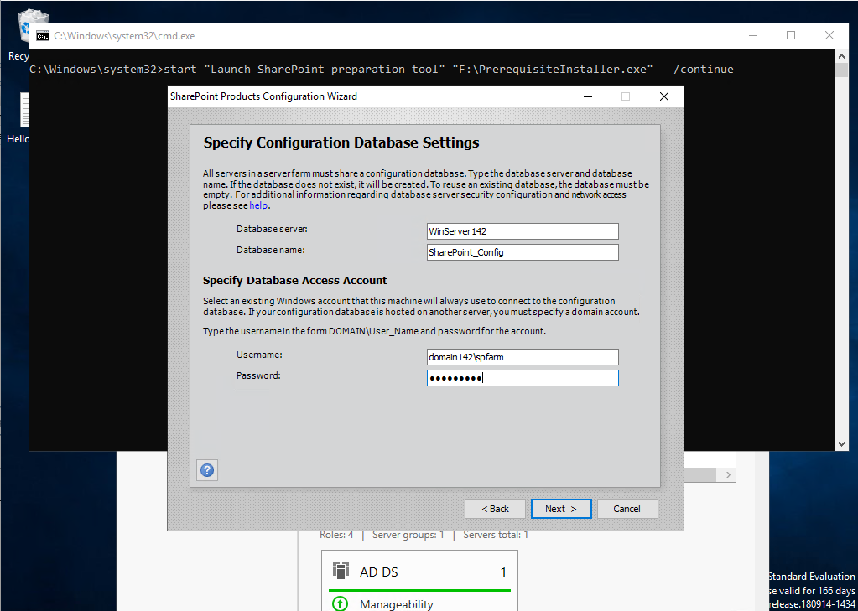

**Passphrase: Password2**

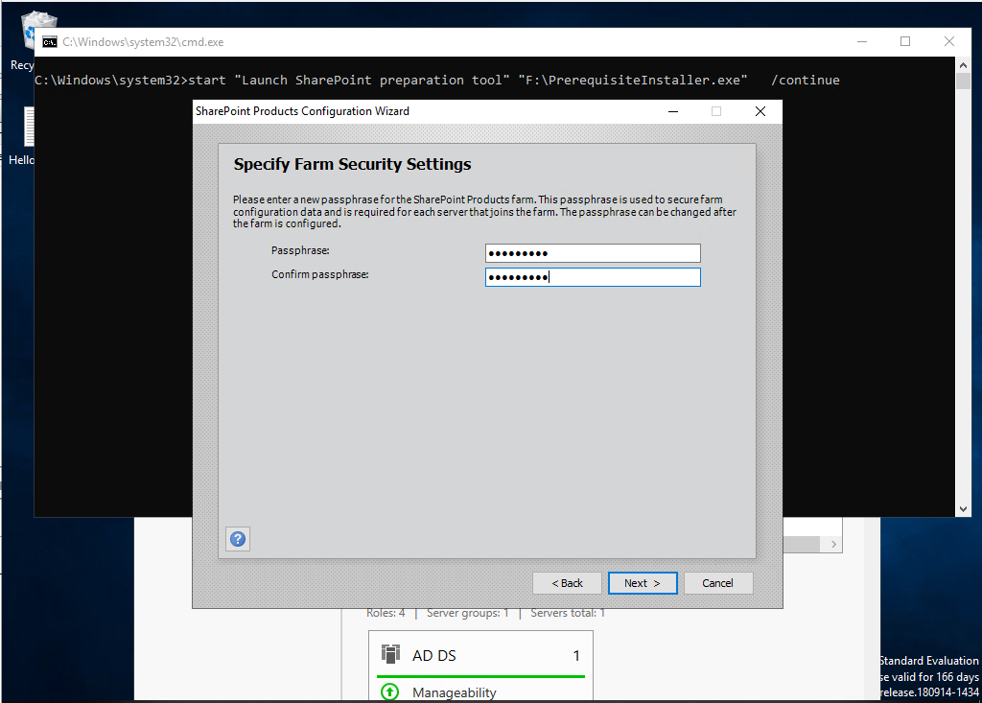

**Select Single-Server Farm**

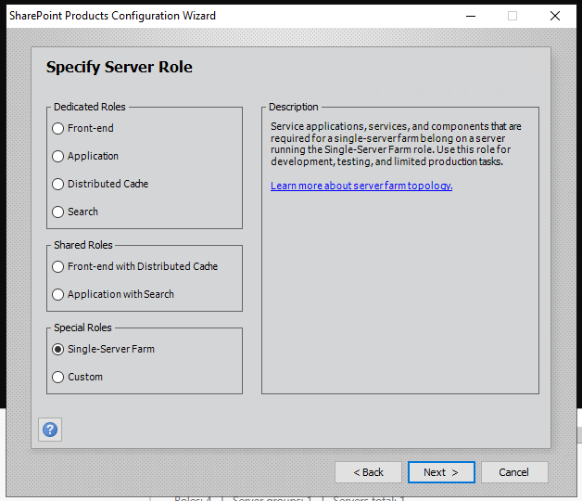

**Keep default settings for Central Admin Security**

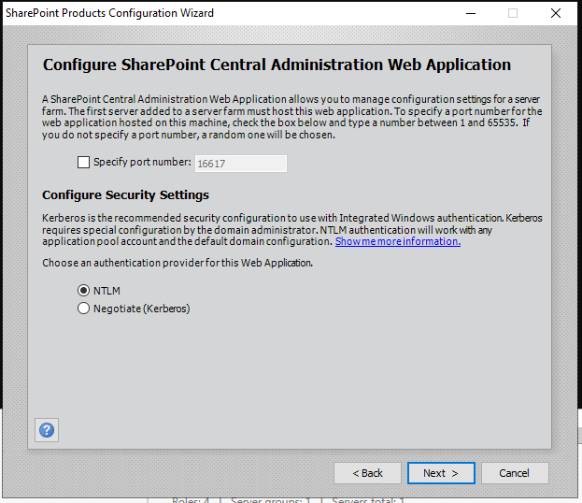

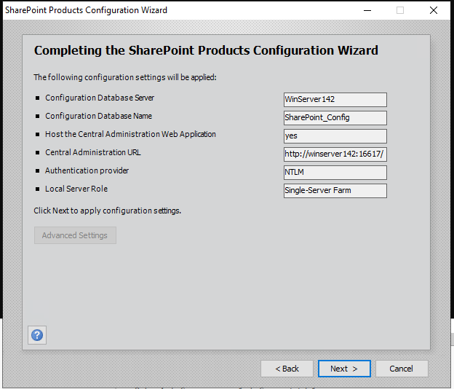

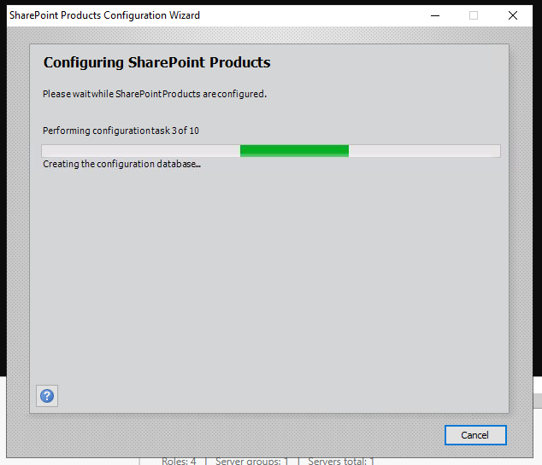

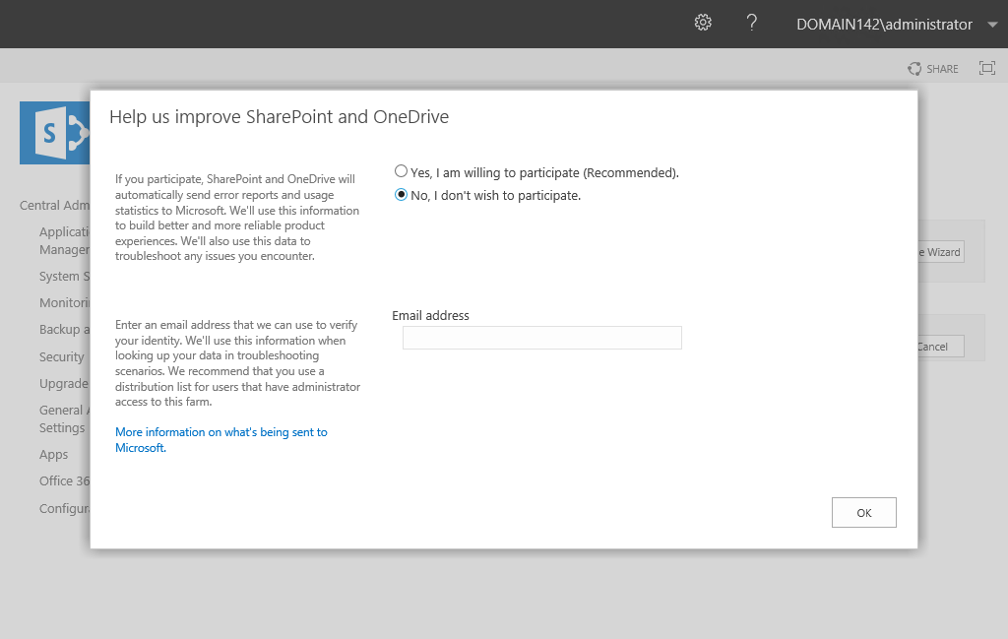

### Configure web-based file collaboration

#### Using the ‘Farm Configuration Wizard’ will simplify this process

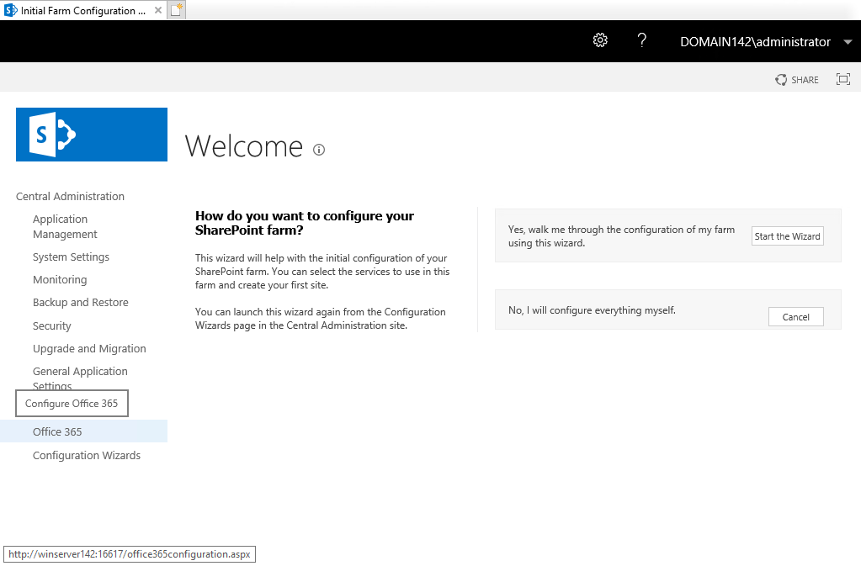

Use the existing spfarm managed service account

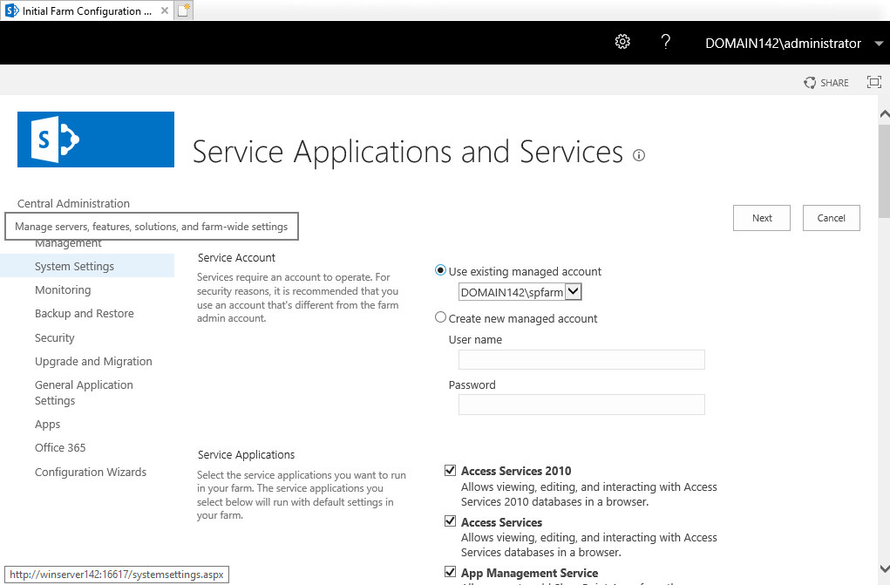

**Error**

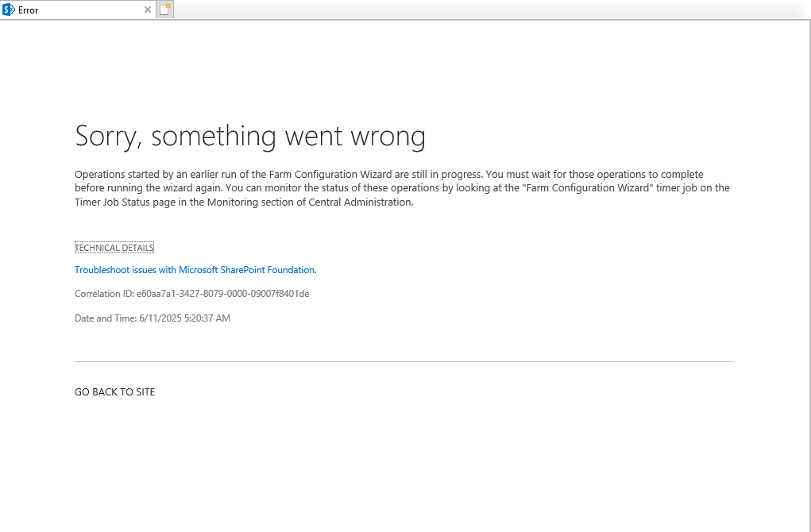

Not sure of what the issue was but It did not hinder the installation.

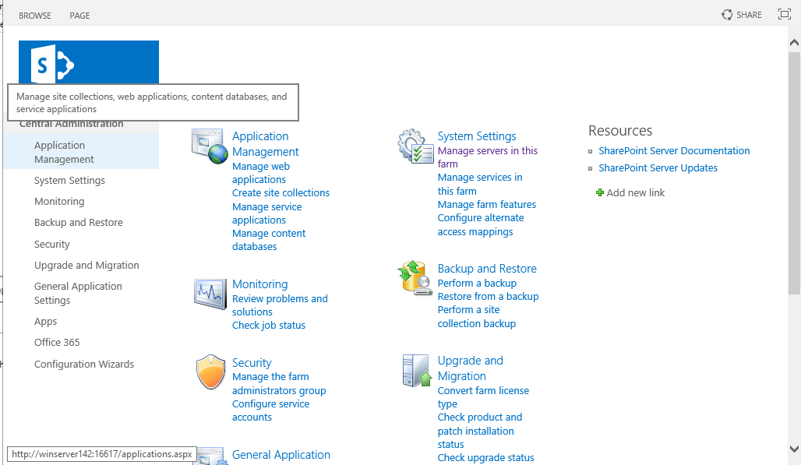

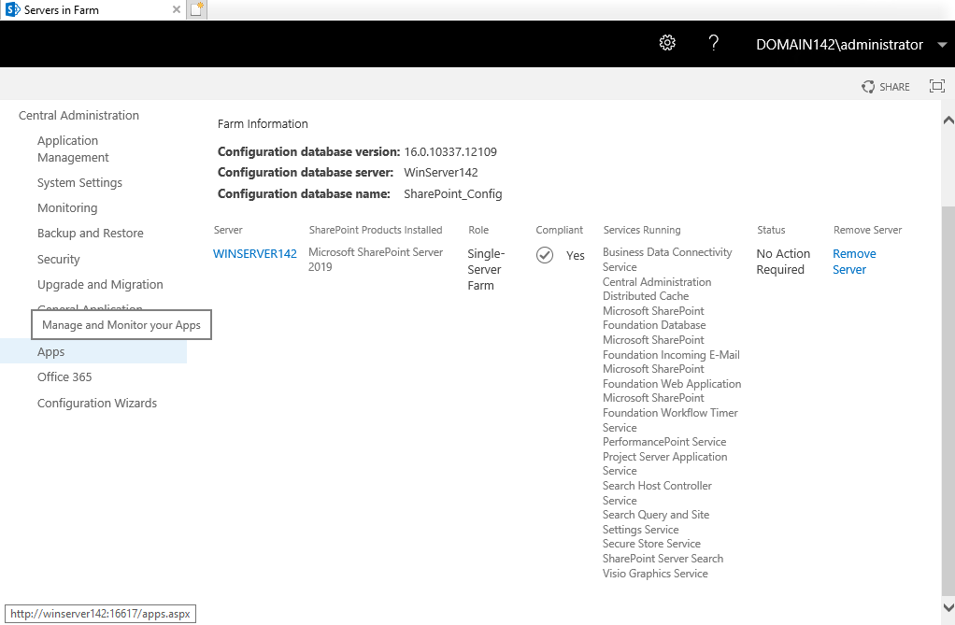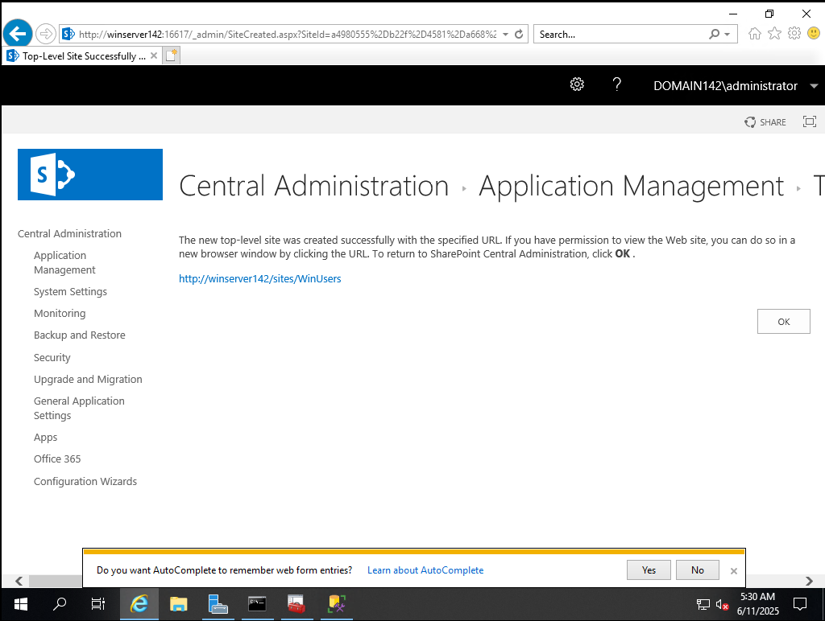

#### Create a Site Collection

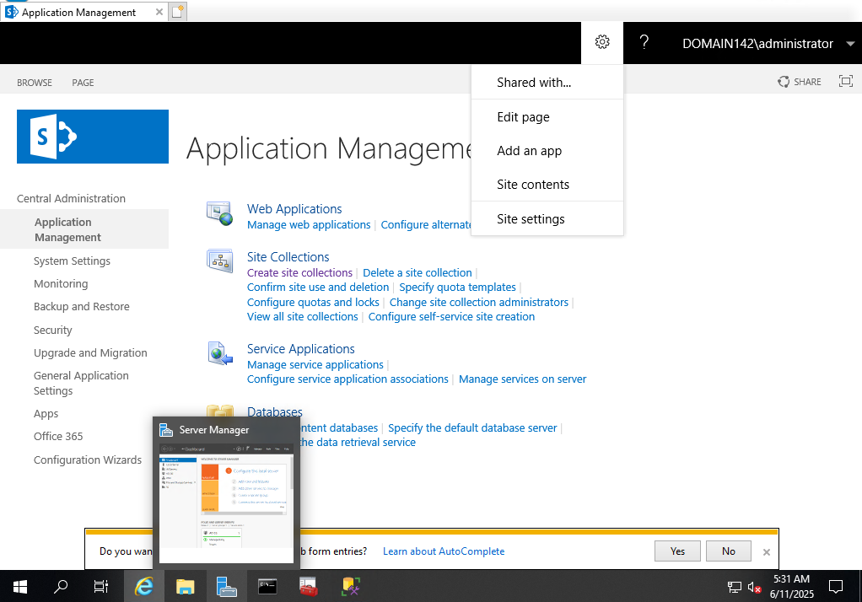

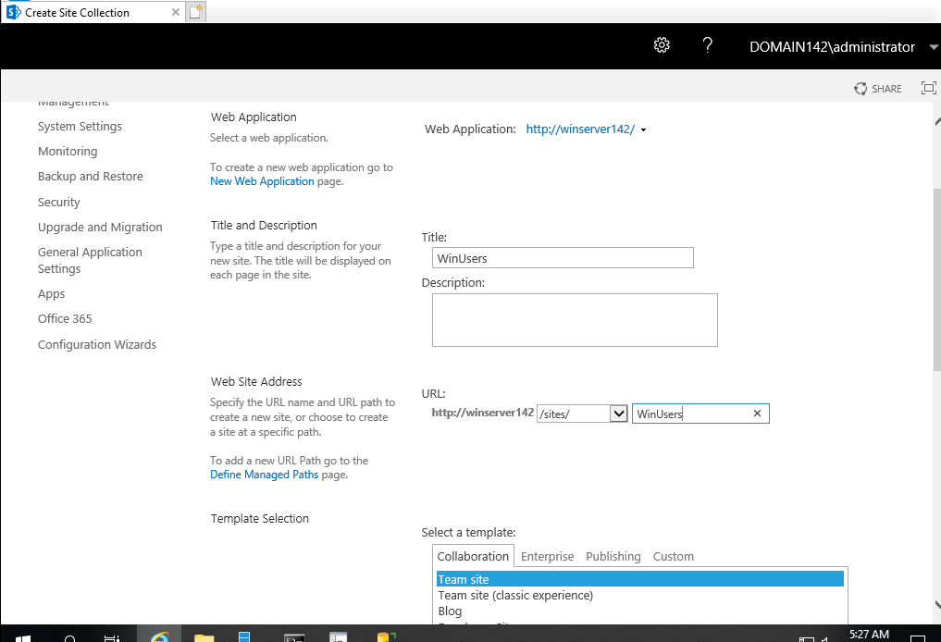

Make note of and document the custom created URL * / **(this is the URL your WinUsers will use to access the site and shared document)

[**http://winserver142/sites/WinUsers**](http://winserver142/sites/WinUsers)

Use the ‘Team Site’ template

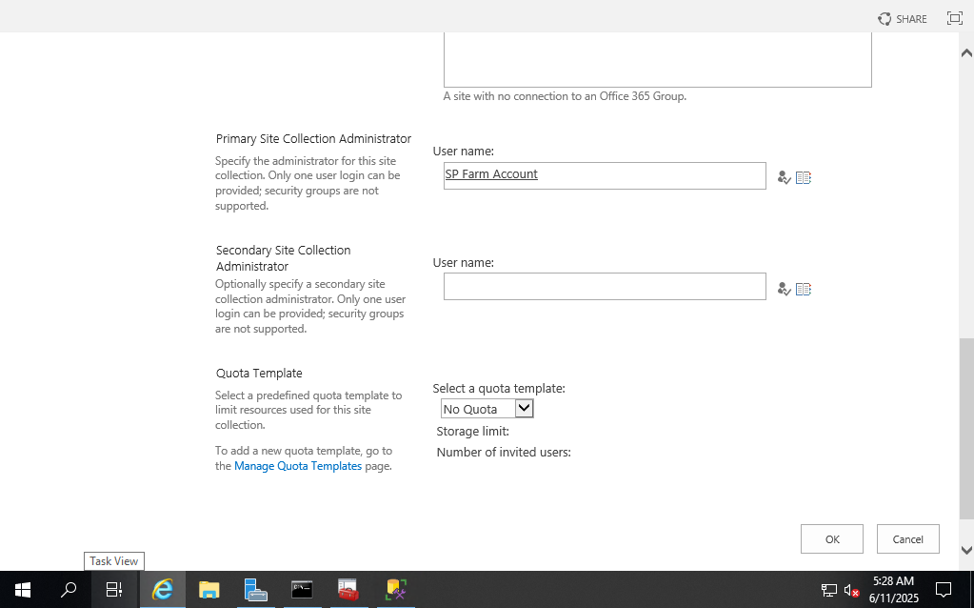

Assign users to the site

Click settings (gear icon)> site settings> people and groups

### Share your SharePoint site with your WinUsers * / **

Create a new group

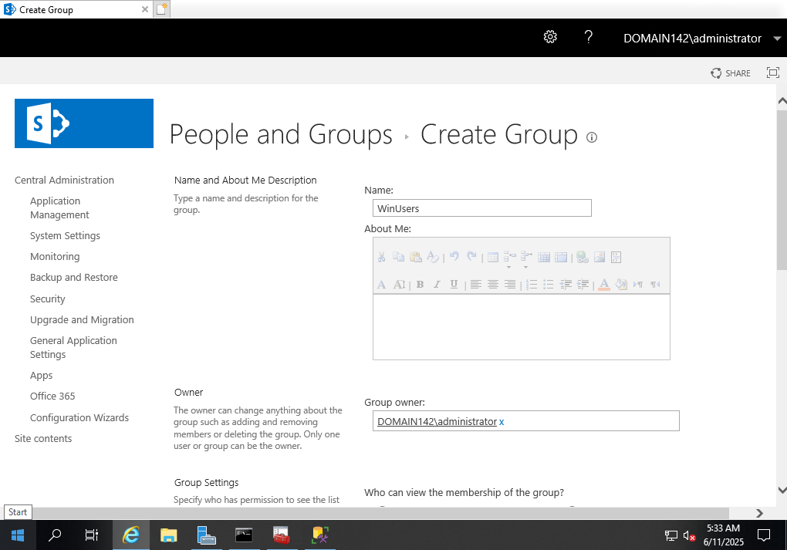

Set permissions

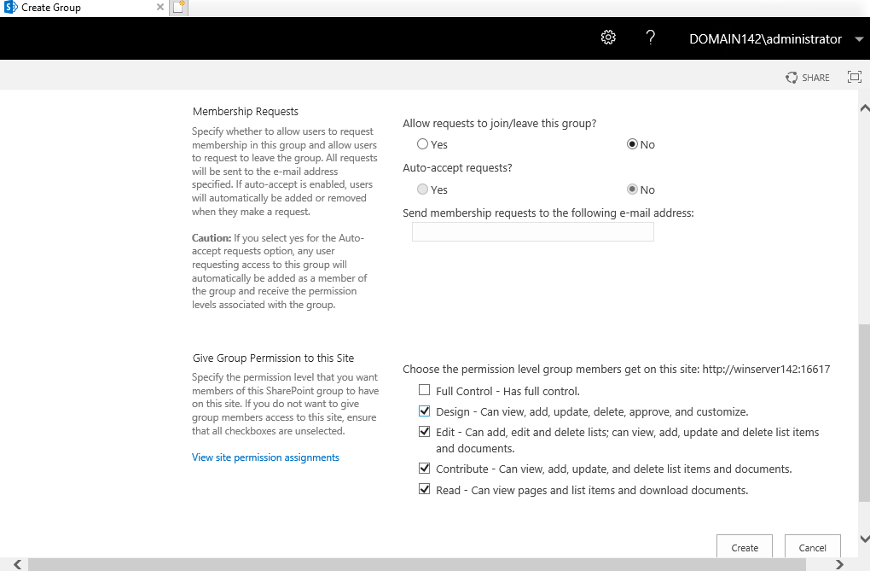

Add users to the group

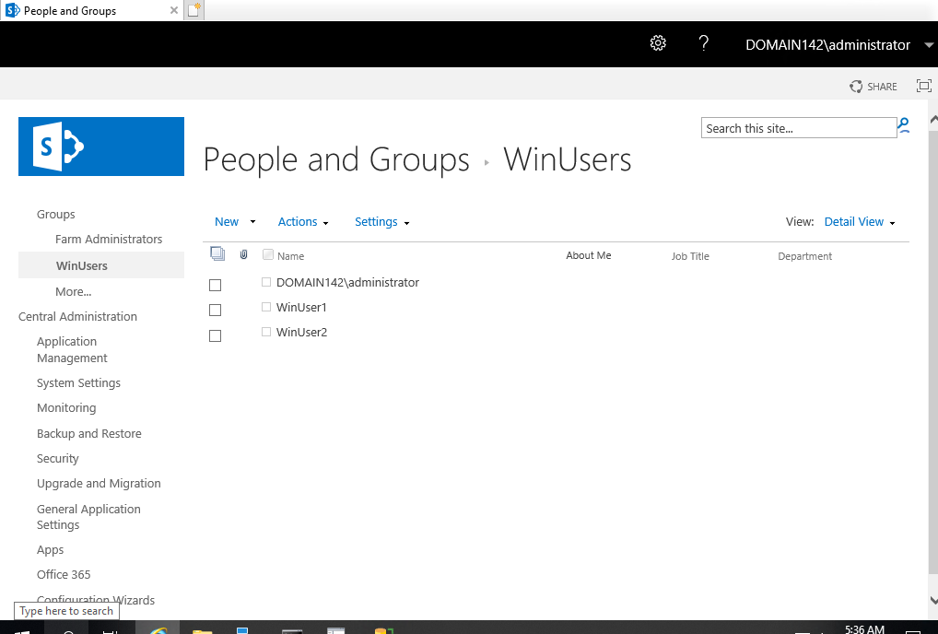

### Create, upload and share at least 1 test document between ‘WinUser1’ and ‘WinUser2’using SharePoint.

Navigate to site contents

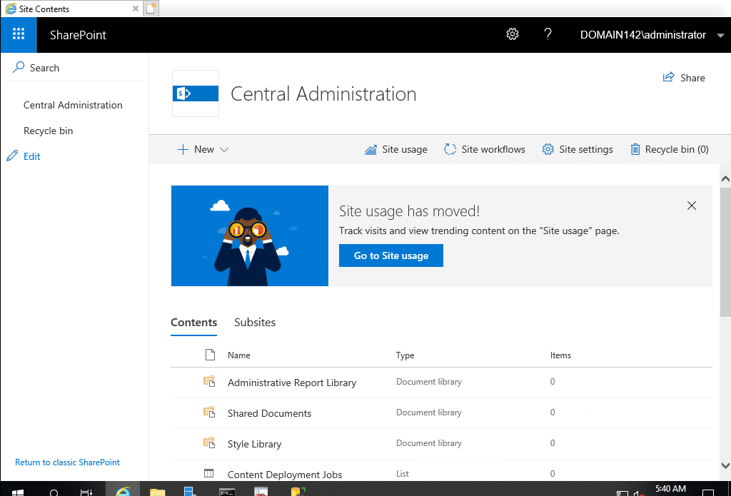

Navigate with WinUsers Site

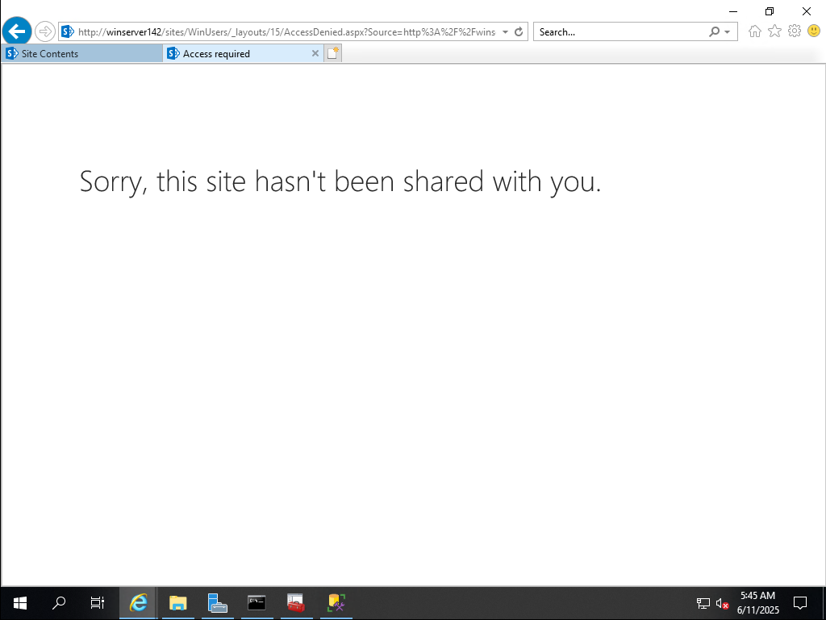

Added SP Farm as Primary Admin instead of Domain Admin, Changed Domain Admin to primary and SP Farm as secondary

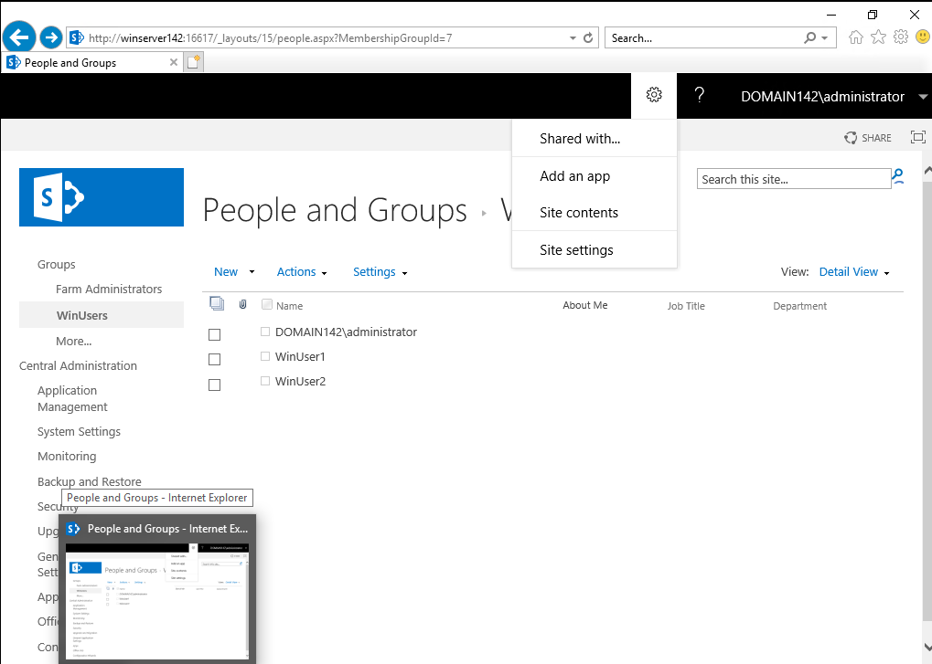

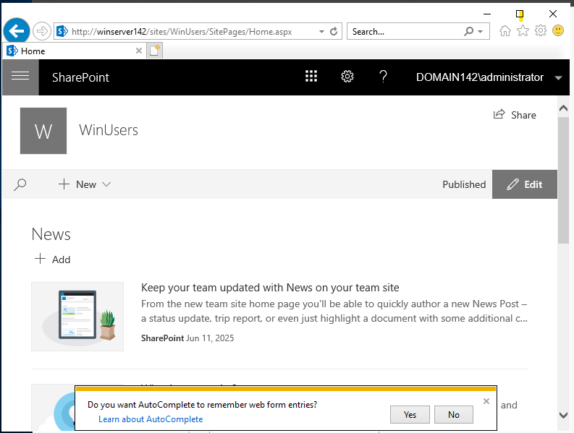

Add users to the members of the site

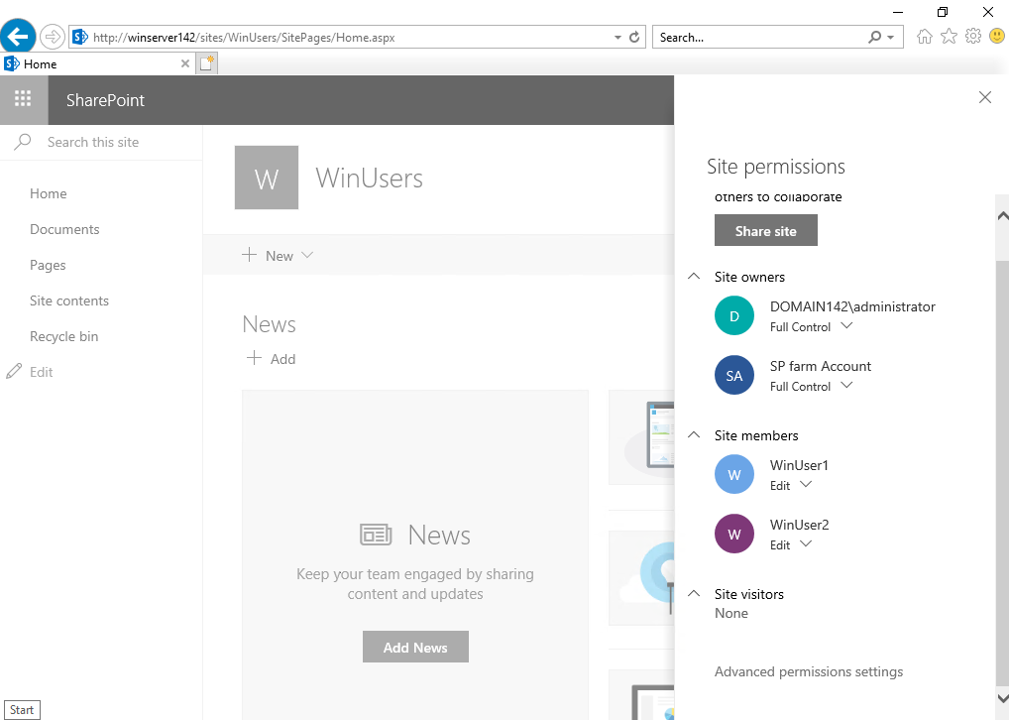

Log on to the server as WinUser1 and verify you have access to the document (but DO

NOT have administrative access to SharePoint) * / ** / ***

Bookmark the SharePoint website for ‘WinUser1’

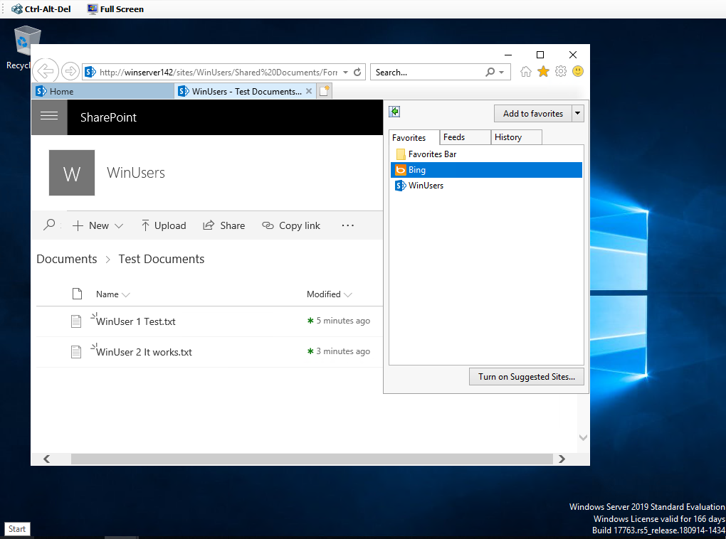

Log on to the server as WinUser2 and verify you have access to the document (but DO

NOT have administrative access to SharePoint) * / ** / ***

a. Bookmark the SharePoint website for ‘WinUser2’

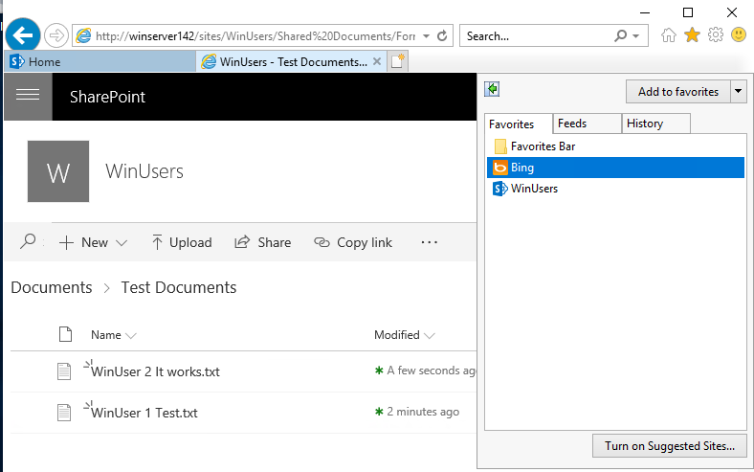

# Linux

Verify your hostname and FQDN is correct **Hostname: Linux242**

**Domain not established yet.**

Open terminal and type hostname CTL

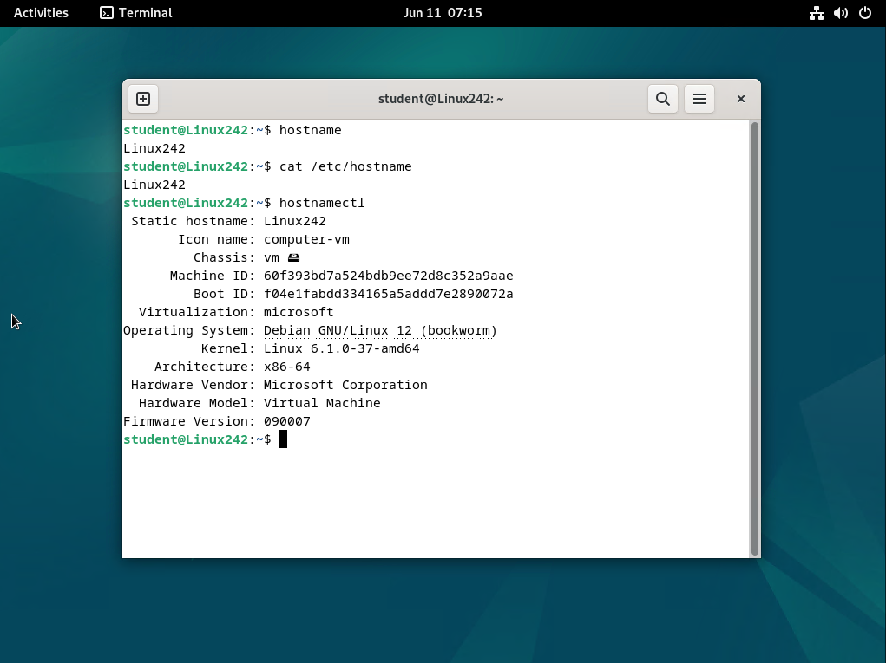

Statically configure the TCP/IP settings as identified in the document titled

Static TCP/IP:

**IP: 172.16.254.42**

**SM: 255.255.0.0**

**GW: 172.16.0.1**

**DNS: 172.16.0.1**

Open Network Settings>IPv4

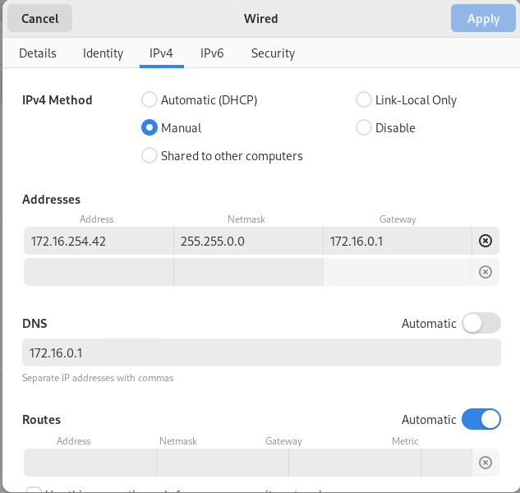

Create a virtual machine checkpoint of the server after you verify the FQDN and IP

### Create users and set their passwords to ‘Password2’

Open Terminal input the following commands >input required information

**Sudo adduser linuxuser1** (For both Users)

**LinuxUsers: Password2**

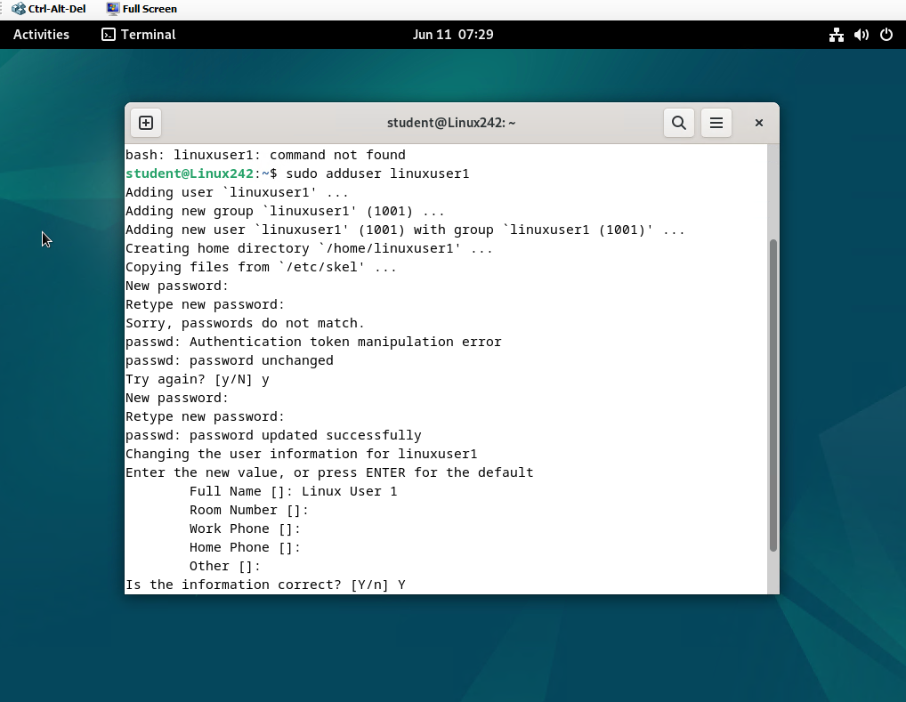

By default, a new user will be added to the group **users**and you can verify it by executing the following command:

**grep ‘users’ /etc/group**

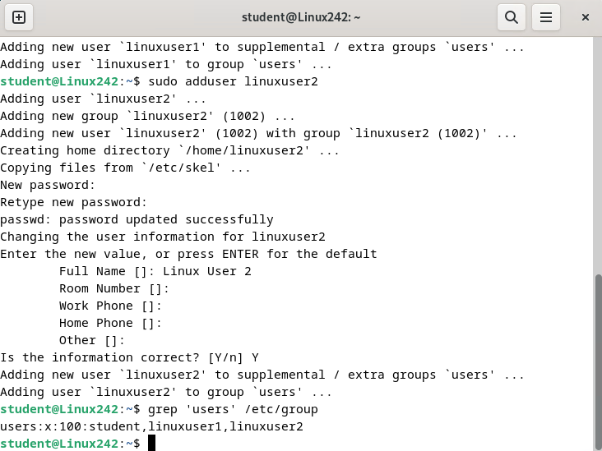

### Install all prerequisite software for OpenDocMan document sharing solution

Prerequisites are to establish a Linux, Apache, MySQL, PHP stack.

<https://shape.host/resources/install-lamp-stack-on-debian-12-a-step-by-step-tutorial>

#### Update the system

**sudo apt update**

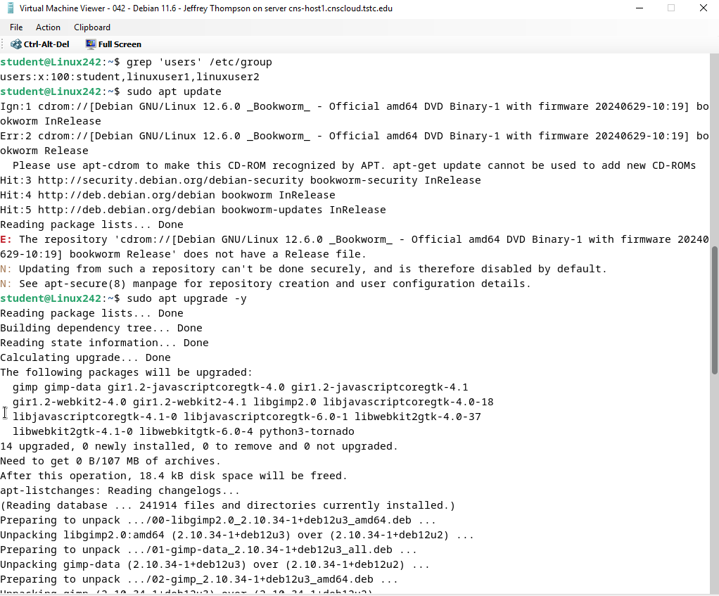

**sudo apt upgrade -y**

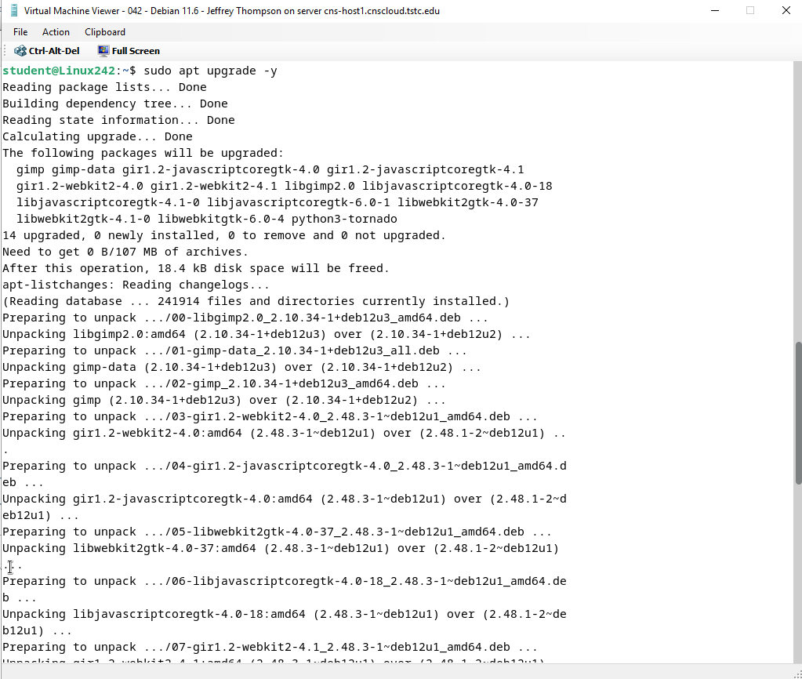

**Sudo apt install -y mariadb-server mariadb-client**

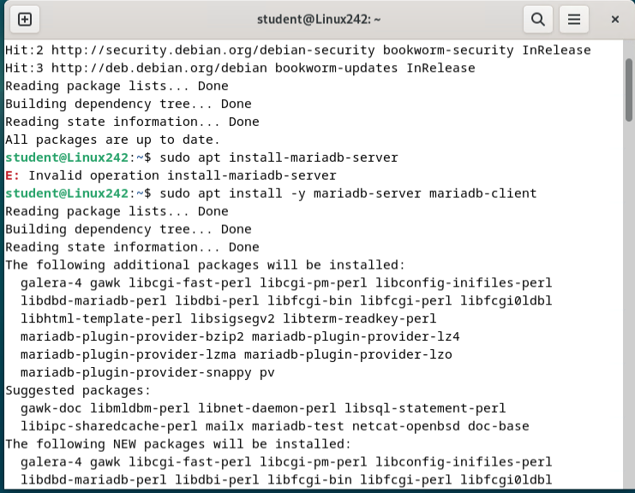

**Sudo mysql_secure_installation**

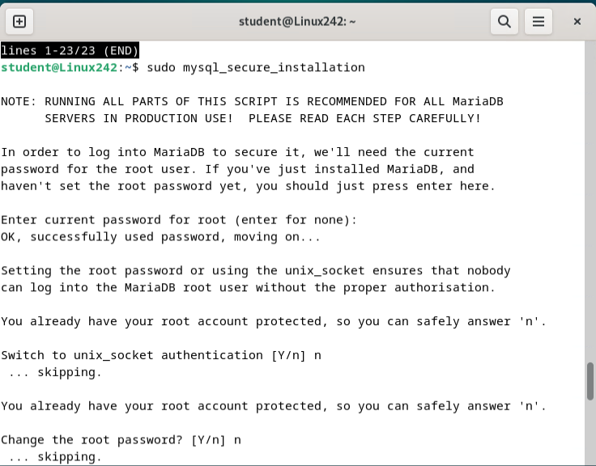

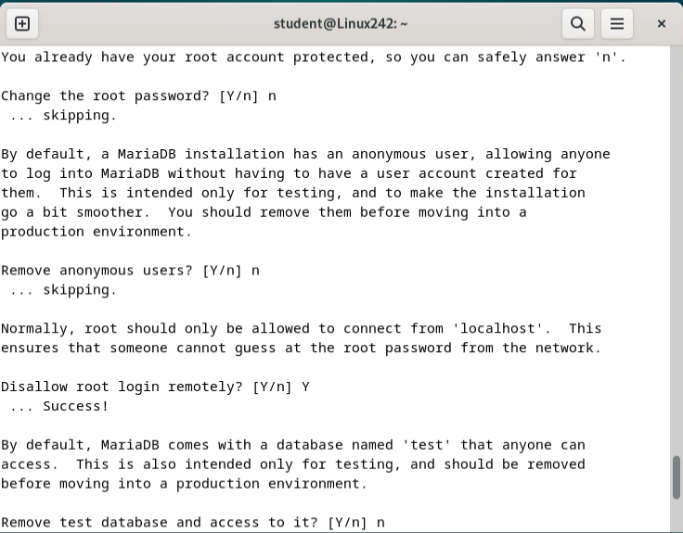

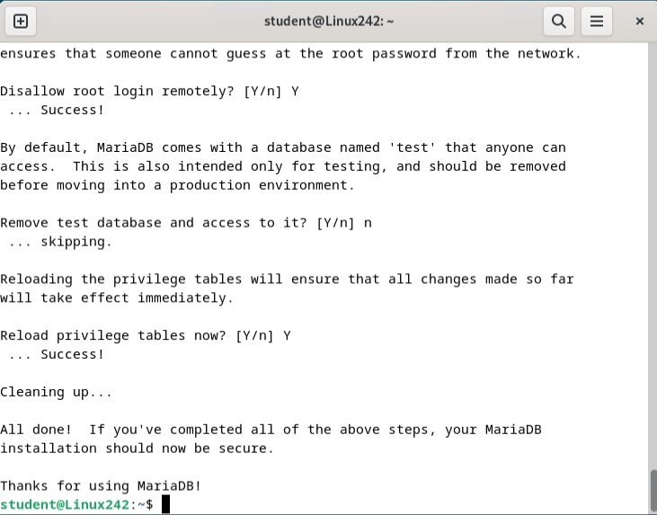

Apache2 was installed previously so we just did a system status

**Sudo systemctl status apache2**

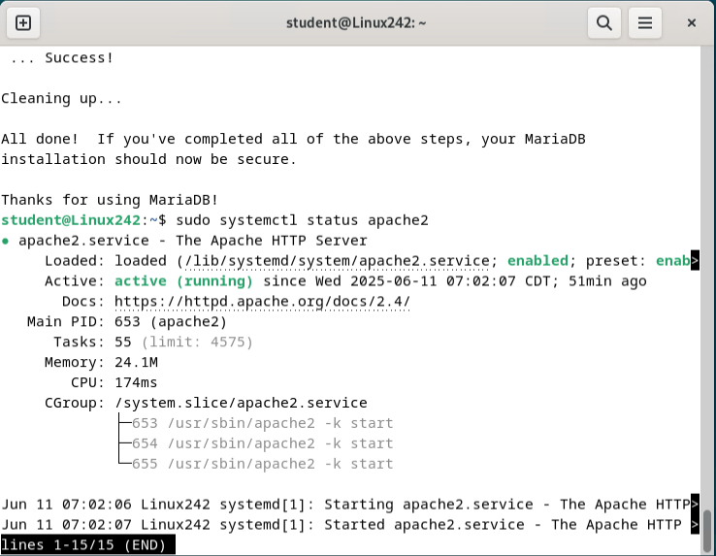

**Enable HTTP and HTTPS Ports**

**sudo apt install ufw -y**

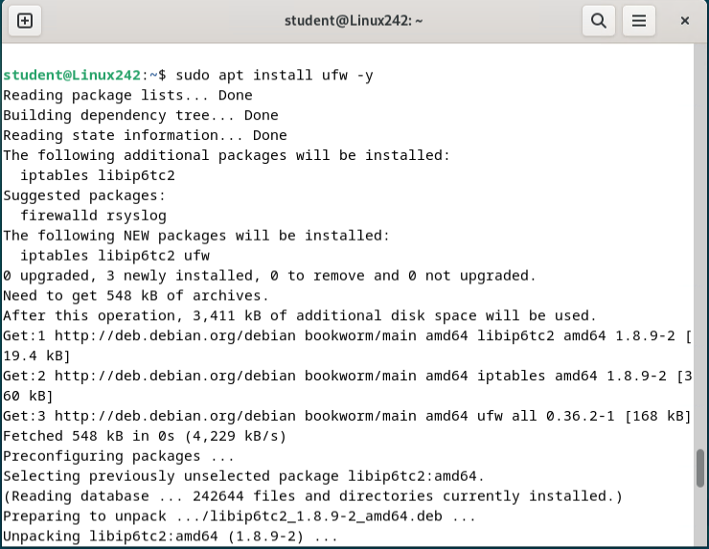

**sudo ufw allow http**

**sudo ufw allow https**

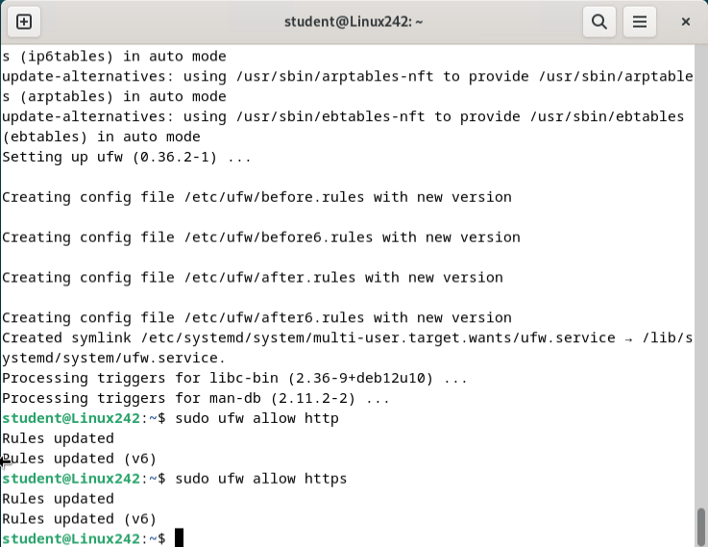

**sudo ufw enable**

**sudo ufw reload**

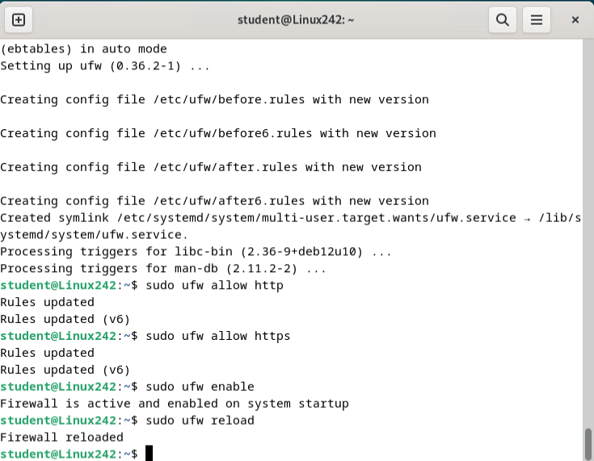

**Install PHP**

**sudo apt install -y php libapache2-mod-php php-cli php-fpm php-json php-pdo php-mysql php-zip php-gd php-mbstring php-curl php-xml php-pear php-bcmath**

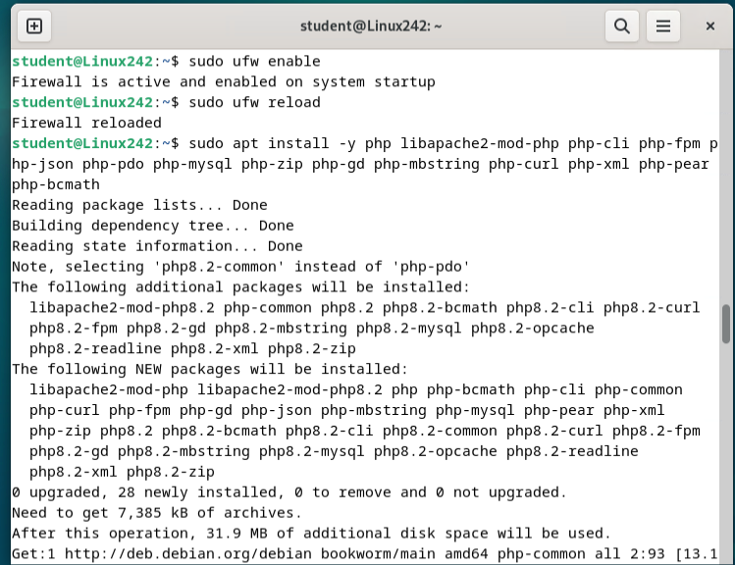

**php -v**

**echo "<?php phpinfo(); ?>" | sudo tee /var/www/html/info.php**

**sudo rm /var/www/html/info.php**

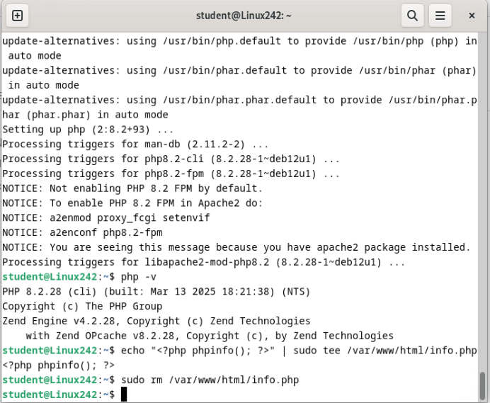

Install your chosen document sharing solution

Verify PHP Modules

**sudo apt install php-mysql php-mbstring php-xml php-zip php-gd php-curl -y**

Create the MySQL Database & User

Database: **opendocman**

User: **opendocuser**

Password: **Password1**

**sudo mysql -u root -p**

**CREATE DATABASE opendocman;**

**CREATE USER 'opendocuser'@'localhost' IDENTIFIED BY 'Password1';**

**GRANT ALL PRIVILEGES ON opendocman.* TO 'opendocuser'@'localhost';**

**FLUSH PRIVILEGES;**

**EXIT;**

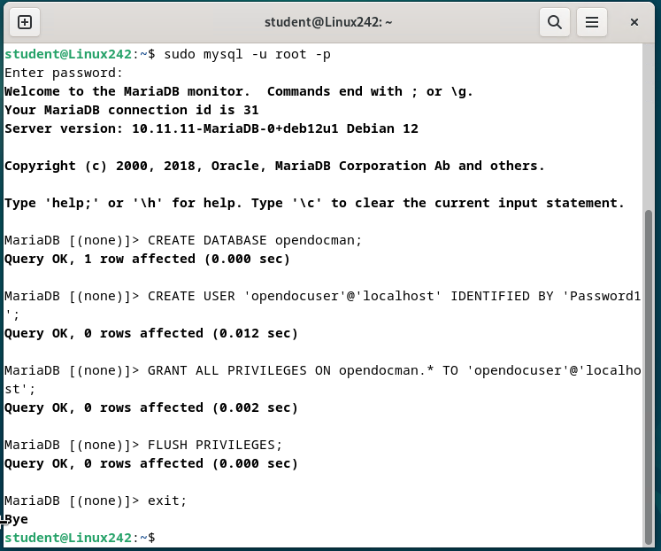

**Enable Apache mod_rewrite**

**sudo a2enmod rewrite**

**sudo systemctl restart apache2**

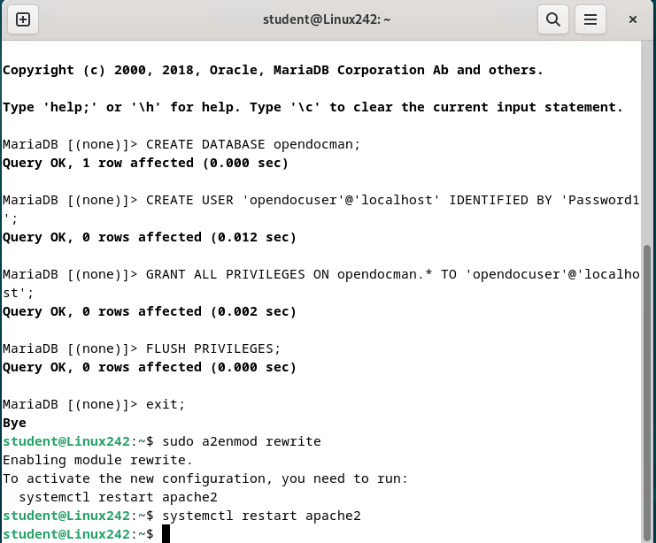

**Set AllowOverride All in Apache Site Config**

**sudo nano /etc/apache2/sites-available/000-default.conf**

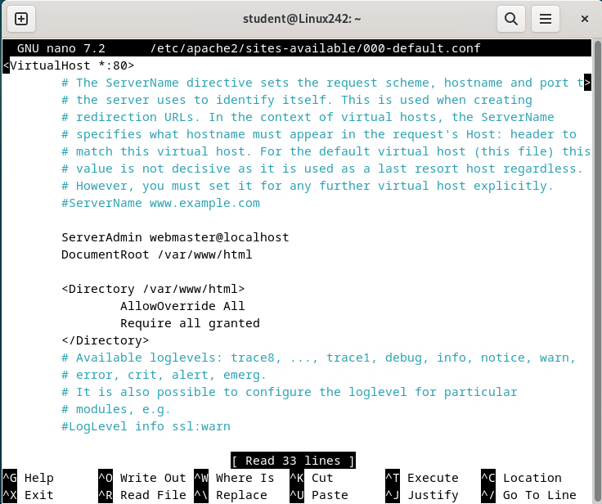

**Verify All Required PHP Modules**

**php -m | grep -E 'mysql|mbstring|xml|zip|gd|curl'**

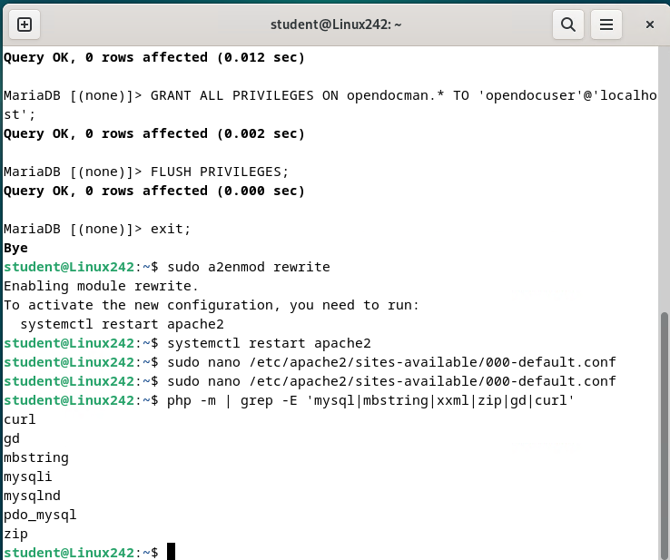

**Verify File Permissions**

**sudo chown -R www-data:www-data /var/www/html/opendocman**

**Error- Cant access opendocman file** 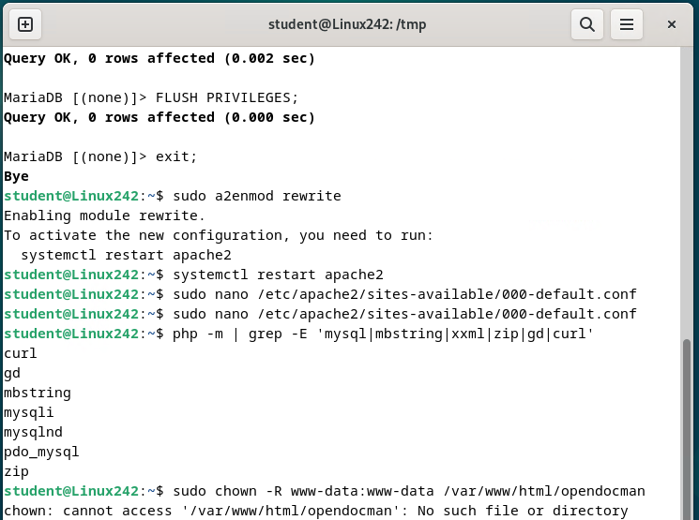

**Redownload and Extract Opendoc**

**cd /tmp**

**wget https://github.com/opendocman/opendocman/archive/refs/heads/master.zip**

**unzip master.zip**

**sudo mv opendocman-master /var/www/html/opendocman**

**sudo chown -R www-data:www-data /var/www/html/opendocman**

**sudo chmod -R 755 /var/www/html/opendocman**

**sudo systemctl restart apache2**

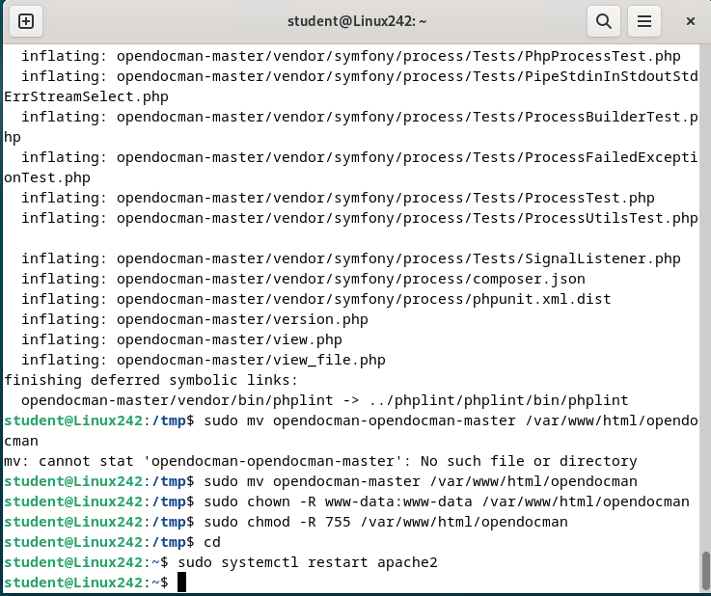

**Go to the install site**

**http://172.16.254.42 opendocman/install/setup-config.php**

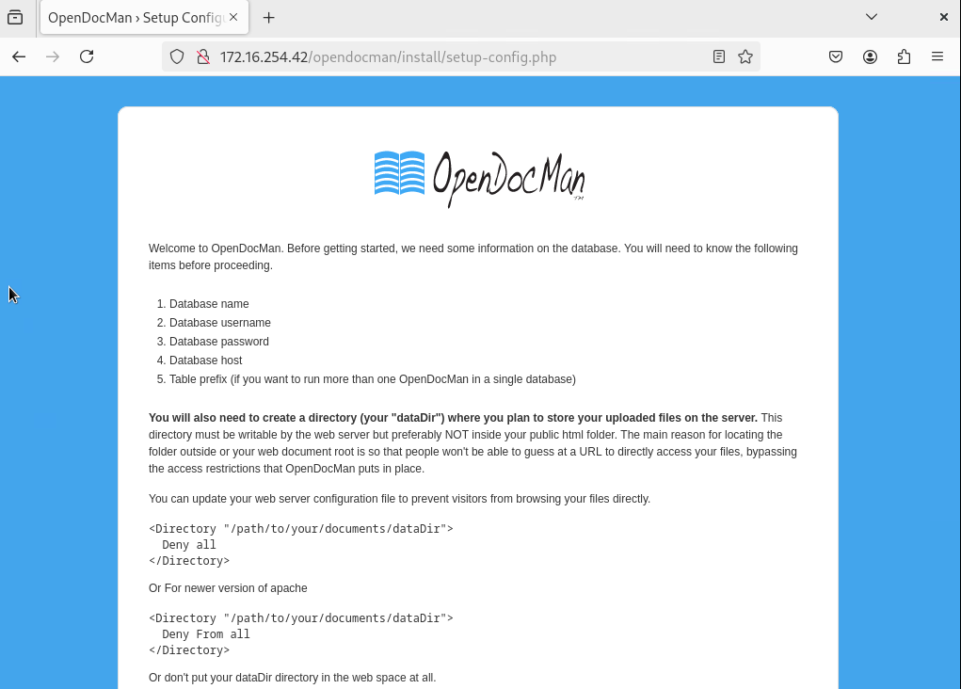

**Create the dataDir**

**sudo mkdir /var/opendocman_data**

**sudo chown -R www-data:www-data /var/opendocman_data**

**sudo chmod 755 /var/opendocman_data**

**Error-No content on the install screen**

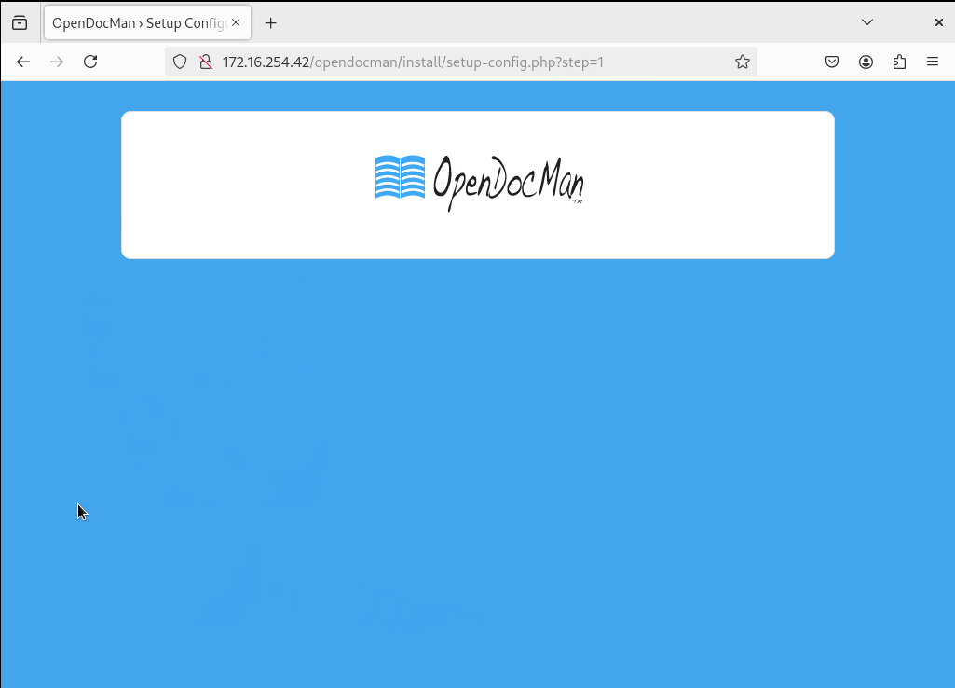

**Check Apache’s Error Log**

**sudo tail -n 20 /var/log/apache2/error.log**

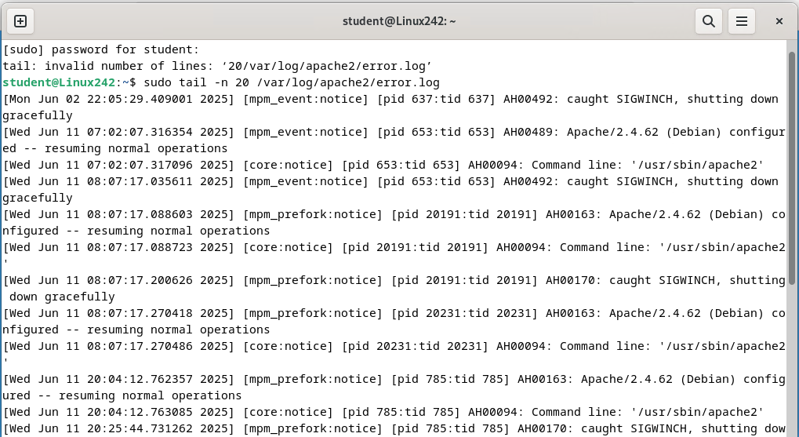

**PHP Error Is Still Being Suppressed**

**enable *explicit* error logging temporarily**

**<?php**

**error_reporting(E_ALL);**

**ini_set('display_errors', 1);**

**?>**

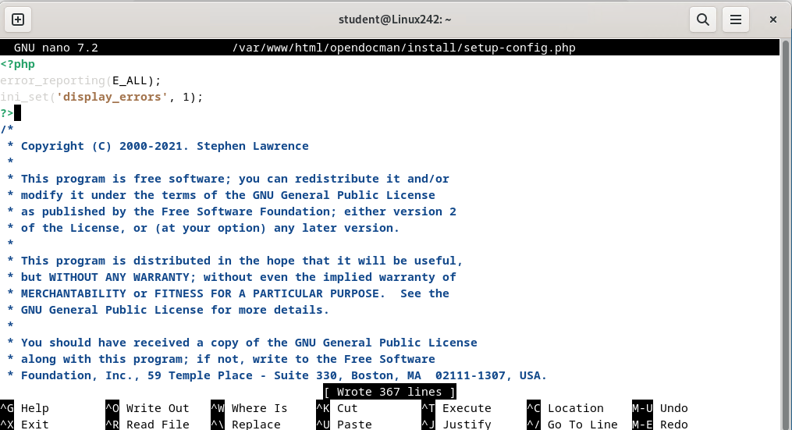

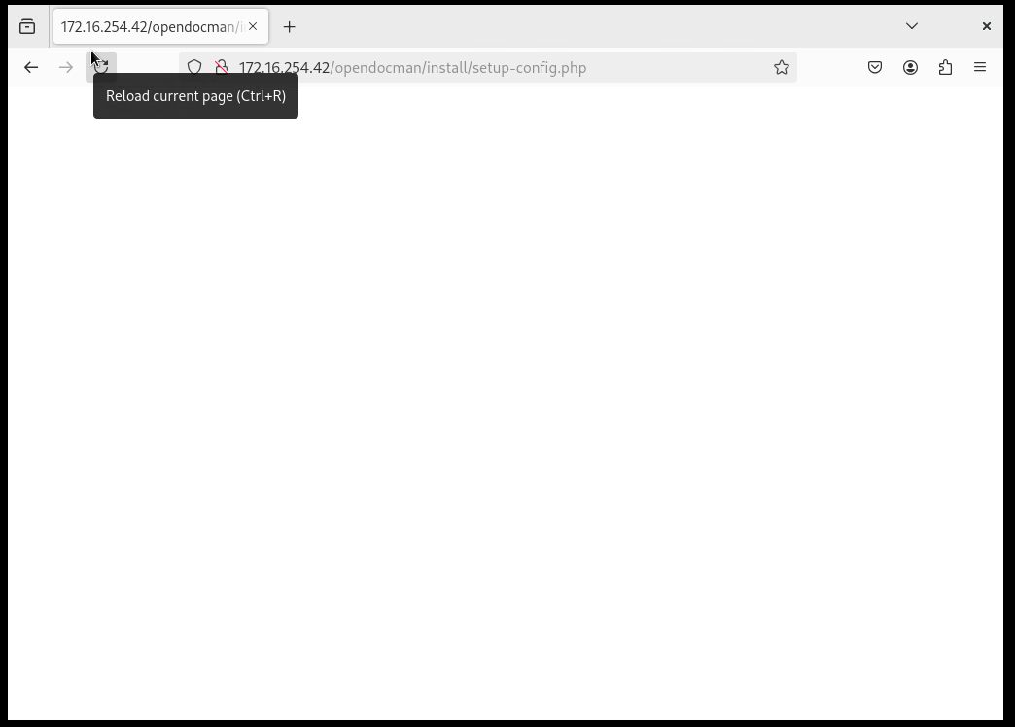

**After research I determined that there is a Missing PHP compatibility for v 8 and above. Need to install PHP 7.4 to be compatible with OpenDocMan**

**Step-by-Step: Install PHP 7.4 on Debian 12**

**sudo apt install -y ca-certificates apt-transport-https lsb-release gnupg curl**

**echo "deb https://packages.sury.org/php $(lsb_release -sc) main" | sudo tee /etc/apt/sources.list.d/php.list**

**curl -fsSL https://packages.sury.org/php/apt.gpg | sudo gpg --dearmor -o /etc/apt/trusted.gpg.d/php.gpg**

**sudo apt update**

**sudo apt install -y php7.4 php7.4-mysql php7.4-mbstring php7.4-xml php7.4-zip php7.4-gd php7.4-curl libapache2-mod-php7.4**

**sudo a2dismod php8.2**

**sudo a2enmod php7.4**

**sudo systemctl restart apache2**

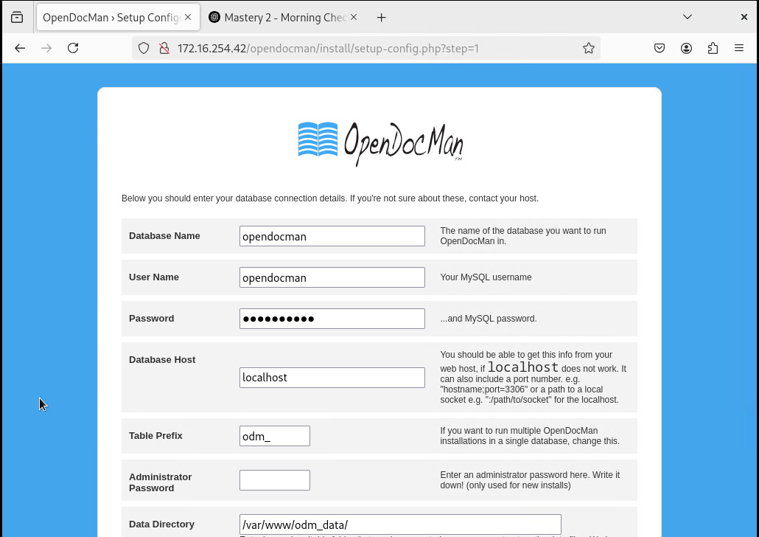

|  |  |
| --- | --- |
| Database Name | **opendocman** |

|  |  |
| --- | --- |
| User Name | **opendocuser** |

|  |  |
| --- | --- |
| Password | **Password1** |

|  |  |
| --- | --- |
| Database Host | **localhost** |

|  |  |
| --- | --- |
| Table Prefix | **odm_** |

|  |  |
| --- | --- |
| Administrator Password | **Password1** |

|  |  |
| --- | --- |
| Data Directory | **/var/opendocman_data** |
|  |  |

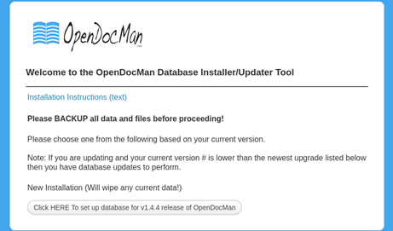

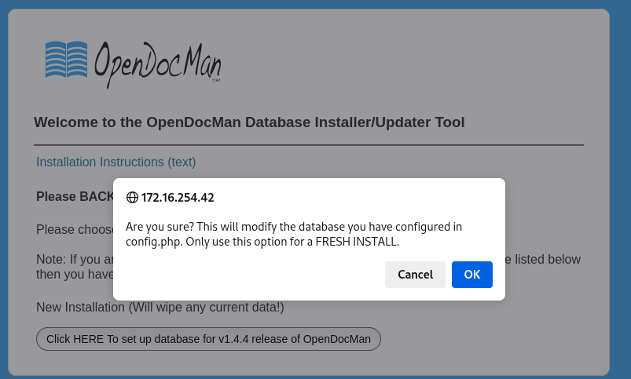

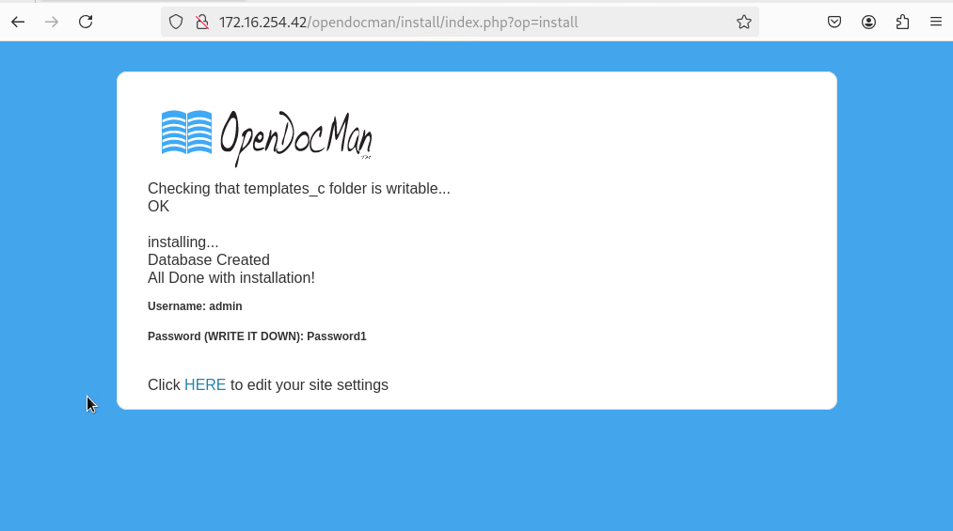

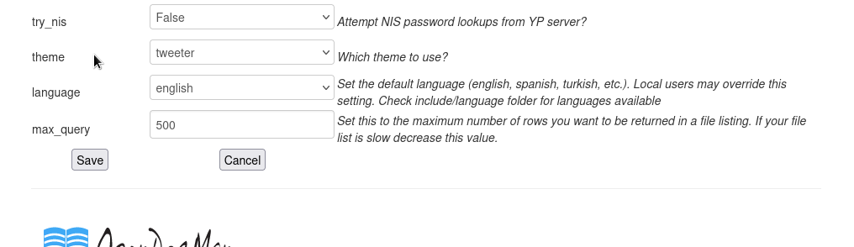

Configure web-based file collaboration Open

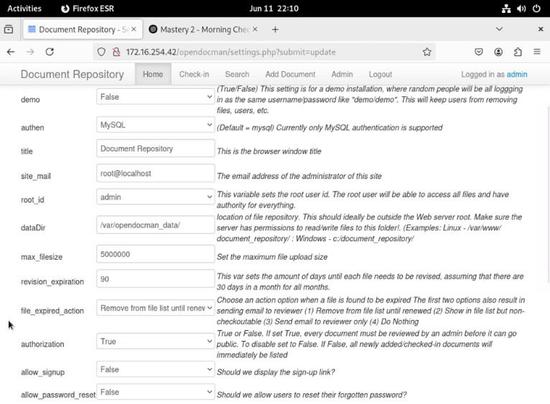



Create users named ‘LinuxUser1’ and ‘LinuxUser2’ 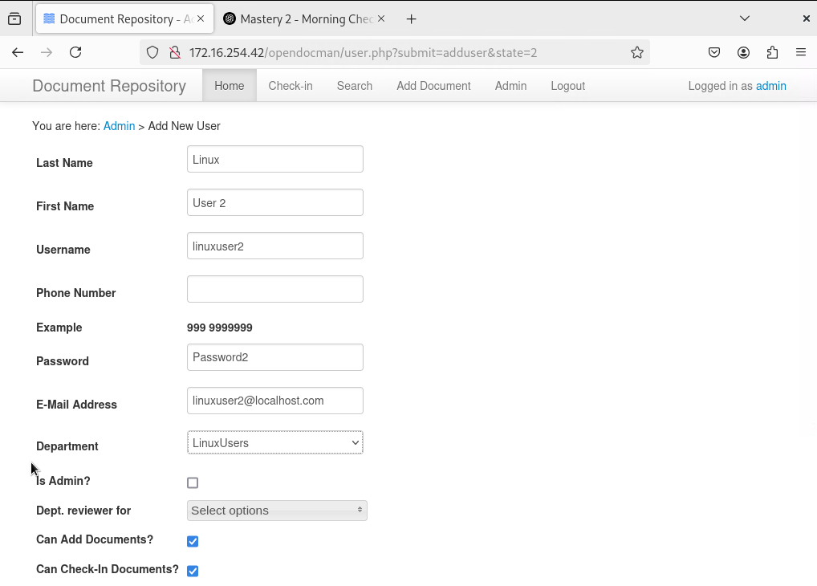

Create and share at least 1 Test document

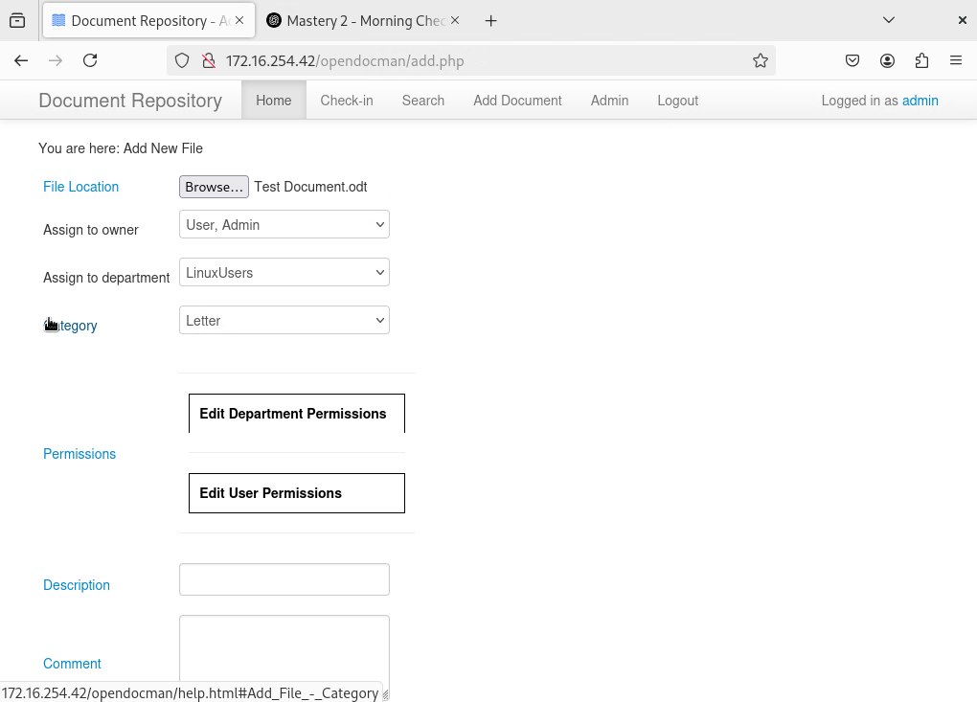

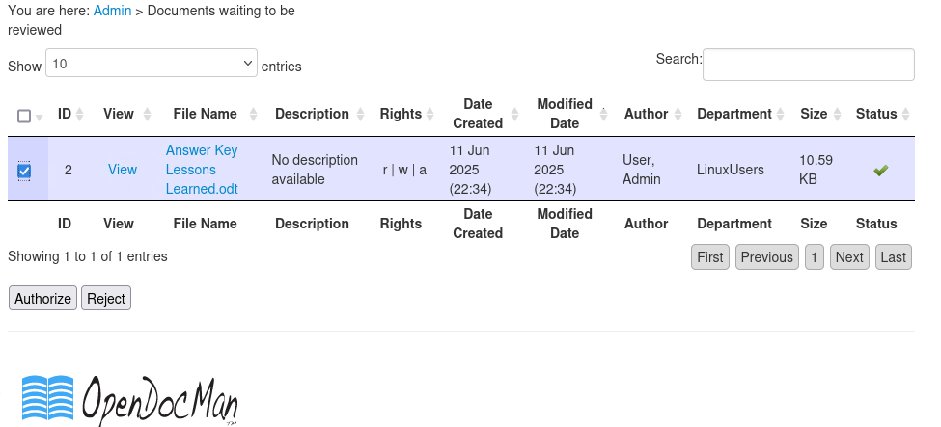

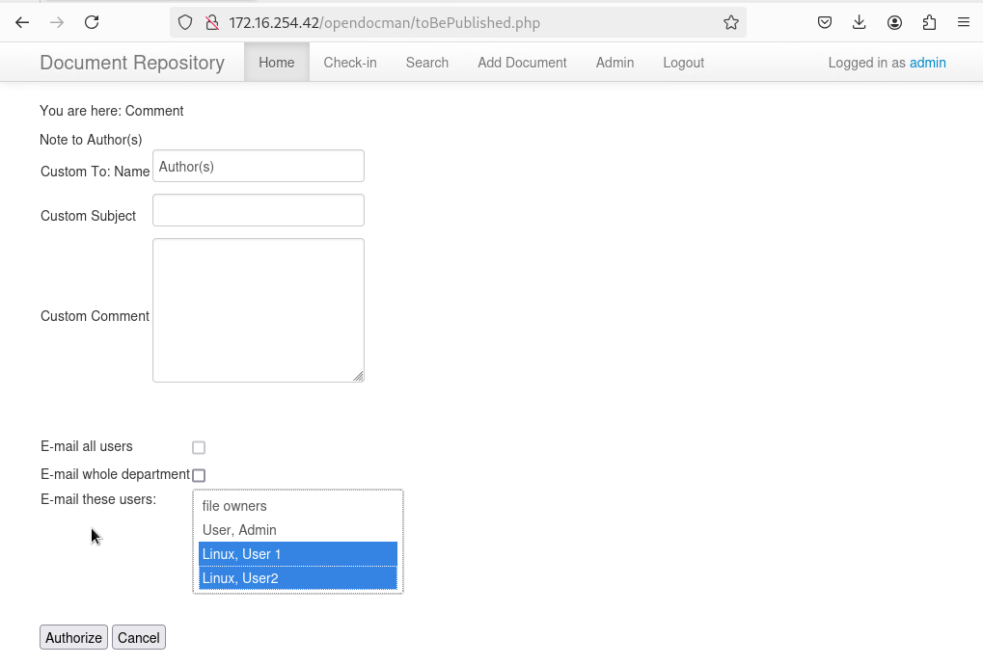

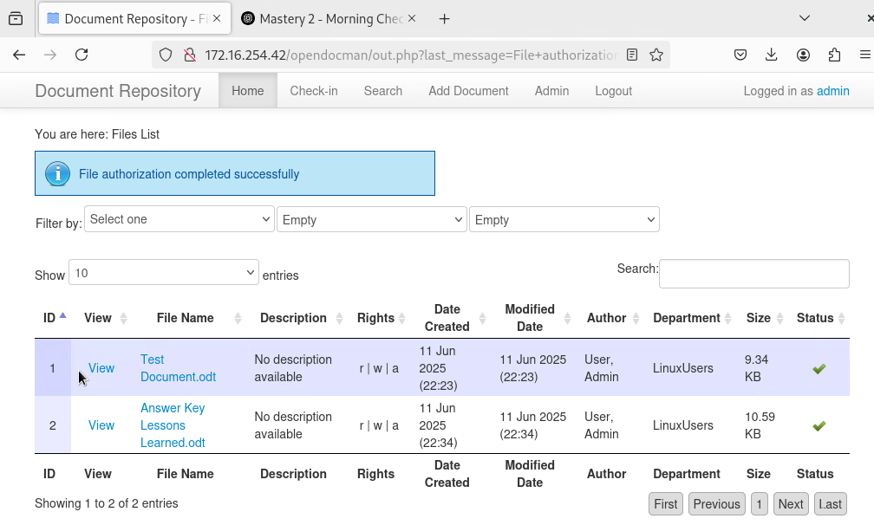

VERIFY ‘LinuxUser1’ has access to the shared document

Bookmark the logon page for your chosen document sharing solution for

LinuxUser1

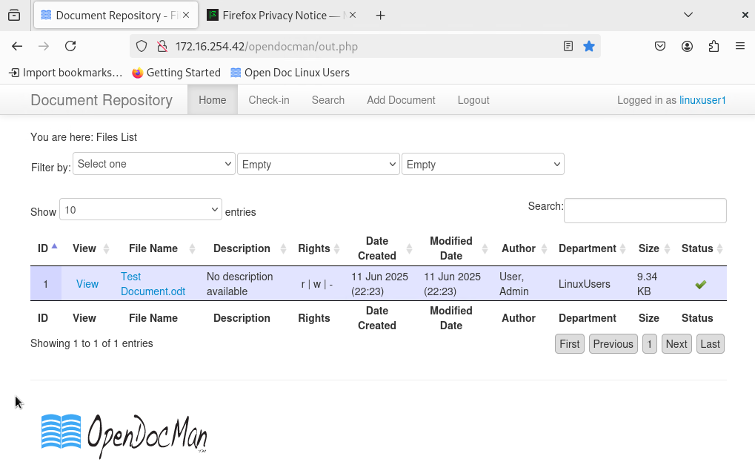

VERIFY ‘LinuxUser2’ has access to the shared document

Bookmark the logon page for your chosen document sharing solution for

LinuxUser 2

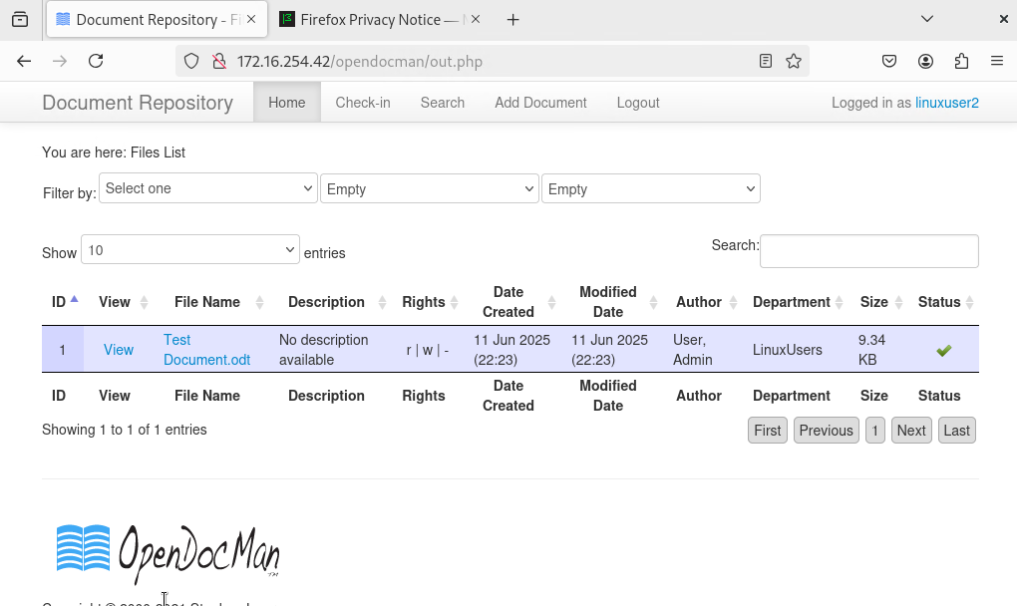

## OpenDocMan Summary

The document management system OpenDocMan was successfully deployed on a Linux web server using Apache, PHP 7.4 instead of PHP 8.2, and a MariaDB database. After creating the necessary data directory and configuring permissions, the installation script was executed through the browser interface. The system successfully connected to the database, launched the setup interface, and allowed admin account creation, confirming the proper configuration of OpenDocMan for document storage and access.

## SharePoint Summary

Microsoft SharePoint was accessed and configured through an enterprise Microsoft AD DS and Microsoft SQL environment. A document library was created, permission roles were assigned, and test documents were uploaded. The SharePoint site successfully displayed uploaded content, allowed version tracking, and maintained access control across users, confirming full functionality of its document collaboration and management features.